**Proverbs 20:18-21**

**Every purpose is established by counsel: and with good advice make war.**

**He that goeth about as a talebearer revealeth secrets: therefore meddle not with him that flattereth with his lips.**

**Whoso curseth his father or his mother, his lamp shall be put out in obscure darkness.**

**An inheritance may be gotten hastily at the beginning; but the end thereof shall not be blessed.**

Proverbs contains a lot of wisdom regarding human communication, and some of these ideas are probably familiar to you from previous discussions of the book! Verse 18 reminds us that communication is valuable for achieving a goal. We need good counsel to succeed in reaching our goals, as individuals and as a community. (See Prov. 11:14 and 15:22). Communication is necessary for us—but only “good” communication. We have way too much of the other kind! In verse 19 we’re told to avoid communication with a “talebearer.” (See Prov. 11:13, 18:8). Although enduringly popular, rumors are usually just unsubstantiated nastiness. We’re told to simply leave such things alone, as they cannot benefit ourselves and they are destructive to the community. Another unfortunate type of communication would be cursing your parents. The “obscure darkness” would be the depths to which disrespect of parents causes a person to sink. We need our parents, and our elders, to provide that good advice to which verse 18 refers! And we are properly obligated to respect those who have done so much for us. This idea of taking one’s inheritance “hastily” is similarly disrespectful. As in the story of the prodigal son, it involves clear rejection of parental guidance and teaching—which, of course, ends badly. Happily, we have that story (and many others) in the Bible, along with these Proverbs, to help us avoid such poor choices and disastrous ends!

Talebearer

* One who spreads vicious stories, rumors, or gossip.
* One who officiously tells tales; one who impertinently or maliciously communicates intelligence, scandal, etc., and makes mischief.

[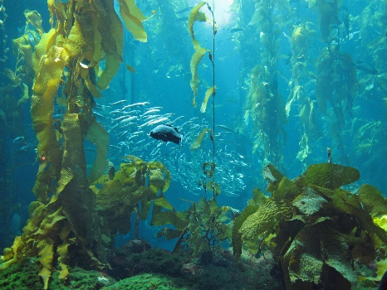](http://blogs.kcrw.com/whichwayla/wp-content/uploads/2014/11/Kelp-Forest.jpg)**Sea Urchins, Sheephead Wrasse, and the Kelp Forest**

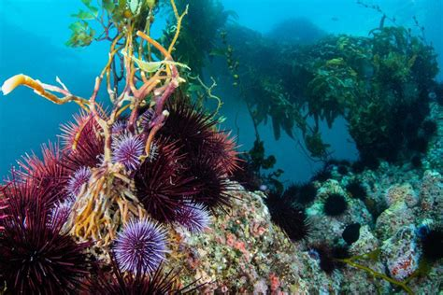[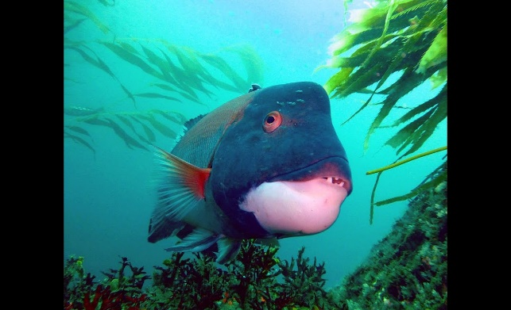](https://i.ytimg.com/vi/eme0Igx4rL0/maxresdefault.jpg)Kelp forests are underwater ecosystems formed by the dense growth of several different species known as “kelps.” Kelp might look like a tree but, really, it is a kind of large, brown algae. Some kinds of kelp can reach heights (underwater) of 150 feet. Kelp does not have roots. Instead, it is secured by holdfasts that lock onto substrates made of rock, or cobble. Although it functions in a way like a root, holdfasts do not absorb nutrients. Gas bladders keep the top parts of the kelp afloat. Many different kinds of creatures hide in the kelp, or eat the algae that accumulates on its leaves. But certain “grazers” within the kelp forest can be a problem: sea urchins. These spiny creatures travel across the sea floor in massive numbers, devouring the stems of the kelp, detaching them from the ocean floor. In such vast numbers, sea urchins can readily wipe out large areas of kelp. The empty spaces they leave behind are called “urchin barrens.” In order to maintain the kelp forest community, sea urchin numbers must be limited. Sea otters like to eat sea urchins, but there aren’t nearly enough otters! Fortunately, sheephead wrasse, a fish with large teeth, are able to break through the spines and eat at least the smaller sea urchins. Sheephead wrasse hide during the night, so they need the shelter of the kelp. By keeping sea urchin numbers down, sheephead wrasse help maintain not only their homes, but the homes of many other creatures. They still face a problem, however, with the larger sea urchins. The long spines of the bigger sea urchins make them difficult. Fortunately, the largest sheephead wrasse (the older males) are able to tackle the larger sea urchins by turning them upside-down. And every fish in the region descends for a bite when one of these large males turn over a big sea urchin! All of these different living things—kelp, sea urchins, sea otters, sheephead wrasse—contribute to their community in various (good or bad) ways. Our communication, likewise, contributes to our community in a range of ways. The sea urchins are a scourge, like rumer-mongers, destroying the ecosystem. The otters and wrasse limit the damage, like good counsel does. But to take on the biggest problems, the community must respectfully turn to their elders, just as we do!

Netflix

One Planet

Season 1

Episode 4: “Coastal Seas”

Start: 21:02 (29:09 from End)

End: 27:16 (22:55 from End)