Take just a moment to think about the last time that you made a decision you *knew* was wrong. I suspect that for many people that decision had something to do with “recompense.” Ever experienced a failure at work and then eaten something you shouldn’t have (a lot of ice cream)? Encountered a financial problem and found yourself driving aggressively? Been embarrassed by a colleague then had a screaming row with your family? We get frustrated or angry and then do something unkind or self-indulgent as “recompense.” We sometimes attempt to make things “fair” to ourselves by being unfair to others! Which makes the juxtaposition of verses 22 and 23 interesting. As Christians, we’re directed to be fair to others and trust in God to make things fair for ourselves—which is pretty much the opposite of our human nature. We have a strong, instinctive sense of what “fairness” means when applied to ourselves, and we want to enforce it. This sense of entitlement—what we, in our own minds, deserve—is well known to inspire stress, dishonesty, anger, rioting, and even murder! But when those instances of “unfairness” occur, we are reminded by verse 24 that God directs our “goings.” What seems “unfair” to us might simply be part of God’s process to save us. And He is the only one who has the right to redress the balance. Verse 25 particularly warns us against the feeling that our obligation to God is unfair. The first part of this verse should probably be rendered “it is a snare to a man hastily to consecrate some of his own property,” when he might later feel such an obligation is unfair or unnecessary. Think about Ananias and Sapphira! We are directed here to be fair and honest to God and other people, and trust God to “recompense” evil on our behalf. How much happier we could be if we followed these instructions!

**Proverbs 20:22-25**

**Say not thou, I will recompense evil; but wait on the Lord, and he shall save thee.**

**Divers weights are an abomination unto the Lord; and a false balance is not good.**

**Man's goings are of the Lord; how can a man then understand his own way?**

**It is a snare to the man who devoureth that which is holy, and after vows to make enquiry.**

[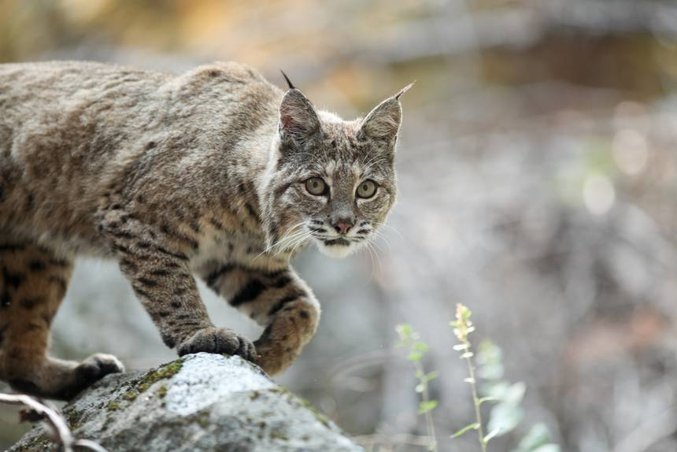](https://media.treehugger.com/assets/images/2019/09/bobcat-hunting.jpg.860x0_q70_crop-scale.jpg)**Bobcats**

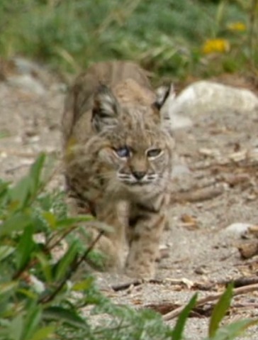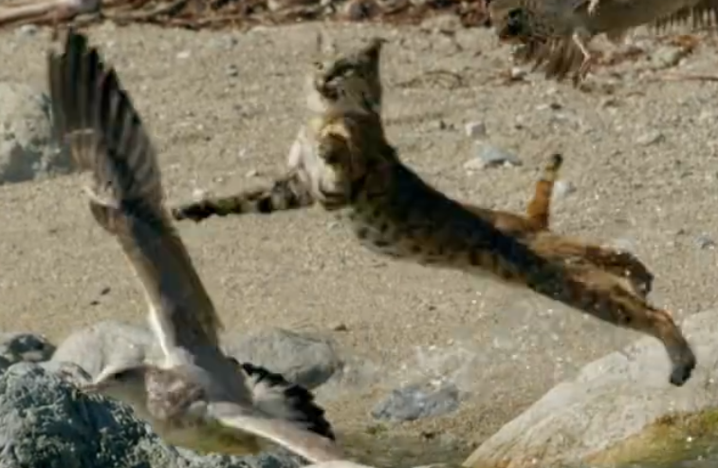The bobcat (Lynx rufus) is a medium-sized North American cat ranging from southern Canada to central Mexico, including most of the contiguous United States. Bobcats are adaptable predators. With a gray to brown coat, whiskered face, and black-tufted ears, the bobcat resembles the other species of the midsized genus Lynx. Bobcats are about twice as large as domestic cats, having distinctive black bars on the forelegs and a black-tipped, stubby (or "bobbed") tail. Though bobcats generally prefer rabbits and hares, they will also hunt insects, chickens, geese and other birds, small rodents, and deer. Certain bobcats, however, are even more adventurous in choosing their prey. On the coast of Northern California lives a particular bobcat, a female, who has specialized in hunting gulls. With a wingspan between 4 and 5 feet, gulls are large and powerful birds. They are also accomplished in the air, launching rapidly into flight whenever danger threatens. This particular bobcat has chosen some challenging prey. With care and persistence, however, she has learned the necessary techniques for hunting gulls: choosing the right target, bursting from cover at the last moment, leaping into the air, and rapidly subduing her catch. She is even able to catch a gull while carrying a gull she has previously caught! If only she could manage to carry them both. Unusual skill in catching gulls, however, is not the only reason this particular bobcat has been carefully studied. She is an interesting subject because she is blind in one eye. Yet she has not chosen to scavenge from roadkill or other predators, nor has she chosen to live off of human refuse. Despite her (unfair) disadvantage in depth perception, she has chosen to develop a unique skill and make a living hunting challenging prey. She is not entitled. Presumably, she trusts God to make “recompense” as He sees fit. Perhaps this remarkable bobcat can inspire us to trust in God as well as she does!

Amazon

Nature: Super Cats

Season 1

Episode 2: “Cats in Every Corner”

Start: 22:45 (29:58 from End)

End: 28:28 (24:15 from End)