**Proverbs 20:8-12**

**A king that sitteth in the throne of judgment scattereth away all evil with his eyes.**

**Who can say, I have made my heart clean, I am pure from my sin?**

**Divers weights, and divers measures, both of them are alike abomination to the Lord.**

**Even a child is known by his doings, whether his work be pure, and whether it be right.**

**The hearing ear, and the seeing eye, the Lord hath made even both of them.**

We hear A LOT today about judgement. I’m sure you’ve heard it. “Don’t judge!” is a pretty common admonition, often followed by the logic that we don’t know what other people are facing in their lives. This is true as far as it goes—God is our Judge, and only He can accurately perceive all our motivations. Unfortunately, this advice can be taken to an extreme that requires us to be both witless and blind. This is not a good posture for anyone, much less a Christian! Yet I’ve known church groups so anxious not to judge others that they would allow a convicted pedophile to teach children’s classes. This tendency defies Solomon’s simple observation that “even a child is known by his doings.” We are, as Christians, required to develop good judgement. As verse 12 observes, God gave many of us functional eyes and working ears (and hopefully something functional located between them.) A leader, king, or judge is intended to discern clearly between right and wrong. What if he refused to judge? Refusing to make any judgments can be rooted in the worst sort of moral cowardice. And yet sometimes we are tempted to make the opposite error: needlessly harsh judgements. Equally wrong, cruel judgments align us directly with the “accuser of the brethren,” Satan. So verse 9 reminds us that while we must indeed make judgements, we must make them from a place of mercy, remembering our own failures. We must apply first to ourselves any standards that we would apply to others, since “divers” standards are an abomination. Developing good judgement is a tricky process! But God has provided us with abundant guidance, both here in Proverbs and elsewhere!

[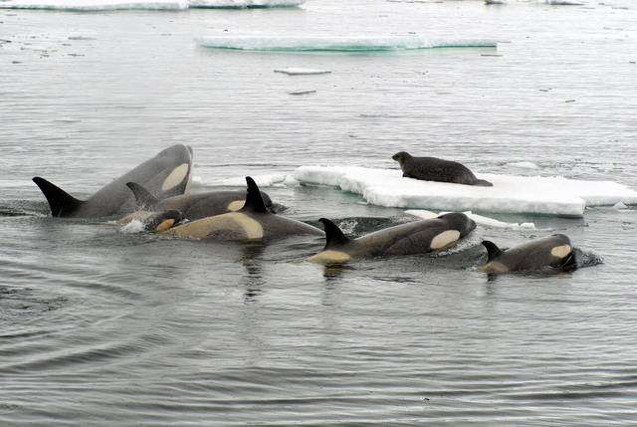](http://blog.nus.edu.sg/lsm1303student2013/files/2013/04/John_Durban-pack-ice_kw_in_Antarctic_with_Weddell_Seal_2-101r8a7.jpg)**Orcas and Weddell Seals**

[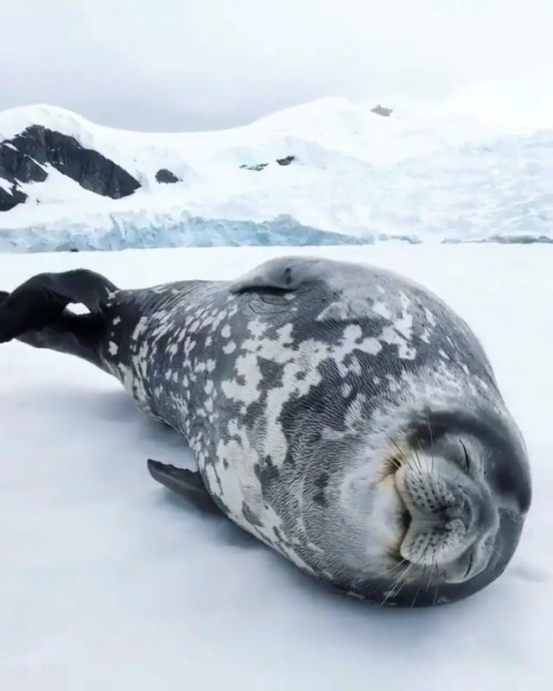](https://i.pinimg.com/originals/f1/03/74/f10374c1b86cedc43376170e70e864c8.jpg)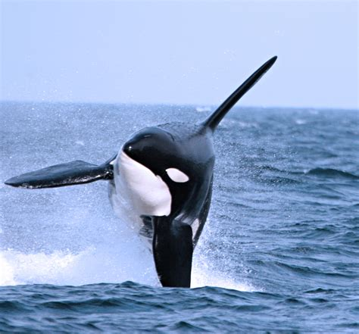Orcas, also called “killer whales,” are astonishingly clever animals. They aren’t actually whales, being the largest members of the oceanic dolphin family, but at least some of them are definitely killers. They live in close family groups, called pods, generally led by the oldest female. Hunting techniques, vocal behaviors, and even diet are passed down within the family. Curiously, some pods hunt and eat only fish, while other pods specialize in hunting mammals including whales, seals, and sea lions. Being clever and very social creatures, orcas within a pod work as a team to hunt prey. In the ice-ridden antarctic sea, certain pods have developed extremely complex methods for catching seals. Weddell seals are some of the recipients of this unfortunate attention. They like to rest on ice floes, out of the cold water and (ideally) safe from predators like the orcas. But orcas have worked out a way to deal with this, at least in terms of the smaller ice floes. After carefully examining the shape and stability of the piece of ice on which the seal is resting, the entire pod lines up and swims quickly toward the ice, diving sharply down beneath it when they get close. This forces a substantial wave over the ice, which either disloges the seal or breaks up the ice. This maneuver is repeated as necessary, forcing the seal into the water. Orcas are much faster than seals. But seals are smaller and more nimble. The orcas can only turn around so fast, and they have to break away to build up speed. If it is clever, a seal can use these awkward moments—and any surrounding ice—to escape the orcas. But the seal has to be both clever and lucky in order to escape, because the orcas work as a team. There are several kinds of careful judgement occuring in this kind of scene. The orcas have to judge their attacks carefully, or their nimble and clever prey escapes. The weddell seal must judge its movements with great care, or it will be eaten. The seal must also judge the threat. Not all orcas are seal-eaters, after all. Imagine a seal refusing to judge whether or not a particular orca eats seals! Or a seal fleeing hysterically every time another shape—seal, walrus, orca, or dolphin—moves through the water. Ridiculous! A seal wouldn’t survive long at either extreme. They need GOOD judgement… as do we!

Amazon

Wildest Places: Antarctica

Season 3

Episode 3: “Connected Continents”

Start: 43:13 (8:47 from End)

End: 49:28 (2:32 from End)