Have you ever noticed that leadership is a very tricky thing? A leader has great influence over others—which can be either extremely good or very, very bad. In order to cause all things to work together for good for God’s people, it is often necessary for God to turn the hearts of our leaders toward His ends. Of course, this directing of hearts cannot interfere with a man’s freedom to choose whether or not to follow the path of salvation. But a leader who is willing to work at God’s direction is an incredibly powerful force! A leader who is willing to be led by God can make the path to salvation more passable for everyone else. And this is just as true on a small scale as on a larger one. God has placed leaders within the small units of our families as well—our fathers! Of course, we are all leaders in some sense. Every one of us is responsible for our influence over others, regardless of how large or small that influence might be. But there is no doubt that we are also influenced in our turn. We need our leaders, on every level, because they are powerful enablers. And when they enable our path to God, how marvelous they can be! And at every level, God chooses and then works with our leaders, turning their hearts “whithersoever he will.” His goal is justice and judgement in our leaders and ourselves, as verse 3 states. We need guides, path-makers, leaders to advise us, correct us when we fail, and most of all to make our Christian duties more possible. They help keep us on the path, far from the proud heart and works of wickedness in verse 4. And they remind us of verse 2, that there is an absolute standard of right and wrong, regardless of our many self-deceptions and excuses. Happily, many of us are greatly blessed to have leaders concerned with “justice and judgement, at least from our fathers or elders. And we can have confidence that God placed these individuals in these positions to help guide us to His path!

**Proverbs 21:1-4**

**The king's heart is in the hand of the Lord, as the rivers of water: he turneth it whithersoever he will.**

**Every way of a man is right in his own eyes: but the Lord pondereth the hearts.**

**To do justice and judgment is more acceptable to the Lord than sacrifice.**

**An high look, and a proud heart, and the plowing of the wicked, is sin.**

[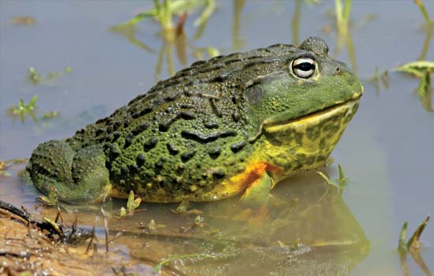](https://cdn.britannica.com/17/163817-004-D7A1C3EF.jpg)**African Bullfrogs**

[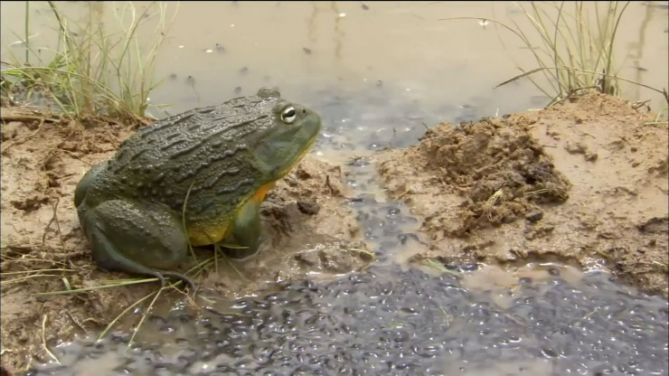](http://www.pbs.org/wnet/nature/files/2014/06/bullfrog-tadpoles.jpg)African bullfrogs are one of the largest frogs in the world, with the males weighing over three pounds. They are also rather fierce. African bullfrogs are voracious carnivores, eating insects, small rodents, reptiles, small birds, and other amphibians. An African bullfrog kept at the Pretoria Zoo in South Africa once ate 17 juvenile Rinkhals snakes. These frogs are also one of the three frog species regularly kept in captivity that have sharp teeth and willingly bite humans when provoked or handled. African bullfrogs breed after heavy rain in shallow, temporary puddles and ditches at the margin of larger ponds and lakes. The males battle for breeding rights, and the females lay about 3,000 to 4,000 eggs at a time. The females and smaller, less successful males leave after breeding, but the dominant males stay to watch over the developing young. The eggs develop swiftly, and tadpoles emerge. Two days after hatching, tadpoles start feeding on vegetation, small fish, and invertebrates. Defending males continue to watch over the tadpoles, which metamorphose within three weeks. During this whole period, the father guards his young. He will valiantly defend them from any perceived threats, pouncing on and biting anything—regardless of size—that comes too close to his tadpoles. But the African bullfrogs’ habit of laying eggs in shallow, temporary pools can cause problems later on, as the hot African sun causes the water to evaporate. But should this begin to threaten the developing tadpoles, their father takes action. If the pool is in danger of drying out, the father uses his legs and head to dig a canal from the drying puddle to a bigger pond. He literally makes a path for his young, guiding them toward safety. But even when they have safely arrived in the larger pod, his job is not done. Father African bullfrogs continue to guard their tadpoles until they are old enough to fend for themselves. Our fathers, elders, and other leaders also work to make paths that guide us to safety! This is undoubtedly a very tough job, so it’s particularly wonderful that God promises to help keep their hearts turned toward Him.

Amazon

Nature: Fabulous Frogs

Start: 24:06 (28:59 from End)

End: 26:33 (26:32 from End)