I do like the sound of gift-giving! But at first blush this advice doesn’t seem very properly Christian. Money is the root of all evil, right? Perhaps not. This is actually a misquote of 1 Timothy 6:10, which tells us that “the **love of** money is the root of all evil.” This, as Timothy points out, tends toward covetousness, which further leads to all sorts of wickedness. Money itself is just a tool that can be used for good or bad. So here in Proverbs we see that such resources can be very positive when properly applied. A gift given “in secret” can ease a lot of stress and resentment. Of course, a gift is not the proper tool for every problem! That’s where the “judgment” of the next verse comes in. We’ve seen this phrase, “to do judgement,” in several verses just in this chapter. Doing judgment, in this sense, is the sole province of the righteous. Good judgment comes from God. He gives us insight into people and leads us through problems. Poor judgment, on the other hand, tends to be cumulative, as verse 16 warns us. And poor judgment can make us poor in other ways as well! Resources like money are tools, and they can be used in positive ways… but we also have the potential to use them for self-indulgence and ultimately self-destruction. So once again we see the need for good judgment! The love of money (involving self-indulgence, pride, or greed) doesn’t reflect very good judgment. The advice to “do judgment” as God directs involves proper management of our resources too!

To do justice and judgment is more acceptable to the Lord than sacrifice. Proverbs 21:3

The robbery of the wicked shall destroy them; because they refuse to do judgment. Proverbs 21:7

**Proverbs 21:14-17**

**A gift in secret pacifieth anger: and a reward in the bosom strong wrath.**

**It is joy to the just to do judgment: but destruction shall be to the workers of iniquity.**

**The man that wandereth out of the way of understanding shall remain in the congregation of the dead.**

**He that loveth pleasure shall be a poor man: he that loveth wine and oil shall not be rich.**

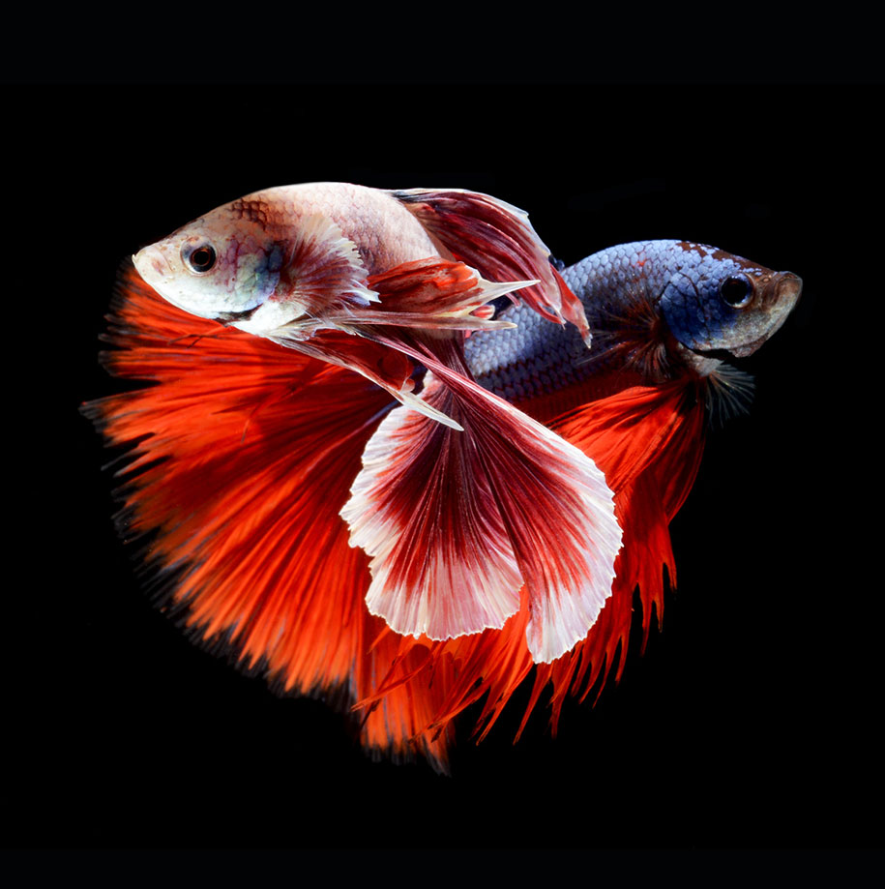**Siamese Fighting Fish**

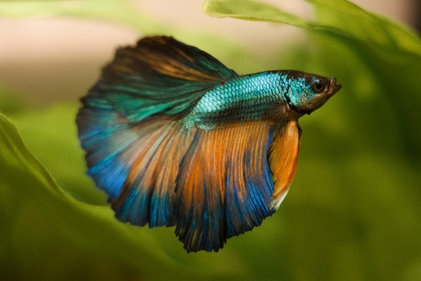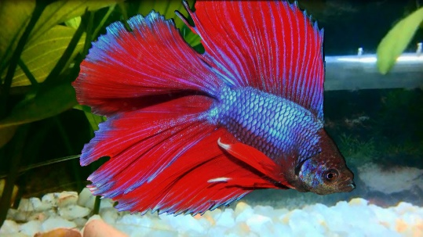The Siamese fighting fish (*Betta splendens*), commonly known as the betta fish, is Thailand’s “national aquatic animal.” A beautiful and highly territorial fish, betta fish are native to the Mekong basin of Thailand, Cambodia, Laos, and Vietnam. They live in standing waters of canals, rice paddies and floodplains. But there is a downside to living here. Water acquires oxygen from being thrown up in the air as it rushes over stones and down waterfalls. Standing water doesn’t have this opportunity, so there isn’t a lot of oxygen in the water for the fish to breathe. Fortunately, the betta fish have a plan for this. Adult betta fish can simply gulp air. But when betta fish lay eggs, the developing young need air too. And they can’t leave their eggs to get it! It’s up to their parents to supply this scarce resource. Happily their father has a plan for this as well. Male betta fish make “bubble nests.” They find a place where a plant or rock breaks the surface of the water, then gulps air and blows small, rather sticky bubbles close together. The bubbles cling to the plant or rock, creating a foamy nest. Then the male wraps his body around the female, which encourages her to release her eggs, which the male quickly fertilizes. Then the parents retrieve sinking eggs and blow them gently into the underside of the bubble nest. Resting next to these air-filled bubbles, the eggs have all the oxygen they need to develop into healthy youngsters. The males continue to guard the nest until all the young are safely hatched. In order to be successful fathers, male betta fish have to have good judgment! They need to use the scarce oxygen resources of their native habitat wisely. Building a large, stable bubble nest, not to mention guarding the young until they hatch, are complex and challenging tasks for such a small fish. The male betta uses his scarce resources to “gift” his young with everything they need, rather than dedicating his resources solely towards his own needs or wants. Fortunately, for us as well as the betta fish, God ensures that it is “joy to the just to do judgement!” And if the betta fish can do it, so can we!

Netflix

Our Planet

Season 1

Episode 7: “Fresh Water”

Start: 34:13 (14:54 from End)

End: 36:06 (13:01 from End)