Have you ever noticed how many problems come down to pride? (Pride, in this context, is the mindset “I’m better than you,” rather than honest pride in your efforts or in your family.) Verse 19 involves contention within the family, which is (in my experience) often due to pride. The spending mentioned in verse 20 is surely pride-related. And the “mighty” in verse 22 have such “confidence” (pride) in their own strength that they are readily cast down. You’ll notice that the “wise” are repeatedly cast in a humble light. There’s a bit of complication in verse 18, where it says, “The wicked shall be ransom for the righteous.” As far as I know, Jesus paid the price for the righteous and the wicked have nothing to do with it! Fortunately, we do have the rest of the Bible for comparison. It’s pretty easy to come to the conclusion that the wicked are “ransom for the righteous” only in the sense that God allows troubles to fall on the wicked which the righteous avoid. The plagues, for instance, came upon the Egyptians because they proudly defied God, while their Israelite slaves were protected. Verse 21 says it all. We need to (humbly) follow after righteousness and mercy. Then God will award “honour” as He sees fit. And when God honors the righteous, they can be honestly and properly proud!

"For I am the Lord thy God, the Holy One of Israel, thy Saviour: I gave Egypt for thy ransom, Ethiopia and Seba for thee.” -Isaiah 43:3

“The righteous is delivered out of trouble, and the wicked cometh in his stead.” -Proverbs 11:8

**Proverbs 21:18-22**

**The wicked shall be a ransom for the righteous, and the transgressor for the upright.**

**It is better to dwell in the wilderness, than with a contentious and an angry woman.**

**There is treasure to be desired and oil in the dwelling of the wise; but a foolish man spendeth it up.**

**He that followeth after righteousness and mercy findeth life, righteousness, and honour.**

**A wise man scaleth the city of the mighty, and casteth down the strength of the confidence thereof.**

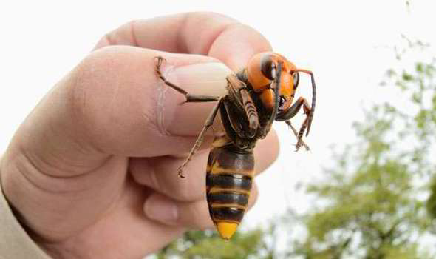**Japanese Hornets and Japanese Honey Bees**

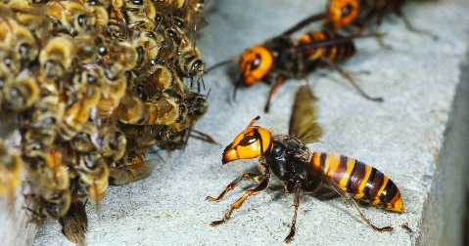Japanese hornets (not-so-fondly nicknamed “murder hornets”) are the largest in the world. They can be up to two inches long with a three-inch wingspan and a quarter-inch stinger. And they have potent venom, which can kill a person in the case of multiple stings. Their venom is necrotic and it contains a neurotoxin as well. The yearly human death toll in Japan is inconsistently reported, but may be 30-50 people (as reported by National Geographic). The recommendation in China is that a person receiving 10 or more stings should seek medical aid, because the venom can cause kidney failure. These are large, aggressive, and powerfully venomous hornets. Just in case you’re not worried yet, they are also invasive and have made their way to Washington State. Gov. Greg Abbot has created a task force to locate and deal with them, should they make it to Texas. Of course Japanese hornets don’t generally prey on people. They prefer bees, and are largely a matter of concern because they could decimate the U.S. bee population. Japanese hornets are five times the size of a honey bee, with a stinger roughly 1/5 of an inch longer than that of a bee. The humble honey bees’ stingers can’t begin to penetrate the hornet’s tough exoskeleton. In 90 minutes, a small group of Japanese hornets can wipe out an entire bee colony and begin feeding the larvae and honey to their own young. These proud hornets have every reason to believe that they have nothing to fear from bees. But Japanese honey bees are just slightly different. They’re still much, much smaller and completely unable to sting the hornet. Japanese honey bees have no more spectacular armament than any other kind of honey bee, but they do have a simple, humble plan. When the hornet attacks, around 500 bees surround it in a ball, vibrating as hard as they can. This vibration heats the center of the ball up to 117 degrees, killing the hornet. The Japanese honey bees have no mighty weapons with which to take on the Japanese hornet, but they can survive slightly higher temperatures. The Japanese hornet—aggressive, powerful, proud—can indeed be defeated by a much lesser humble enemy, because the bees are “wise.” At least, God has given them a wise strategy! He has given us a wise strategy too—to follow after righteousness and mercy—and we should consider using it!

Amazon

Wildest: Islands

Season 1

Episode 6: “Japan: Islands of Extremes”

Start: 35:35 (16:44 from End)

End: 39:38 (12:41 from End)