Did you know that children learn to lie, on average, at between two and three years of age? As we grow to adulthood, we lie constantly. A respectable estimate is that people lie in about 25% of their social interactions, and are lied to about 200 times per day. A great many of these lies, of course, are “polite” responses... the rest are often based in pride. A bit concerning is the fact that most of us believe that we are generally honest. There’s a certain amount of self-deception going on here too! So perhaps it’s not terribly surprising that many people also lie to God. The “sacrifice” of an unrepentant person is already “an abomination,” but many offer such a sacrifice “with a wicked mind,” that is, in an attempt either to deceive God or to deceive their (church) community. But God is never fooled. He reads hearts! We can deceive ourselves, and others, but never God. He knows those who have been “false” witnesses, and those who speak “constantly,” or rather “consistently.” A “wicked” person proudly deceives himself into believing that his own path, his own wisdom, his own preparations, will always be sufficient. But the wise man, the “upright,” humbly directs his way as God has instructed. It’s curious how deceit is depicted here, as both internally and externally directed. Both types of dishonesty seem well rooted in pride. Which only reinforces the fact that “safety is of the Lord.” We should not allow ourselves to be deceived into trusting any other source! Our only safety lies in following as God directs, changing our ways to match His, and living honestly and humbly in His will.

**Proverbs 21:27-31**

**The sacrifice of the wicked is abomination: how much more, when he bringeth it with a wicked mind?**

**A false witness shall perish: but the man that heareth speaketh constantly.**

**A wicked man hardeneth his face: but as for the upright, he directeth his way.**

**There is no wisdom nor understanding nor counsel against the Lord.**

**The horse is prepared against the day of battle: but safety is of the Lord.**

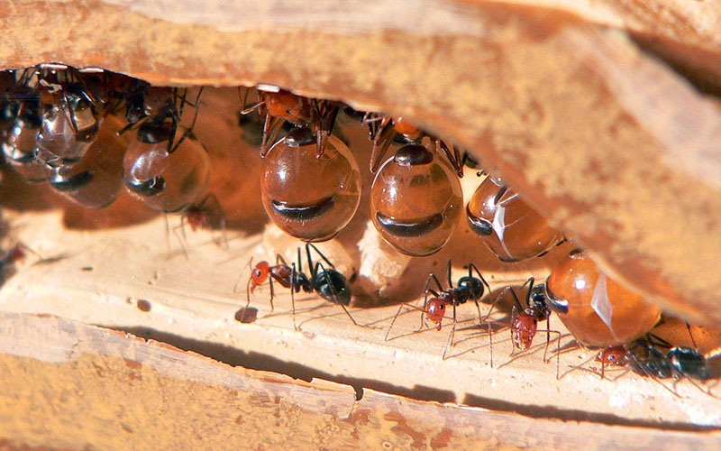**Honeypot Ants**

The name “honeypot ants” describes a number of different species of ant that live in arid or semi-arid climates around the world. The particular species of honeypot ant in which we’re interested today is *Camponotus inflatus*, native to Australia, though there are similar species in the hotter, drier regions of the US. The interior of Australia is also quite dry and desert-like, and the wet spring season is very short. Honeypot ants feed mostly on nectar, painstakingly collected by the workers from flowers while they bloom. But they must work out a way to store the food. As you are probably well aware, flowers do not bloom during the punishing heat of the long summer! Fortunately, God has provided these ants with a remarkable storage system. A certain type of specialized worker ant, known as a “replete,” feeds on nectar until its abdomen begins to swell. The replete then takes up residence hanging from the ceiling of one of the chambers in the nest. While the wet season lasts, other worker ants continue to collect nectar, which they feed drop by drop to the replete. The replete’s abdomen can continue to swell until it reaches the size of a grape. When they need to access these living stores of nectar, worker ants stroke the antennae of the replete. The replete then regurgitates drops of nectar, which the worker ants can eat or carry to others as needed. Consider for a moment how much trust is placed in these repletes. They serve as the “bank” of food for the entire colony. They have to be honest, or the whole colony starves to death in the long hot summer. But somehow that never happens. The repletes faithfully maintain the nectar (as cool as possible, hanging from the ceiling) and humbly give it up whenever it is required of them. They do their job honestly and well, trusting in the directions that they are given. We also have been given a great trust, to do God’s work until He comes. We must be faithful witnesses, honestly reporting what God has done for us. And we too must humbly trust in the directions that we have been given, because “safety is of the Lord” and beyond our scope.

Amazon

Wildest Places

Season 1: “Australia”

Episode 1: “Outback Deserts”

Start: 9:48 (42:12 from End)

End: 13:29 (38:31 from End)