We’d all like to be comfortable, right? We want to have everything we need… and a fair bit more besides. Many people place worldly (financial) success as their most fundamental goal. These verses warn of several characteristics that will ensure this goal is never met. The first is the quality of being “hasty,” which in this context we may read as “careless and impatient.” It’s easy to see that the plans of a hard worker are likely to bring prosperity because of the efforts put forth. Those of the impatient and careless worker will probably fail even if they are good plans. Good planning isn’t worth much if it isn’t followed up with careful execution! The second characteristic by which people ensure failure is deceit. The phrase here translated “a vanity tossed” may be literally rendered, “a driven breath.” Those who seek to establish fame and fortune upon lies are a mere breath that will suddenly pass away. Verse 7 addresses dishonesty in an even broader sense. The wicked “refuse to do judgment,” that is, they have no regard for justice and no respect for the process of discerning between truth and falsehood. They commit “robbery,” either overtly in the sense of outright theft, or more subtly by permitting injustice to proliferate. This “shall destroy them.” So if we desire the “plenteousness” referenced in verse 5 we need the opposite characteristics: diligence, honesty, and good judgement. You’ll notice such characteristics are attributed only to the “pure,” who defy the inherent “forward and strange” way of the human heart!

**Froward:**

* Habitually disposed to disobedience and opposition.
* Stubbornly contrary and obstinate.
* Perversely inclined; willful; refractory; petulant; peevish.

**Proverbs 21:5-8**

**The thoughts of the diligent tend only to plenteousness; but of every one that is hasty only to want.**

**The getting of treasures by a lying tongue is a vanity tossed to and fro of them that seek death.**

**The robbery of the wicked shall destroy them; because they refuse to do judgment.**

**The way of man is froward and strange: but as for the pure, his work is right.**

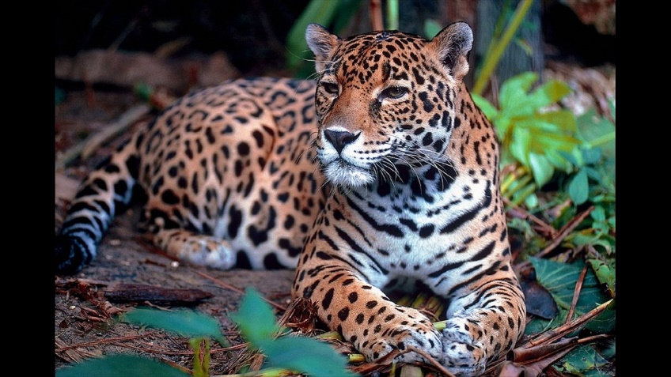**Jaguars**



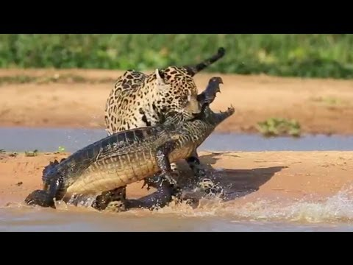The jaguar is a large cat native to the Americas. The jaguar's present range extends from Southwestern United States and Mexico in North America, across much of Central America, and south to Paraguay and northern Argentina in South America. Jaguars are the largest native cat species of the New World and the third largest in the world, behind the tiger and the lion. Like other cats, the jaguar is an obligate carnivore, meaning that it eats meat almost exclusively. They are opportunistic hunters, walking slowly down forest paths, listening for and stalking prey before rushing or ambushing them. The jaguar attacks from cover, generally from a target's blind spot, with a massive pounce. The ambush may include leaping into water after prey, as a jaguar is quite capable of carrying a large kill while swimming. Jaguars don’t mind water! That comes in handy, as one of the Jaguar’s typical targets is an animal called a caiman, a relative of the crocodile. The common caiman can be more than eight feet long and weigh up to 88 pounds. They are far from easy prey! The jaguar isn’t so very much larger than the caiman—and the jaguar’s pounce often lands it in the water, which is to the caiman’s advantage. Caimans are also, after all, accomplished ambush predators. They fight back, trying to drown the cat. The jaguar must survive a long period of water-wrestling in order to take the caiman as prey. Hunting caimans requires careful planning, precise execution, and really good judgement. Apparently jaguars have all of these characteristics in sufficient quantity to make caimans one of their frequent prey items. They even have, for lack of a better phrase, a sense of fair play—demonstrated by preying on far-from-defenseless creatures quite likely to become hunter rather than hunted. We could do worse than to have the powerful and persistent jaguar as our model for diligence, honesty, and good judgement!

Netflix

Our Planet

Season 1

Episode 7: “Fresh Water”

Start: 21:34 (27:33 from End)

End: 27:17 (21:50 from End)