There is very little in the world as alluring as “great riches.” If we just had the money, we imagine, we would be happy. Everything would be easy. But it isn’t true. I realize that it’s hard to believe, but happiness doesn’t come from money. You would still be you regardless of the amount in your bank account… and you would probably still be your own worst enemy, as most of us are, even if you were worth millions. Happiness comes from being on good terms with our Creator, not from money. We’re focusing on the wrong end of the procedure! Our Creator is accessible to us all, rich or poor. Being wise, that is, fearing God, He gives us help in preparing for the future, allowing us to “foresee the evil” and be ready for it. The “simple,” (those who disregard their Creator) ignore His warnings as to the future and are easily snared. On the other hand, the “forward” (those who defy their Creator’s will) actually end up ensnaring themselves. But if we will be among the “prudent,” (those who are actually living in God’s will) then prosperity, honor, and eternal life will also be ours! If we embrace “great riches” or great honor then we will end up destroying it all. If we embrace God then all the rest follows naturally!

Being “simple” as in verse 3 is a deliberate act. The simple refuse to accept wisdom which comes from the Lord.

“The law of the Lord is perfect, converting the soul: the testimony of the Lord is sure, making wise the simple.” Psalm 19:7

“How long, ye simple ones, will ye love simplicity? and the scorners delight in their scorning, and fools hate knowledge?” Proverbs 1:22

**Proverbs 22:1-5**

**A good name is rather to be chosen than great riches, and loving favour rather than silver and gold.**

**The rich and poor meet together: the Lord is the maker of them all.**

**A prudent man foreseeth the evil, and hideth himself: but the simple pass on, and are punished.**

**By humility and the fear of the Lord are riches, and honour, and life.**

**Thorns and snares are in the way of the froward: he that doth keep his soul shall be far from them.**

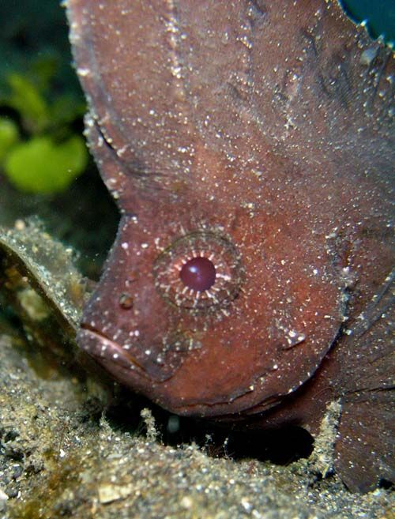**Cockatoo Waspfish**

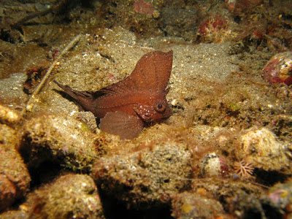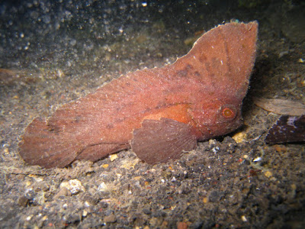The cockatoo waspfish is a fish, not a bird or an insect. They grow to about six inches long, and they live at the bottom of warm, Western Pacific waters from Japan to Australia. They are called “cockatoo” because of the huge dorsal fin that runs down their entire body and flares especially proudly on top of the head, reminiscent of the feathery headdress of the cockatoo bird. Unlike a bird, however, the cockatoo waspfish has to cope with things like…water. And that giant dorsal fin makes swimming awkward. The cockatoo waspfish is the least graceful predator you’ve ever seen. Utterly rotten swimmers, they appear to accidently fall, trip, flop and roll across the sea floor. In this video clip, the narrator actually states that “in a fiercely competitive habitat, that could appear to be an evolutionary… mistake. However, there’s no room for such missteps in the muck.” There are a couple of problems here. Firstly the premise of evolution is exactly that there have been a lot of random missteps that accidently turned out well. Secondly the narrator is arguing that the cockatoo waspfish’s awkwardness is valuable. It makes the fish resemble a bit of floating debris rather than a living creature (which indeed it does), protecting it from bigger predators. Here’s the problem: the cockatoo waspfish has venomous spines in its fins which can inflict painful stings on any predator. That’s where the “wasp” part of the name comes in. Two completely distinct and effective defense mechanisms “evolving” in one small fish seems excessive! Why hasn’t it “evolved” swimming ability, seeing as it has venom for defense? The simple answer is that God has a sense of humor. Also He gives us the humble, bumbling cockatoo waspfish as an example. The “simple” one here is the narrator! The cockatoo waspfish, while appearing to be simple, is actually doing just as its Creator intended. It is humbly “hiding” itself from danger, rather than using the “thorns and snares,” or venomous spines, of the froward. And despite its awkwardness, God sees that the cockatoo waspfish prospers! If we follow Him then we’ll prosper too.

Amazon

Wildest Places

Season 2: “Pacific”

Episode 2: “Bays”

Start: 39:30 (12:30 from End)

End: 41:05 (10:55 from End)