Have you noticed that there seem to be really a lot of ways to do the wrong thing, while there is only the one way to do the right thing? If it were a matter of odds, I’d say the odds were against us! There are just too many ways to go wrong. Slothfulness is not very respectable. Verse 13 mocks the timidity of the “slothful man,” who comes up with absurd excuses to defend his laziness. Yet the man who is just too adventurous doesn’t fare any better: he falls into a pit! Verse 14 mentions “he that is abhorred of the Lord,” the rebellious person who insists on following his own path, far from God’s instructions. Verse 15 addresses the difficulties associated with childish “foolishness.” Yet how many of us in our attempt to grow out of foolishness have tended to stray into selfishness or greed? This too is a real problem! It seems in our attempts to escape one type of wrong-doing, we readily fall into another. How can we ever choose the correct path? Fortunately, “the eyes of the Lord preserve knowledge.” We may not be able to navigate the correct path successfully by ourselves, but we don’t need to! We just have to follow God’s directions, and He does the rest. God watches over and protects someone who is sincerely trying to follow His will, but at the same time He counters the plans of the disobedient and brings them to nothing. Which may be the reason we have such difficulty locating the right path in our own strength!

**Proverbs 22:12-16**

**The eyes of the Lord preserve knowledge, and he overthroweth the words of the transgressor.**

**The slothful man saith, There is a lion without, I shall be slain in the streets.**

**The mouth of strange women is a deep pit: he that is abhorred of the Lord shall fall therein.**

**Foolishness is bound in the heart of a child; but the rod of correction shall drive it far from him.**

**He that oppresseth the poor to increase his riches, and he that giveth to the rich, shall surely come to want.**

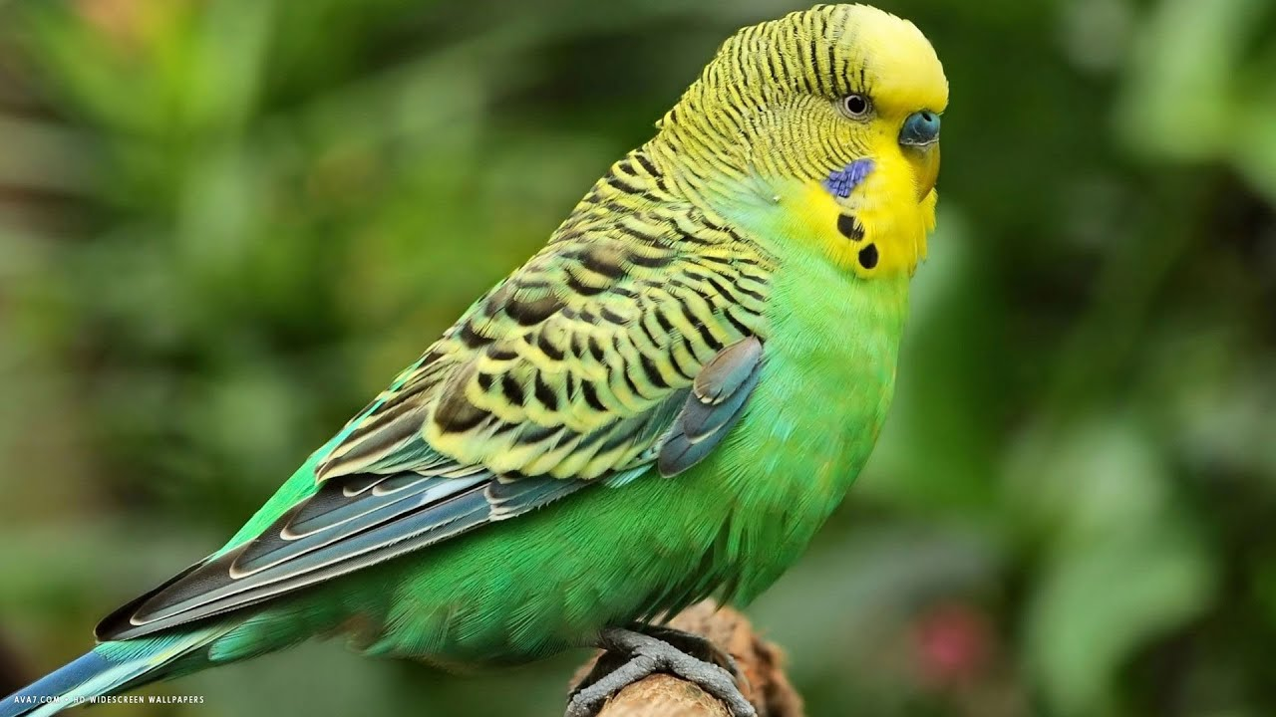**Budgerigar**

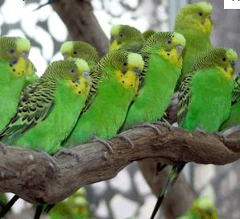Affectionately nicknamed “budgies” by the Australians, you would probably identify these small birds as “parakeets.” It turns out that only Americans call them that! Although a number of different colors of pet budgies are available at your local pet store, these color variations have been achieved by careful breeding. Wild budgies are green and yellow with black scalloped markings on the head, back, and wings. Budgerigars are nomadic and flocks move on as necessary. They prefer open habitats, primarily the scrublands, open woodlands, and grasslands of Australia. Normally found in small flocks, budgies can form very large flocks under the right conditions. Flocks follow the availability of food and water, so a plentitude of food and water can create enormous flocks. But each bird is small and relatively helpless, being only about seven inches long and without obvious defense mechanisms. They are prey for a great many birds of prey as well as snakes and other animals. A huge, chattering flock of budgies seems like a pretty vulnerable target, especially when they have to pause to get a drink! Fortunately, God looks after all of His creation, not just the people. And He provided the budgies with a pretty good plan: swarm and drop. And that’s just what the birds do! When a bird of prey attempts to bring down one of the small birds, the budgies come together in a massive swirl of birds. In the confusion, the bird of prey is unable to choose a target. Even when the bird of prey manages to isolate a single budgie, that bird just drops to the ground as the others swirl and chatter distractingly nearby. The predator is baffled by the motion, noise, and color, and the budgies are able to drink safely and move on. It seems like every move the budgies make should bring them into even greater danger, but they are protected by instincts given by their Creator. Similarly, it sometimes seems like every choice we make is likely to get us into ever greater trouble. But we too are protected by our Creator, who watches over those who would be His!

Amazon

The Gathering Swarms

Start: 5:34 (47:30 from End)

End: 9:46 (43:18 from End)