There are genuinely terrible things in this world: death, suffering, despair. And people make poor choices. It can be hard to know what’s right, especially when you’re listening to the wide range of opinions that society offers. How can we be sure? There’s a lot of fear, uncertainty, and doubt out there. Which way should we go? Right now, with coronavirus making the rounds, uncertainty is prevalent. People are making fear-based decisions. But we don’t have to live like that. God has given us—even us—“excellent things in counsels and knowledge,” so that our “trust may be in the Lord.” Verses 17-18 guarantee that if we humbly listen to the wisdom that God has provided for us (as in the Bible) and apply ourselves to studying that wisdom (as in studying the Bible), then that wisdom will be within us—and “it is a pleasant thing.” That is, we will have the security of knowing the Creator of the universe and having His guidance in our hearts and on our lips at all times. And that is a pleasant thing! It’s the security that the frightened people of our world are so vainly seeking. We don’t need to live in uncertainty and fear. We have every opportunity to “know the certainty of the words of truth.” We have the answer sheet, complete and correct. And possessing that certainty, we are able to “answer the words of truth” to those who ask us!

**Proverbs 22:17-21**

**Bow down thine ear, and hear the words of the wise, and apply thine heart unto my knowledge.**

**For it is a pleasant thing if thou keep them within thee; they shall withal be fitted in thy lips.**

**That thy trust may be in the Lord, I have made known to thee this day, even to thee.**

**Have not I written to thee excellent things in counsels and knowledge,**

**That I might make thee know the certainty of the words of truth; that thou mightest answer the words of truth to them that send unto thee?**

**Monarch Butterflies**

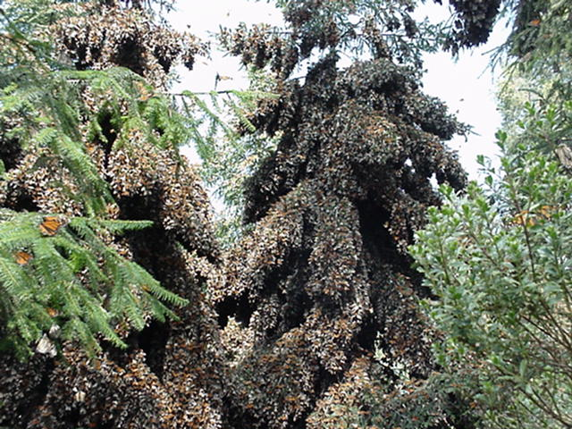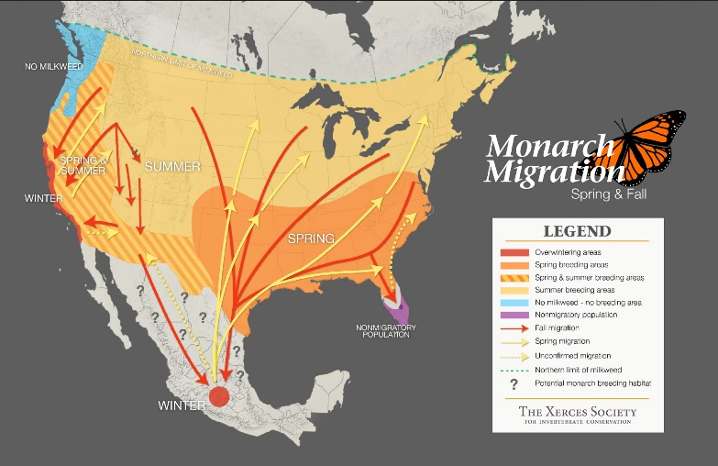You’ve probably seen a monarch butterfly before! Large, delicate, beautifully colored insects, they flutter around the flowers and perch on grasses in the summertime. Have you ever wondered about where they go in the wintertime? Unlikely though it might seem, monarchs are one of the butterflies that have a major migration! Although the exact dates change each year, by the end of October, the population of monarchs east of the Rocky Mountains migrates southward, toward central Mexico. Butterflies travel thousands of miles south to reach their distant overwintering site. But here’s the astounding part: the distance and length of these journeys exceeds the normal lifespan of monarchs, which is less than two months for butterflies born in early summer. The first generation leaving the overwintering sites only migrates as far north as Texas and Oklahoma. The second, third and fourth generations return to their northern breeding locations in the United States and Canada in the spring. But in late summer a fourth or fifth generation, the migratory generation, hatches, pupates, and emerges as winged butterflies. But they don’t mate. They begin the long, long journey to their overwintering grounds, where they hibernate in precisely the same trees that their great-grandparents chose. These monarchs can live for more than eight months. When the weather begins to warm, these migrating monarchs begin to travel northward. Along the way they finally have the opportunity to mate and lay eggs, giving rise to the second generation. So the natural question is: how do monarch butterflies find their hibernation sites? They use the exact same trees, not the same general region! Certainly butterflies can’t remember four generations back. How can they possibly find their way? The same way we can! Like us, monarch butterflies have the certainty of God’s guidance. Unlike us, they listen!

Amazon

The Gathering Swarms

Start: 1:37 (51:27 from End)

End: 5:27 (47:37 from End)