These verses continue the God’s direct plea, begun in verse 17, that His people listen to Him and follow His advice. “Rob not the poor,” this section begins, “because he is poor.” When I read these words I hear a silent, “and what’s wrong with you anyway, stealing from poor people? You big bully!” Possibly that’s just me. The second part of the verse suggests that is counsel particularly applies to the judges who sat “in the gate” at the time. It warns them against favoring the wealthy and oppressing the poor in order to gain personal profit. Object though we might, there’s no denying that the wealthy (or otherwise privileged) receive a different justice even today. We are absolutely not to participate in such a thing. Christians have no business reflecting on how they can adjust their decisions (judgments) for their own benefit—monetary, social, or otherwise. We have a much larger mission: show Christ to a fallen world. We cannot afford to divert our attention from this singular goal! Fortunately, we are assured that the Source of justice is keeping an eye on proceedings. For those who are actually in the right, God Himself will “plead their cause” as well as bringing His justice on those who have judged so poorly. Interestingly, these verses move directly from this appeal for justice to the injunction against associating with “an angry man.” We should have learned from our history that associating with others—the wrong others—carries serious risks. How often have people been carried along in the wake of their companions, little realizing the damage they’re causing or the danger they’re in! We’re engaged in the Great Controversy and can’t afford to be caught up in secondary conflicts. And if we just do our job well, then God will sort out the rest.

**Proverbs 22:22-25**

**Rob not the poor, because he is poor: neither oppress the afflicted in the gate:**

**For the Lord will plead their cause, and spoil the soul of those that spoiled them.**

**Make no friendship with an angry man; and with a furious man thou shalt not go:**

**Lest thou learn his ways, and get a snare to thy soul.**

**Soldier Crabs**

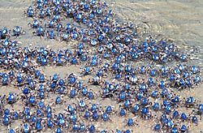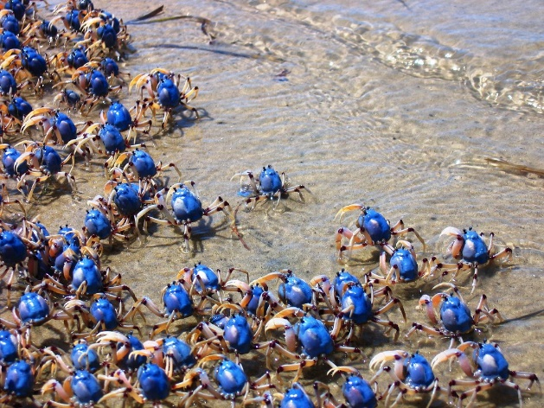Soldier crabs live on sandy beaches from the Bay of Bengal to Australia. Adults are about 1 inch across, the size of a cherry. Soldier crabs are white, with blue on their backs, and nearly spherical. Because of their unusual shape and leg arrangement, soldier crabs are able to easily march forward. They spend much of the time buried in the sand, emerging few hours before low tide. Upon emergence, the crab performs "the most aerobatic grooming mechanism recorded from the Brachyura" (a suborder of crustaceans). In less than a second, the crab falls onto its back, thus removing any sand it has accumulated on the carapace, and then flips upright again in a "half somersault." Within 15 minutes of emergence, large numbers of soldier crabs walk simultaneously towards the water in an almost straight line, responding to some unknown signal in unison. Because of the shape of their bodies and the arrangement of their legs, soldier crabs generally walk forward instead of sideways. They can move at about 10 yards per minute. Having reached a suitable moist area, the crabs begin to feed rapidly, working transversely across the beach as they do so. They clean the sand by eating bacteria and organic matter then disposing of the remaining sand as round pellets. Eventually, at another unknown signal, the army breaks up and the individual crabs travel up the shore. There they dig themselves back into the sand in a unique corkscrew motion. Notice how single-minded they are! These crabs don’t care a bit about the size of their neighbors’ patch. Neither do they join together in any form of aggression. They simply don’t have greed or the societal injustices bred by greed. Although many crabs are territorial, soldier crabs move rapidly and in unison to good feeding grounds without apparent conflicts. They have a job: clean the sand. All extraneous factors are just that—extraneous. Their focus is absolute. This is the focus we’re meant to have about our job!

Amazon

Wildest Places

Season 1: “Australia”

Episode 4: “Wild Coasts”

Start: 11:54 (40:06 from End)

End: 14:22 (37:38 from End)