How does a Christian behave? The non-believers around us are often very pleased to help us with that answer! It’s not surprising, really. A lot of folks are just looking to gain some kind of advantage. “A Christian helps others,” goes the logic, “so you can help me!” I’ve also heard extensive variations on “Christians are kind to others, so you must allow me to take advantage of you. That would be really kind!” To hear some tell it, Christians are the intended doormats and victims of the world. No wonder people don’t want to be Christian! Interestingly, though, it doesn’t seem very consistent with the advice that God Himself is providing at the end of Proverbs 22. These verses continue God’s appeal, begun in verse 17, to listen to His wisdom and follow His guidance. You may remember the focus of the previous four verses, which advised singular focus on our own task. These verses follow a similar trend. Interestingly, however, this section begins with the admonition that we are not to allow ourselves to be made victims! Not even in the name of kindness! Many of our non-believing neighbors would think that standing surety for a friend would be an act of kindness. But Proverbs advises us repeatedly against it. We are required to acknowledge that we have little control of the future, and we must act accordingly! In real-world terms, don’t get yourself into debt because you don’t know what’s going to happen. At the same time, we are not to make victims of others, either. (Moving landmarks was a common strategy of the time for increasing one’s lands—generally at your neighbor’s expense and in contradiction of some previous agreement. Not a very honest practice.) We are to be neither victims nor victimizers, but skillful, hardworking people focused on doing our jobs to the very best of our God-given ability!

**Proverbs 22:26-29**

**Be not thou one of them that strike hands, or of them that are sureties for debts.**

**If thou hast nothing to pay, why should he take away thy bed from under thee?**

**Remove not the ancient landmark, which thy fathers have set.**

**Seest thou a man diligent in his business? he shall stand before kings; he shall not stand before mean men.**

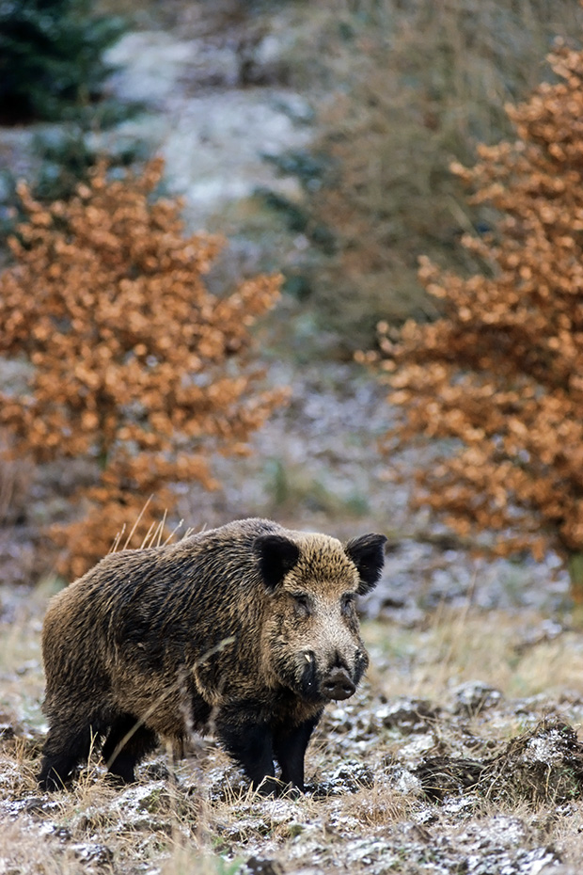**Wild Boar vs. The Wolf Pack**

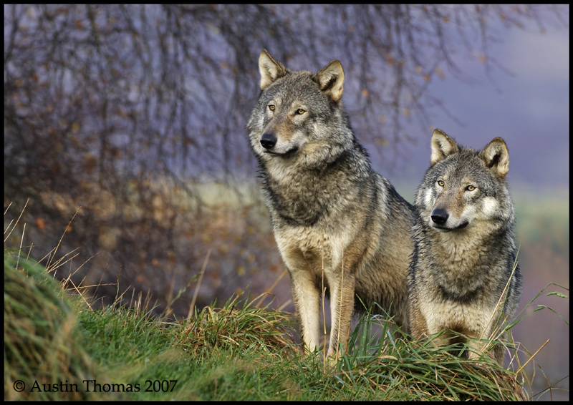The wild boar, also known as the "wild pig," is native to much of Eurasia and North Africa, and has been introduced to the Americas. They are bulky, heavy animals with short and relatively thin legs. Wild boar have a hump behind the shoulder blades, supporting a short, thick neck and massive head. Their heads are structured for digging. The head acts as a plough, while the powerful neck muscles allow the boar to turn over quantities of soil. Wild boar are capable of turning rocks weighing over a hundred pounds. Surprisingly speedy, with extremely sharp reflexes, wild boar can run at a maximum speed of 25 mph and jump nearly five feet in the air. The wild boar is also a highly versatile omnivore. Their diet includes roots, tubers, bulbs, nuts, berries, seeds, leaves, bark, twigs, earthworms, insects, mollusks, fish, rodents, insectivores, bird eggs, lizards, snakes, frogs and carrion. They will also eat garbage if they can get it! A 110 lb boar needs around 4,000–4,500 calories of food per day with the majority of its diet dug from the ground. Acorns and beechnuts are invariably its most important food items in temperate zones. The grey wolf is the main predator of wild boar throughout most of its range, but this predation mostly takes the form of wolves preying on straying juveniles. It is very rare for wolves to take on a fully grown female, and almost unheard of for wolves to take on an adult male. Adult boar are noticeably clever and extremely powerful animals. A single boar poses a significant threat even to a large wolf pack. But wild pigs don’t go around attacking wolf packs, either! Their focus is firmly on finding food, most of which is plant matter and unlikely to fight back. Wild boar won’t be made victims, but they are not (in most cases) victimizers. (There are exceptions for male in the mating season, but that’s different.) For the most part, wild boar stay focused on digging up enough calories! We, too, should keep our heads down! We should treat others well, refuse to be victims, and stay focused on doing our tasks as diligently and skillfully as we can manage… until we stand at last before our heavenly King!

Netflix

Untamed Romania

Start: 8:02 (1:24:42 from End)

End: 11:14 (1:21:30 from End)