Authority is a tricky topic. Who’s in authority? What are their responsibilities? Proverbs has some guidance! First and most obvious, verse 6 indicates that parents have authority over children—and the responsibility to guide them into the way they “should go.” Verse 7 points out that a wealthy man has authority over the poor, and the “lender” has authority over the “borrower.” These are certainly valid observations about the way things work! And there’s some subtextual advice here: don’t borrow, and work to avoid being “the poor!” But that’s not all. There are consequences to being the “rich” or the “lender.” Those in authority over others are particularly responsible for treating them well! Those who sow iniquity cannot reap any positive harvest, and their rod of anger (symbol of their authority and instrument of punishment) will fail. The “scorner” is to be removed from the societal discourse by those in authority, which sounds like a lot of disagreeableness. And those who want entrance to the highest levels of authority are enjoined to focus on loving “pureness of heart,” which should limit the ungodly! It seems that, like leadership, God has authority (and those in it) under His special purview. Which is a blessing to all of us who follow Him!

**Proverbs 22:6-11**

**Train up a child in the way he should go: and when he is old, he will not depart from it.**

**The rich ruleth over the poor, and the borrower is servant to the lender.**

**He that soweth iniquity shall reap vanity: and the rod of his anger shall fail.**

**He that hath a bountiful eye shall be blessed; for he giveth of his bread to the poor.**

**Cast out the scorner, and contention shall go out; yea, strife and reproach shall cease.**

**He that loveth pureness of heart, for the grace of his lips the king shall be his friend.**

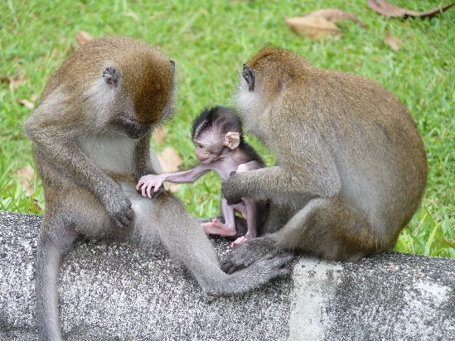**Long-tailed Macaques of Lopburi**

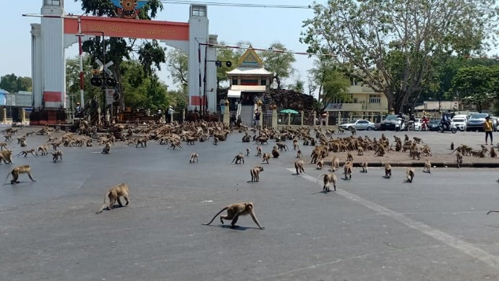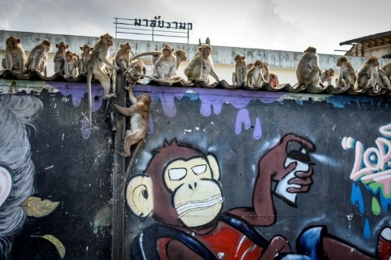Long-tailed macaques are lively and clever monkeys that live in matrilineal groups of 3-20 females, their offspring, and one or more males. Both males and females have a clear dominance hierarchy which applies when they have to resolve conflicts. As in other primate societies, the less dominant individuals usually lose to a higher-ranking individual when conflict arises. Long-tailed macaques also appear to require reconciliation after a fight. They are clearly very clever and socially adept animals. And about six thousand of them live in Lopburi, a city in central Thailand. They live partly in the ruins of a temple there, and they serve as a draw for the tourists. Surprisingly, long-tailed macaques have made a success of city living, owing in large part to their existing social structures. They look to older and more experienced members of the troop for guidance. Living in Lopburi, the macaques follow their leaders to understand traffic and find locations where they can forage for food. But humans have a part to play in the monkeys’ urban success too. Tourists have been feeding them regularly, and the macaque population has exploded. But the tourists are few and far between these days, and the monkeys are not getting nearly as many handouts—and they don’t like it. They have begun robbing stores and homes, even attacking people for food. Locals have put up wire to keep them out—complaining that the people live in cages while the monkeys are outside. The macaques have run the people out and taken over in parts of the city, even commandeering a disused movie theatre where they lay out their dead. Officials have decided to sterilize 500 of the monkeys in order to stem population growth. So who is in authority? What are their responsibilities? The monkeys in authority appear to be doing their jobs. The people in authority, well, perhaps not so much. Humans have authority over monkeys, right? They have trained these monkeys to expect certain things—foolishly, perhaps. The monkeys haven’t changed. And now they are reaping “vanity!” Hopefully we can handle our authority—and responsibilities—better!

Netflix

Night on Earth

Season 1

Episode 5: “Sleepless Cities”

Start: 25:32 (15:14 from End)

End: 28:20 (12:26 from End)