“Labour not to be rich,” says Proverbs 23:4. Such an idea flies directly in the face of capitalism, the American Dream, my going to work on Monday, and the ultimate life goal of everybody who is anybody. We need money, after all. Right? Perhaps not! This statement is about motivation. It’s not suggesting sloth! Firstly, work is a blessing. Secondly, Proverbs (not to mention the rest of the Bible) has a range of disapproving things to say about laziness. This verse does, however, indicate that wealth is neither our motivation nor our ultimate goal. Money cannot be relied upon, for one thing (see v. 5). For another, God has given us each tasks which aren’t money-driven. We are not to be pulled into the orbit or influence of those who have money as their sole motivation! Consider all of the verses surrounding “labor not to be rich.” They warn of the dangerous company of the rulers, especially those “that hath an evil eye,” that is, an avaricious and covetous nature. Devoting our time to such company is sure to pull us away from our primary tasks, and likely to cause other problems. We labor for God, not merely for wealth.

**Proverbs 23:1-8**

**When thou sittest to eat with a ruler, consider diligently what is before thee:**

**And put a knife to thy throat, if thou be a man given to appetite.**

**Be not desirous of his dainties: for they are deceitful meat.**

**Labour not to be rich: cease from thine own wisdom.**

**Wilt thou set thine eyes upon that which is not? for riches certainly make themselves wings; they fly away as an eagle toward heaven.**

**Eat thou not the bread of him that hath an evil eye, neither desire thou his dainty meats:**

**For as he thinketh in his heart, so is he: Eat and drink, saith he to thee; but his heart is not with thee.**

**The morsel which thou hast eaten shalt thou vomit up, and lose thy sweet words.**

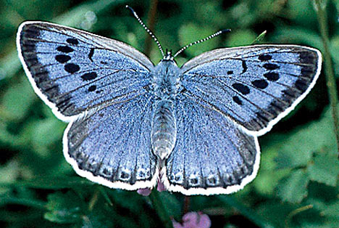**The Large Blue Butterfly**

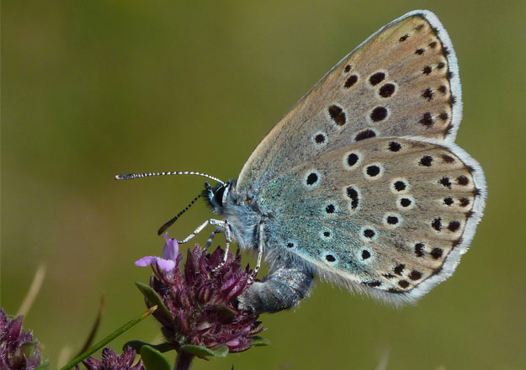The “Large Blue” is a European butterfly. They are, unsurprisingly, blue with dark spots on their wings. Like other butterflies, large blues hatch from eggs as larvae and spend quite a while as a caterpillar before spinning a cocoon and turning into butterflies. But large blues have a unique method for surviving as larvae! Female large blue butterflies lay eggs on specific plants (in particular wild thyme or marjoram) that may be found close to the nests of a certain species of red ant. When the eggs hatch, the larvae simply drop to the ground. This is very strange behavior for a small insect that cannot defend itself! They also secrete pheromones that are specific to the red ant that the larva hopes to attract, so that the ants will believe that the caterpillar is actually a worker ant larva. If they successfully mimic a larval ant, the caterpillar is taken back to the host nest and fed by the ants. Once in the nest, the caterpillar begins to emit a noise which sounds very similar to a larval queen ant. The worker ants feed the caterpillar assiduously, even feeding it more often that the real ant larvae. The ants will even rescue the caterpillar first when danger threatens. So what could this rather unusual, but successful brood parasite have to do with the acquisition of wealth? Why are people so driven to have wealth anyway? What do you want money for? There are lots of answers to this question! Some of the answers have to do with arrogance or pride, some of them have to do with greed, but I imagine that most people want money for a much simpler and basic reason: security. People want to protect themselves and their families in an uncertain world. And wealth offers a certain kind of security—at least temporary security from starvation or exposure. But the thing that people forget is that true security comes always and only from God. Wealth can never offer true security. But this strange, fuzzy, blue butterfly knows this! It doesn’t store up food or guard itself from hungry ants. Instead it drops helplessly to the ground, and pours its energy into producing pheromones, trusting that its scented camouflage will work in time. We also can trust blindly in God’s directions! We may pour our energy into the work that God has given to us to do, trusting totally that He will provide us with all the security we need.

Netflix

Untamed Romania

Start: 1:02:08 (30:36 from End)

End: 1:09:02 (23:42 from End)