It’s an ugly topic. Nobody much likes it. But it seems that we have an obligation to help others discern right from wrong. That means that we are in the difficult and awkward position of correcting others. We have an unfortunate tendency to postpone correction of poor attitudes and habits, especially those of young people. Nobody really enjoys correction! So we tend to put off dealing with wrong habits until these habits have become obviously troublesome—usually to us. In early stages, we laugh at unfortunate behavior. Sometimes we think it’s cute! Defiance that might be kind of adorable in a two-year-old is intolerable in a teenager. And the time when bad attitudes and unfortunate habits of mind might be easily corrected goes by, and the child’s character becomes harder and harder to change. Proverbs assures us that firm correction—unpleasant as it might be for all participants—is critically necessary for preserving the life of the young person. It’s not easy, but it is important! Obedience is a habit that is best developed early in life. Inculcating that habit is an extremely challenging task for parents, elders, teachers, and anyone else who has influence. We have an obligation to help others distinguish between God’s way and everything else.

**Proverbs 23:13-16**

**Withhold not correction from the child: for if thou beatest him with the rod, he shall not die.**

**Thou shalt beat him with the rod, and shalt deliver his soul from hell.**

**My son, if thine heart be wise, my heart shall rejoice, even mine.**

**Yea, my reins shall rejoice, when thy lips speak right things.**

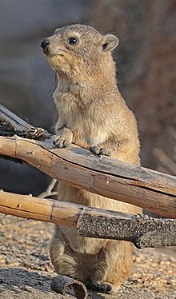**Rock Hyrax**

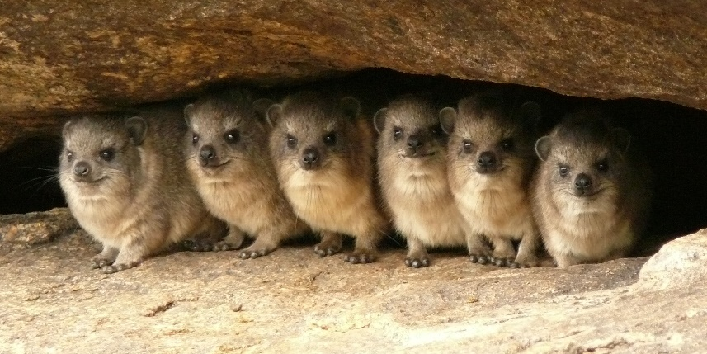The rock hyrax is a small mammal native to Africa and the Middle East. They weigh 9-11 pounds, have short ears and tail, and are supposed to be the closest living relative of the elephant. Hyraxes do share features with elephants, such as toenails, excellent hearing, sensitive pads on their feet, small tusks, good memory, higher brain functions compared with similar mammals, and the shape of some bones. The rock hyrax is found at elevations up to 13,800 feet in habitats with rock crevices allowing it to escape from predators. Hyraxes typically live in socially complex groups of 10–80 animals. They don’t stray far from their rocky refuges, and usually have one or more members of the group acting as sentries from a prominent lookout position. On the approach of danger, the sentries give an alarm call, and they quickly retreat. Despite their seemingly clumsy build, they are able to climb trees, and will readily enter residential gardens to feed on the leaves of citrus and other trees. Mother rock hyraxes give birth to 2-4 pups, after a gestation period of 6-7 months. The pups are well developed at birth, with open eyes and a complete coat of fur. They can eat solid food at the age of two weeks, and are weaned at ten weeks, although they won’t reach adult size until they turn three. The pups need to spend that time learning, because they need to become adept at climbing, botony, and social networking. These skills are necessary because the alternative is pretty much to be eaten by large bird of prey known as a Verreaux’s eagle. Nature’s education is harsh, and the pups take some hard falls while learning. But the alternative is worse! This is pretty much true for us as well. No one likes correction, but death is much worse.

Amazon Prime

Wild Desert

Start: 38:55 (3:12:47 from End)

End: 42:19 (3:09:23 from End)