Why would anybody “envy sinners?” They’re unhappy people who will die permanently, right? Who would be envious of that? Well, of course there’s more going on here! Sinners **get to** do whatever they want, often without apparent fear of the end that they are earning for themselves. They **get to** indulge themselves however they like. The righteous **have to** be obedient, **have to**do the right thing, **have to**exercise some self-control and self-denial, right? Consider this phrasing for a minute! Do some people really **get to be** wicked while we **have to be** righteous? Sounds like envy to me! But sinners are often unhappy—I find that doing wrong makes me unhappy--and they have very poor prospects for the future. What we’re really talking about here seems to simply a matter of timing. It’s delayed gratification! Doing the right thing makes us happier—in the long run. Doing the wrong thing—whatever we want in that instant—makes us feel satisfied for a moment but ultimately unhappy. Keep your focus on the long run and you’ll find that we **get to** obey, **get to** be righteous, and **get to** enjoy real, lasting happiness!

**Proverbs 23:17-21**

**Let not thine heart envy sinners: but be thou in the fear of the Lord all the day long.**

**For surely there is an end; and thine expectation shall not be cut off.**

**Hear thou, my son, and be wise, and guide thine heart in the way.**

**Be not among winebibbers; among riotous eaters of flesh:**

**For the drunkard and the glutton shall come to poverty: and drowsiness shall clothe a man with rags.**

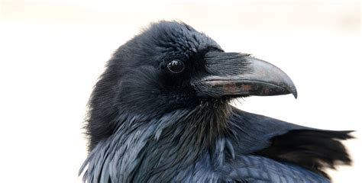**Ravens and the Delayed Exchange Test**

Let’s be honest about this: delayed gratification is hard. Equally unsurprisingly, people have noticed this before! The ability to delay gratification—that is, to surrender a reward that you can have instantly in favor of something better in the future—is not something we’re born with. We develop it around 3-5 years of age. But we’d never expect an animal to be able to understand delayed gratification, right? It turns out that some animals have mastered this skill too. It turns out that chimps, crows, and children between 3 and 5 all have about the same success rate! It’s called the delayed exchange test and it works like this: A raven (he appears to be called Rumu) enjoys eating small cubes of bread. But he really likes cubes of cheese. He is offerd a bread cube. And he makes his choice! He has been taught that he can either eat the bread or wait and exchange it for a cube of cheese. It turns out that not only does he understand the concept, he is able to wait quite a while for his cheese reward. Ravens appear to have a significant sense of time elapsed and planning for the future. This isn’t as surprising as it might be, because ravens hide food (referred to as “cacheing”) for later consumption in the winter. And they certainly have a sense of value! Cheese is “worth” more than bread, so the raven is willing to surrender the bread to get the cheese. What a clever bird! If only humans were able to make the same sort of calculation. Then our “expectation shall not be cut off.” Eternal life with our Creator is worth more than the momentary satisfaction of self indulgence!

Amazon Prime

Bird Brain

Start: 38:50 (14:11 from End)

End: 42:57 (10:04 from End)