Have you ever lost perspective? Gotten wrapped up in what you were doing, in what you wanted, in where you were going, and missed something important? Perhaps you were lucky enough to have a good friend or family member point it out to you before something really bad happened. We all lose perspective sometimes, but that is just another reason why we’re not alone in the world! The plea in verse 23—“buy the truth, and sell it not”—reminds us to focus on what’s really important! And the advice to listen to your parents goes right along with that. Our families (and/or friends) help us when we’re at risk of losing our sense of what is and isn’t important. Of course, as verse 26 suggests, this presupposes that our families (and/or friends) actually have a well-established sense of what matters most! Truth—comprehension of the difference between what’s real and what’s not—is important. But the truth mentioned here is almost certainly the truth of the Bible. God is omnipotent as well as personal, and He cares what you do!

**Proverbs 23:22-26**

**Hearken unto thy father that begat thee, and despise not thy mother when she is old.**

**Buy the truth, and sell it not; also wisdom, and instruction, and understanding.**

**The father of the righteous shall greatly rejoice: and he that begetteth a wise child shall have joy of him.**

**Thy father and thy mother shall be glad, and she that bare thee shall rejoice.**

**My son, give me thine heart, and let thine eyes observe my ways.**

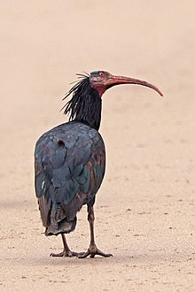**Northern Bald Ibis**

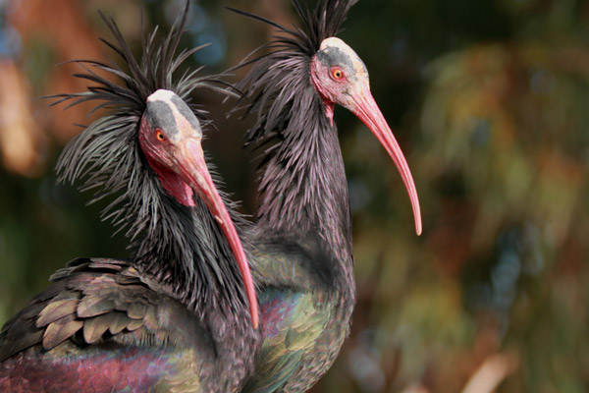The northern bald ibis is a migratory bird found in barren, semi-desert or rocky habitats, often close to running water. They’re gregarious, long-legged black birds with unfeathered heads and long, red, down-curved bills. They breed colonially on coastal or mountain cliff ledges, typically laying two to three eggs in a stick nest. They feed largely on lizards, insects, and other small animals. Once widespread across the Middle East, northern Africa, and southern and central Europe, the northern bald ibis disappeared from Europe over 300 years ago. In 2019 there were about 700 wild birds remaining in southern Morocco. There are about 2000 northern bald ibises living in captivity. Various organizations have thought reintroduce birds into the wild, but there have been several issues with this plan. In particular, northern bald ibises are migratory. And birds learn their migration route from their parents! Ibises released on their own have not done well, as the birds have no idea how to reach their historical wintering grounds. To deal with this, certain researchers hand-raise ibises and teach them to follow an ultra-light. They are then able to fly the migratory route with the birds following the plane. So the ibises learn the migratory routes by experience, led by their “parents,” almost as nature intended! There are now about 40 (migrating!) semi-wild northern bald ibises following their traditional routes in Europe. We humans also tend to need our parents to lead the way. When we lose perspective, our families are able to put us back on course. But without that guidance people tend to be just as lost as the ibises—without any adults to show them the route!

Amazon Prime

Migrating Birds: Scouts of Distant Worlds

Start: 19:30 (1:10:28 from End)

End: 21:56 (1:08:02 from End)

Start: 30:34 (0:59:24 from End)

End: 33:33 (0:56:25 from End)