Taken together, these verses suggest a stern indictment of human pride! Verse 9 says, in essence: “Don’t get into discussions with fools. Your words won’t benefit anybody, no matter how good your arguments might be.” And why would a person be determined to have such a discussion? Pride. Pride in our own wisdom. Verses 10 and 11 warn: “Don’t try to cheat other people, especially those who are already disadvantaged. God Himself takes up the cause of those who are disadvantaged, and you don’t want to be on the other side of that!” And why might we do otherwise? Well, greed and selfishness are reliable motivators. But these too trace quickly back to pride. Pride is at the root of so many of our problems! But it’s verse 12 that clinches it for me. I would paraphrase verse 12 as something along these lines: “Focus all of your attention on learning the things that you ought to know. Listen up, because there’s a lot that you still need to work on.” And would we do anything else? Well, pride. And laziness. But mostly pride. There’s something prideful in the human heart that bridles at the thought that we might still have a lot to learn. We’re accomplished people, after all, with many skills. And we would generally rather focus on our accomplishments. But—and here’s the thing that we can take away from this passage, especially verse 12—we still (all of us) have so very much to learn! When we compare our poor, pitiful understanding with the infinite, glorious knowledge of our Creator, it’s not so insulting to recognize that we still have quite a lot of things to learn.

**Proverbs 23:9-12**

**Speak not in the ears of a fool: for he will despise the wisdom of thy words.**

**Remove not the old landmark; and enter not into the fields of the fatherless:**

**For their redeemer is mighty; he shall plead their cause with thee.**

**Apply thine heart unto instruction, and thine ears to the words of knowledge.**

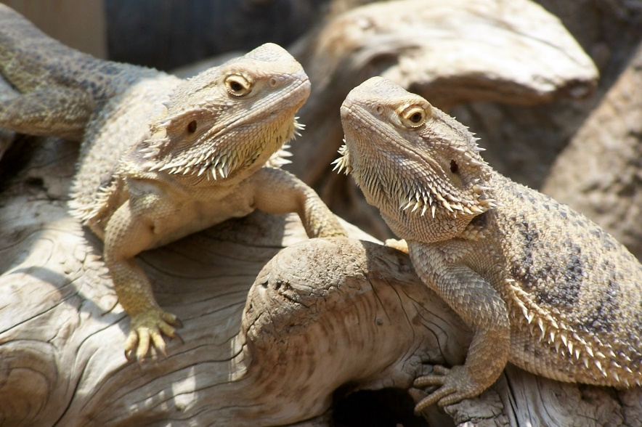**Bearded Dragons**

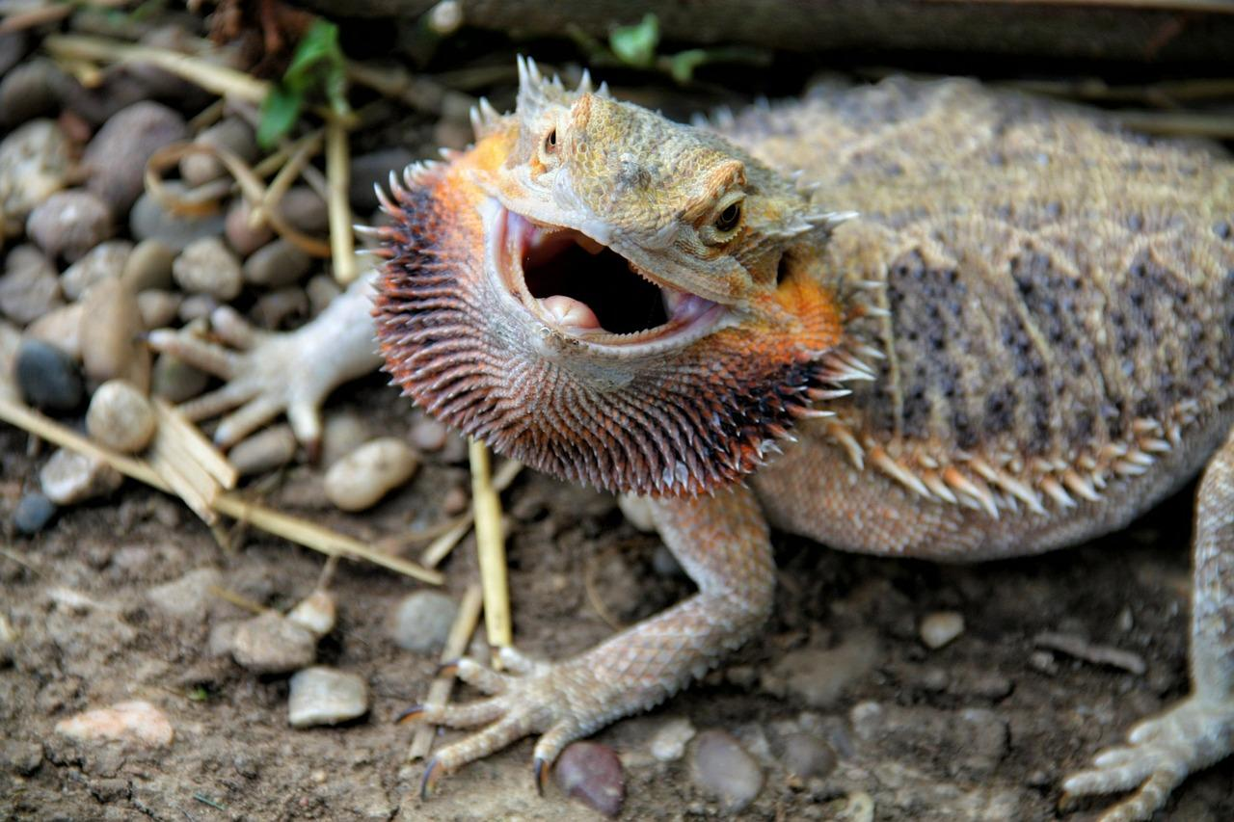Bearded dragons are lizards native to the Austrailian Desert. Males can grow up to about 24 inches long, while females grow to about 20 inches. They are semi-arboreal, spending a lot of time on branches and in bushes. As they grow, bearded dragons establish social hierarchies, much like mammals do. Individuals display aggression to those dragons beneath them in the hierarchy, and appeasement to those above. Males bob their heads up and down (while darkening and flaring their beard) to impress females. Smaller males will often respond to larger males’ head bobbing by waving an arm in submission. Female bearded dragons have been seen lowering themselves towards the ground and intermittently arm-waving whilst moving away from a dominant male in an attempt to either appease or escape. The bearded dragon has also been shown to perceive illusion (Delboeuf illusion). In an experiment at the University of Padua, bearded dragons were presented with two different sized plates with the same amount of food. The bearded dragons chose the smaller plate more often than they chose the larger one, showing that they were able to perceive the illusion and interpret that a larger plate does not always mean more food. And as we see in the video, bearded dragons are able to recognize other bearded dragons in a video and learn from the taped behavior! That’s a lot of study and learning from a tiny lizard brain! As humans, we have a lot more mental potential to work with. We have the materials that we need and the Holy Spirit for guidance, so all we need is the humility to learn as God directs us!

Amazon Prime

Think Like an Animal

Start: 28:43 (25:04 from End)

End: 31:10 (22:37 from End)