God is our Creator, so He knows us pretty well! And He knows what we’re inclined to want—the good life! That’s why we’re inclined to be “envious against evil men.” We want wealth, pleasure, ease, status, and any number of other things. And many of these things are often found in the possession of “evil men”—the morally ambiguous and obviously powerful—the brute force enthusiasts of our society. Such individuals are often to be found living the high life, if only temporarily. Various consequences generally ensure that the “evil” don’t get to keep their profits for long. Perhaps that’s why Proverbs assures us that people of this kind can’t build the house. They can only study destruction. The good life that we want can only be found “through wisdom!” And of course, wisdom comes from God. Only through Him can we hope to establish a house, and fill it with “all precious and pleasant riches.” Real strength comes from wisdom, not from any apparent wealth or power that we might acquire. So we shouldn’t envy the “evil men” who can only destroy. We must acquire wisdom, so that we can build something!

**Proverbs 24:1-6**

**Be not thou envious against evil men, neither desire to be with them.**

**For their heart studieth destruction, and their lips talk of mischief.**

**Through wisdom is an house builded; and by understanding it is established:**

**And by knowledge shall the chambers be filled with all precious and pleasant riches.**

**A wise man is strong; yea, a man of knowledge increaseth strength.**

**For by wise counsel thou shalt make thy war: and in multitude of counsellors there is safety.**

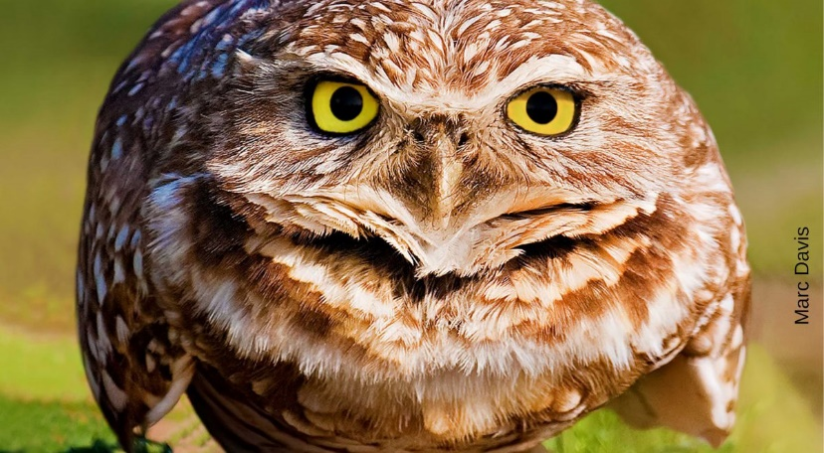**Burrowing Owls**

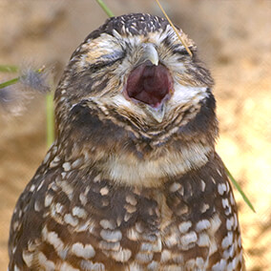The burrowing owl is a small, long-legged owl found throughout open landscapes of North and South America. They live in open, dry areas with low vegetation, including grasslands, agricultural areas, or deserts. As their name suggests, burrowing owls nest and roost in burrows, such as those excavated by prairie dogs. Unlike most owls, burrowing owls are often active during the day, although they tend to avoid the midday heat. Like many other kinds of owls, though, burrowing owls do most of their hunting from dusk until dawn, when they can use their night vision and hearing to their advantage. But burrowing owls still face a lot of challenges. Their unusual ground-based lifestyle makes them targets for many predators, including domestic cats and dogs. The burrow isn’t much protection from animals that can dig efficiently, like dogs or coyotes. And chasing down fast-moving insects is a lot of work for not that much food—especially when a mother burrowing owl has a number of chicks to support. Fortunately, God has provided these owls with some wise solutions! You see, burrowing owls aren’t the only animals that live underground. Snakes like burrows too. When a dog or coyote begins to take a bit too much interest, a burrowing owl can retreat to its burrow and make a sound that closely immitates the warning rattle of a rattlesnake. There aren’t that many animals willing to mess with a rattlesnake in its burrow! And the mother burrowing owl with chicks to feed can set up food delivery close to her front door. By spreading animal dung nearby, she can attract various types of beetles in a steady stream. There’s no need to chase down food when it presents itself for the taking! God has given the burrowing owls a number of wise strategies to build their “house” and fill it with the owl version of riches. He’s given us some wise strategies too. They’re all laid out in Proverbs, and the rest of the Bible. It’s time to listen like a burrowing owl!

Amazon Prime

Nature: Natural Born Hustlers

Season 5: Natural Born Hustlers

**Episode 1: Staying Alive**

**Start: 29:52 (23:10 from End)**

**End: 34:08 (18:54 from End)**

**Episode 2: The Hunger Hustle**

**Start: 8:57 (44:07 from End)**

**End: 12:08 (40:56 from End)**