The English Standard Version for v. 11-12 reads: “*Rescue those who are being taken away to death; hold back those who are stumbling to the slaughter. If you say, ‘Behold, we did not know this,’ does not he who weighs the heart perceive it?...*” This is an uncomfortable requirement! We might actually have to try and reason with people who are doing the wrong thing! They will probably NOT thank us for this! How much I’d rather say, “I don’t know anything about it; it’s really none of my business.” Of course, our Creator knows this… hence verse 12 and the observation that He will “render to every man according to his works.” The next verses try to suggest that there’s something sweet about all this, although I doubt such conversations will be pleasant at all. But can you imagine what it would feel like if that person asks you why you did nothing? Why you didn’t tell them? Why you didn’t stop them? If they should die suddenly, won’t you ask those questions of yourself? The “reward” we are promised here is a peaceful lack of regret, and the confidence that our expectations “shall not be cut off!”

**Proverbs 24:11-14**

**If thou forbear to deliver them that are drawn unto death, and those that are ready to be slain;**

**If thou sayest, Behold, we knew it not; doth not he that pondereth the heart consider it? and he that keepeth thy soul, doth not he know it? and shall not he render to every man according to his works?**

**My son, eat thou honey, because it is good; and the honeycomb, which is sweet to thy taste:**

**So shall the knowledge of wisdom be unto thy soul: when thou hast found it, then there shall be a reward, and thy expectation shall not be cut off.**

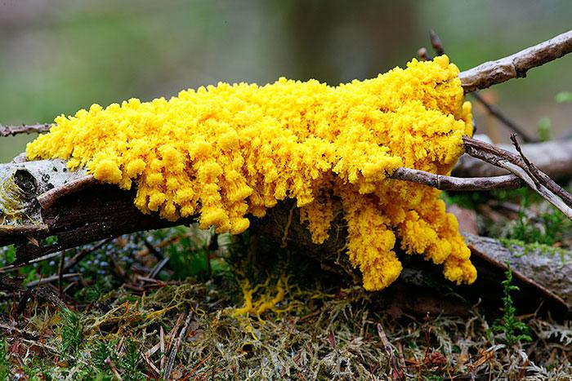**Physarum Polycephalum**

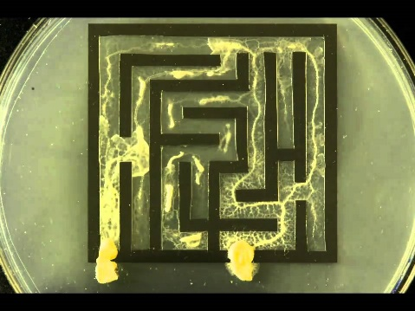Physarum polycephalum is an acellular slime mold or myxomycete, is a protist with diverse cellular forms… but its friends call it Blob. At least, some of the scientists who study it call it Blob! This single-celled organism—neither plant nor fungus—can be found in many different environments all over the planet. And it can do a fair number of amazing things! A team of Japanese and Hungarian researchers have shown that Blob can solve the shortest path problem, retracting from everywhere in a maze except on the shortest path between food sources. When offered more than two food sources, Blob still produces efficient networks. In a 2010 paper, oatflakes were dispersed to represent Tokyo and 36 surrounding towns, and Blob created a network similar to the existing train system. The experiment has been repeated using road networks in the United Kingdom and the Iberian peninsula with similar results. Blob also demonstrates some forms of learning and memory. Blob doesn’t like salt, and large amounts of salt will kill it. But a particular Blob can be “taught” to tolerate a small amount of salt in order to reach a food source. And once Blob has "learned” to get past the salt, it can share this information with other blobs! Since blobs can be separated and recombined without harming them, scientists gradually “teach” a Blob to tolerate salt and then allow it to combine with another, “naïve” Blob. When they are once again separated, the previously “naïve” Blob demonstrates the same tolerance to salt! The brainless Blob is evidently obligated to share its experience. We ought to be able to share our experiences a lot more easily. And once we have a relationship with God, we have a *responsibility* to share what we have learned with others!

Amazon Prime

Secret Mind of Slime

Start: 36:46 (16:15 from End)

End: 40:07 (12:54 from End)

Start: 46:11 (6:50 from End)

End: 48:34 (4:27 from End)