We know that God protects His people! God does allow us to be instructed by the consequences of our actions, of course, but that is what’s best for us. God intervenes to help His people in calamity, but the wicked are overthrown. We are warned in the next several verses about having the right attitude toward others, particularly to the wicked. We aren’t supposed to be glad when (inevitably) bad things happen them. We aren’t supposed to be anxious about the wicked or envious of them. Taken together, this seems to be largely a question of focus. Our focus is supposed to be on God, and our relationship to Him. But it’s pretty easy to let the focus slip! These verses tell us that we aren’t supposed to feel good or bad or afraid or jealous or anything else regarding the wicked! These verses tell us essentially: “Never mind them. They’re doomed. Focus on what you’re meant to be doing so that you don’t join them!” It’s freeing! We don’t need to split our focus—just keep it on God!

**Proverbs 24:15-20**

**Lay not wait, O wicked man, against the dwelling of the righteous; spoil not his resting place:**

**For a just man falleth seven times, and riseth up again: but the wicked shall fall into mischief.**

**Rejoice not when thine enemy falleth, and let not thine heart be glad when he stumbleth:**

**Lest the Lord see it, and it displease him, and he turn away his wrath from him.**

**Fret not thyself because of evil men, neither be thou envious at the wicked:**

**For there shall be no reward to the evil man; the candle of the wicked shall be put out.**

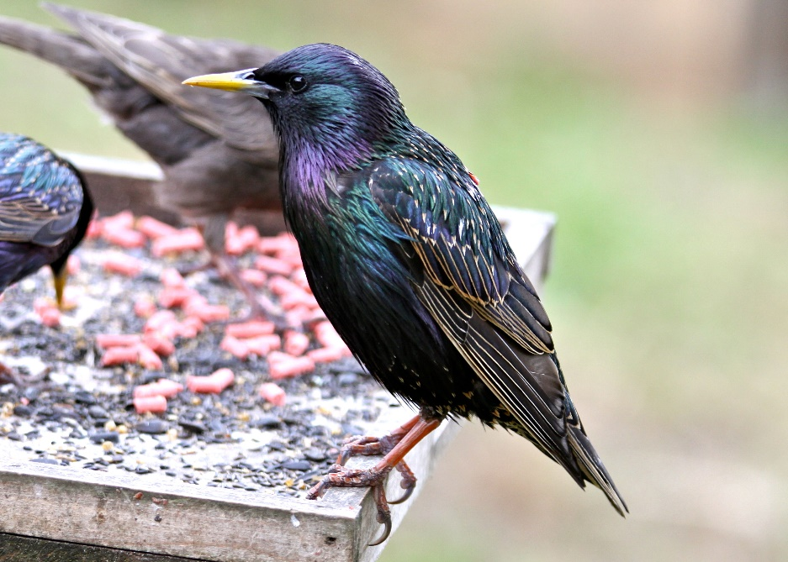**Starlings and Stripes**

There was once a starling called Arnie. And Arnie is helping scientists understand how birds percieve their environment as they fly. Starlings are gregarious, active birds that tend to prefer open country. Their flights are strong and direct. A flying starling can move very quickly. Scientists were interested in the way that birds process rapidly changing visual input during flight. Hence, Arnie. The scientists set up an artificial corridor of boards painted with black and white stripes. Initially, the stripes were oriented horizontally. Arnie flew through this corridor repeatedly, and the scientists averaged his times. Then the scientists changed the corridor, so that the lines were oriented vertically. Once again, Arnie’s times were averaged. When the stripes were oriented horizontally, he averaged 16.5 ft/sec. When flying between the vertical stripes, he only averaged 15.3 ft/sec. Changing the orientation of the stripes on the walls actually slowed him down! It’s thought that Arnie percieves the smooth, continuous horizontal lines as an open environment. The constantly changing black and white pattern of the vertical lines, on the other hand, might be percieved as a series of potential obstacles in a cluttered environment. So Arnie slows down to give himself more time to avoid a possible collision. Of course, we know that stripes on a wall can’t really interfere with Arnie’s speed. It’s his perception of the stripes which causes the issue. He is inclined to focus on the walls rather than keep his eyes on the goal at the end of the corridor. We humans also tend to focus on the wrong thing! Of course, for Arnie, this is probably a wise choice which helps him watch for predators and avoid flying into things. But if we fail to focus on our goals—becoming like Jesus—then we’re likely to fly into something a lot more damaging than a tree!

Amazon Prime

Inside Animal Minds

Episode 2: “Dogs and Super Sense”

Start: 28:33 (24:48 from End)

End: 32:12 (21:09 from End)