We are told quite firmly here to fear the Lord, and the king, and don’t get involved with those who “are given to change.” This is a rather politically charged statement! The “change” we’re talking about here is obviously related to the Lord and the king. So this refers to relgious or political change. But there are plenty of good, worthy relgious or political causes, right?! Of course there are. I believe the problem here is focus. We’re supposed be representing Christ to the world. This is not the same as founding political action committees or religious reformations. At the same time, we are not required to be either unaware of or indifferent to our surroundings! The next verses tell us plainly that we are responsible to distinguish clearly between righteousness and wickedness. We are to rebuke wickedness, not pretend that there’s nothing wrong with it. It’s a question of focus! We can and should exercise sound judgment, distinguish between right and wrong, but not get caught up in anything that takes our attention off of our job as Christ’s representatives.

**Proverbs 24:21-26**

**My son, fear thou the Lord and the king: and meddle not with them that are given to change:**

**For their calamity shall rise suddenly; and who knoweth the ruin of them both?**

**These things also belong to the wise. It is not good to have respect of persons in judgment.**

**He that saith unto the wicked, Thou are righteous; him shall the people curse, nations shall abhor him:**

**But to them that rebuke him shall be delight, and a good blessing shall come upon them.**

**Every man shall kiss his lips that giveth a right answer.**

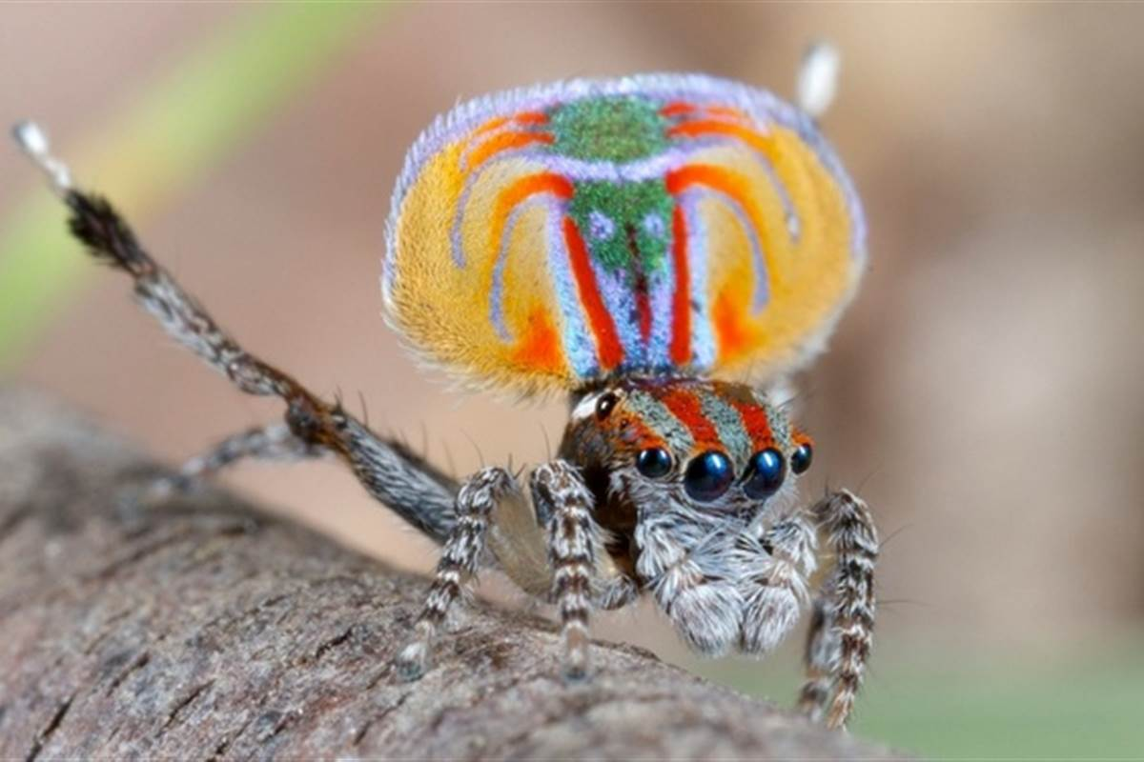**Peacock Spiders**

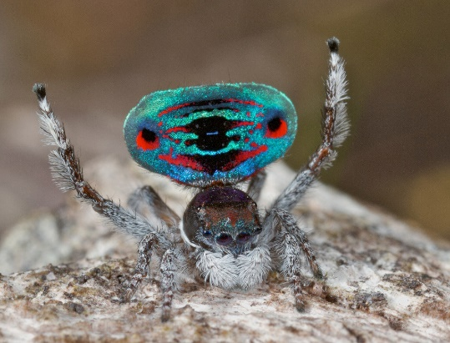Peacock spiders, a type of jumping spiders, are tiny predators. Both genders reach only about 5 mm in length—less than the length of a grain of rice—but they hunt insects and other spiders many times their own size. Male peacock spiders have several special tricks, which they use for attracting females. The first is looks! Males have flap-like extensions of the rabdomen with white hairs that can be folded down. When he meets a female, the male peacock spider raises his abdomen, then expands and raises the flaps so that the abdomen forms a white-fringed, circular field of color, further framed by the third pair of legs whch are raised for display. Sound is also very important. The male’s “vibrations” accompany the dance. The exact mechanism of how these vibrations are produced is not known, but it is known that that they are produced almost solely from rapid movements in their abdomen. The male has to work hard for her attentions! That’s because this is a spider-eating spider. If she is unimpressed, he may become meal instead of mate. His performance is critically important! But at his tiny size, it’s difficult to command attention. Many human vibrations (cars, trains, lawnmowers, televisions, etc) can drown out his efforts. When this happens, the male peacock spider ups his visual signaling and continues the dance! That’s because he is utterly focussed. Anything less may cost him his life! What we need to realize is that this is true for us as well. Anything less than complete focus on God’s will may very well cost our lives also. So we should take a page from the peacock spider’s playbook, and focus on staying alive!

Amazon Prime

Magical Land of Oz

Season 1

Episode 3: “Humans”

Start: 8:11 (46:34 from End)

End: 13:41 (41:04 from End)