Christians are not known today, in general, as people of deep thought. They’re considered to be “people of faith,” which is thought to be synonymous with “irrational people” or “people who reject reason.” But Proverbs has a very different perspective! The fool in verse 7 is one who rejects wisdom (that comes from God). He may very well accept the sort of counterfeit “wisdom” that abounds in the world, but he rejects godly wisdom because it is “too high.” *His actions are not dictated by reason, but by desire.* This is a key truth! Real wisdom comes from God, and it dictates that actions should be based on reason and not desire. And this division—acting by reason or acting by desire—differentiates God’s people from the wicked. If we were to act by reason, we would follow the advice that we’ve seen in Proverbs! Helping others, being generous and kind, standing for the right thing—this would improve our lives as well as the lives around us. That would be the best course for everybody—reason dictates that it should be followed. But we often see something quite different! The wicked and “mischievous” among us, the vicious scorners who think themselves so clever, are indulging in self-gratification rather than reason. And we have an obligation, as Christians, to open our mouths “in the gate,” and stand in the “day of adversity. We have the duty and privilege of standing for reason in a world that is largely bereft of it. We must put our desires aside and stand for God—but we have the universe’s best backup!

**Proverbs 24:7-10**

**Wisdom is too high for a fool: he openeth not his mouth in the gate.**

**He that deviseth to do evil shall be called a mischievous person.**

**The thought of foolishness is sin: and the scorner is an abomination to men.**

**If thou faint in the day of adversity, thy strength is small.**

**Animal Fairness**

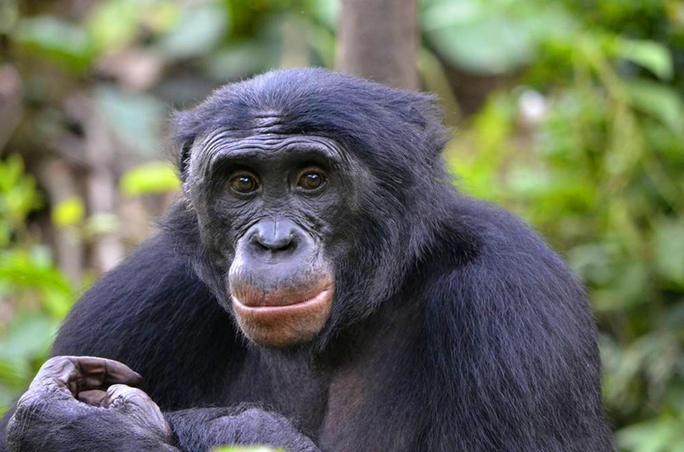Standing up for others seems to be quite a difficult task. Humans certainly seem to have great difficulty with it! But we have a better grasp of fairness when it applies to ourselves. That is, we’re perfectly capable of demanding that others are “fair” in their treatement of us from a young age. And it turns out that a number of other creatures are capable of the same observation! There is a famous TED-talk video featuring capuchin monkeys who absolutely demand equal pay for doing a simple task. As long as both monkeys are receiving a piece of cucumber for the task, then they are perfectly happy to continue doing it repeatedly. But if one monkey recieves a grape—greatly preferred over cucumber—then the other monkey will fling the cucumber back in researcher’s face and generally throw a fit. It turns out that this experiement has been repeated with other animals, and many of them have similar reactions, including dogs, birds, and chimpanzees. But in some of the experiments with chimps, the chimp receiving the better treat will refuse to eat it until the other chimp is supplied with the same treat! It seems that some animals are capable of distinguishing fair treatment for others as well as for themselves. Another great ape, the bonobo, has proven itself willing to sacrifice some of its own food in favor of sharing with a stranger. Apparently, it’s unfair to eat in front of them. This behavior greatly surprised scientists. Perhaps the animals are attempting to help us understand reasonable behavior!

Amazon Prime

Nova: Inside Animal Minds

Episode 3: Who’s the Smartest?

Start: 40:36 (12:46 from End)

End: 43:34 (9:48 from End)