This chapter begins with a statement of origin: These proverbs were written by Solomon, and they were copied down in this present form by “men of Hezekiah.” And the first observations recorded by this work of scholarship? Perhaps unsurprisingly, they have to do with study—or in the language of the KJV, searching. Not everything can be searched out in study—God is infinitely beyond us, and the inner lives of others are never quite known to us. But it is nevertheless “the honour of kings” to “search out a matter.” The clearest implication in this case seems to be that it is honorable on the part of kings to do whatever research they can so that that can judge matters fairly and knowledgably. But this statement has broad applications. It is worthwhile for all of us to search out all manner of things, so that we can make good judgements! But study isn’t the end of the story. Verses 4 and 5 here reference the next step. Once we have studied a matter out, we can distinguish between good and bad, right and wrong, silver and dross! The next step requires us to take action to preserve what’s good and eliminate the rest.

**Proverbs 25:1-5**

**These are also proverbs of Solomon, which the men of Hezekiah king of Judah copied out.**

**It is the glory of God to conceal a thing: but the honour of kings is to search out a matter.**

**The heaven for height, and the earth for depth, and the heart of kings is unsearchable.**

**Take away the dross from the silver, and there shall come forth a vessel for the finer.**

**Take away the wicked from before the king, and his throne shall be established in righteousness.**

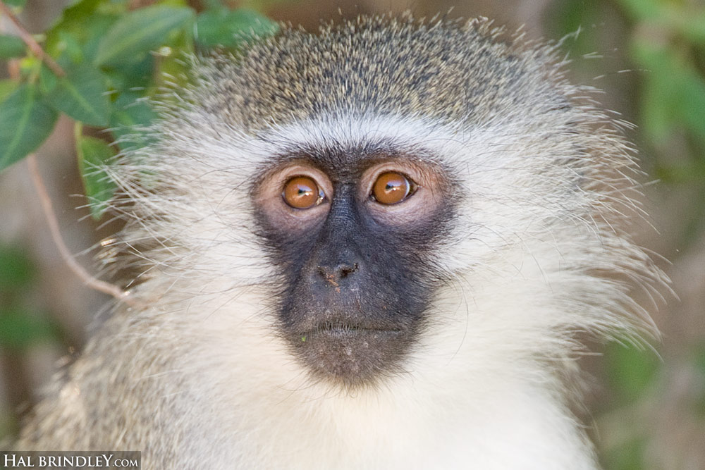**Vervets**

The vervet is an “Old World” monkey native to Africa. They are highly social and noted for a range of human-like characteristics, including hypertension, anxiety, and even alcoholism. They live in social groups of between 10 and 70 individuals, and the different genders have separate dominance hierarchies. In their natural environments, vervets have four predators, namely leopards, eagles, pythons, and baboons. When a vervet sees one of these animals, they make a particular alarm call. Vervets have distinct calls for each of these different predators. When a land predator, like a leopard, approaches the vervets, you would naturally expect them to take to the trees—and they do. And when vervets hear the alarm call for a leopard, you would also expect them to go for the trees. But they may not! It seems that vervets prefer to check the situation before fleeing. Researchers have explored these responses by playing vervet alarm calls to the monkeys over a speaker. When they hear the alarm call, the vervets freeze and look around carefully, assessing the situation before they react. One might say, in fact, that they like to “search out” the matter before choosing their reaction. Of course, when the threat can be located, the monkeys don’t hesitate to take appropriate action. This serves as a pretty good example for us! We need to make our judgements carefully, after close study. But then we must take action!

Amazon Prime

Think like an Animal

Start: 2:08 (51:39 from End)

End: 3:14 (50:33 from End)

Start: 5:01 (48:46 from End)

End: 5:47 (48:00 from End)