Strong feelings can be very difficult to control. Perhaps one of the hardest to contain is anger. The commentaries suggest that verse 23 should probably tell us that as the north wind drives the rain, so an angry countenance drives a backbiting tongue. That is very true! We have to control our feelings, even when others are lashing out as in verse 24. And yet even anger can be a good thing, as verse 26 suggests. Carefully channeled, even anger can be in God’s service! We can’t have the righteous submitting meekly to the wicked, after all. And yet at the same time, we can’t be indulging in pride. To do so is like eating too much honey—it will make you ill. It all comes down to verse 28. A Christian is obliged to “rule over his own spirit.” Failure to do so will result in extremely speedy destruction, like a city that lacks defenses. Strong feelings can indeed be very difficult to control and channel into God’s service. And we often just don’t want to! But allowing wants and feelings to make our decisions really does make our “city” defenseless.

**Proverbs 25:23-28**

**The north wind driveth away rain: so doth an angry countenance a backbiting tongue.**

**It is better to dwell in the corner of the housetop, than with a brawling woman and in a wide house.**

**As cold waters to a thirsty soul, so is good news from a far country.**

**A righteous man falling down before the wicked is as a troubled fountain, and a corrupt spring.**

**It is not good to eat much honey: so for men to search their own glory is not glory.**

**He that hath no rule over his own spirit is like a city that is broken down, and without walls.**

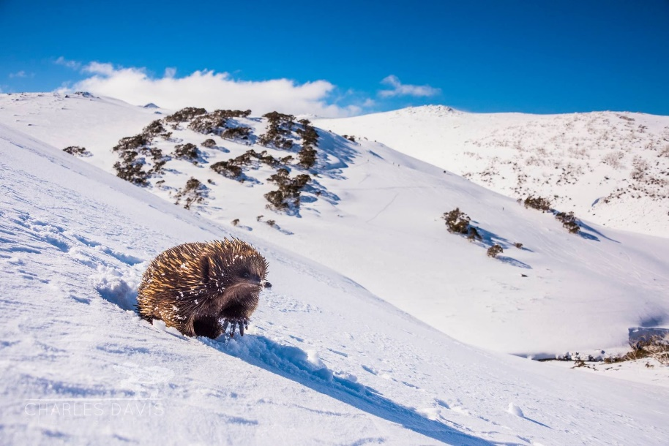**Echidnas**

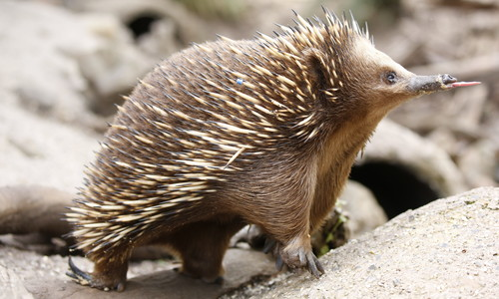Echidnas are rather remarkable creatures. Sometimes termed “spiny anteaters” for their insect-eating ways, these highly unusual animals aren’t closely related to anteaters at all. They’re monotremes, egg-laying mammals, and they are one of only two species that fits in that category. The other, also an Australian native, being the platypus. Echidnas can live in surprisingly chilly conditions in the Snowy Mountains, hibernating on and off through the winter. Of course, when spring comes, there still aren’t a lot of insects around. This should surely upset the spiny anteater! But instead, echidnas simply toddle off downhill. They are capable of lowering their body temperature to 41°F, in order to reduce the amount of food that they need. As the Snowy Mountain-dwelling echidnas descend from their wintery hibernation, they are quite likely to encounter rivers swollen with spring flooding. Fortunately—if rather surprisingly—echidnas are quite accomplished swimmers. Given the unique shape of their back feet, one might be tempted to think otherwise. But it turns out that echidnas actually seek out a swim for bathing and grooming. So the calm (and quite literally cool) echidna is amply able to make its way down the mountainsides in search of insects in the early spring. This patient, stress free approach is credited with allowing echidnas to live up to 50 years—quite a lot longer than other, similarly-sized mammals! All of which goes quite a ways to suggest that Proverbs is once again giving us good advice! If we control ourselves and “rule” over our feelings, then we will, like the echidna, live in a secure “city” with good, solid walls!

Amazon Prime

Magical Land of Oz

Season 1

Episode 1: Land

Start: 1:39 (53:05 from End)

End: 4:47 (49:57 from End)