These verses should be subtitled: “How to avoid making a fool of yourself in public.” The humble person may be called forward, but someone who stands in another’s rightful place is likely to be humiliated. Verse 8 encourages us to take careful thought before starting trouble. The context is that of a lawsuit—and we see that those who start such proceedings “hastily” are soon put “to shame.” Verses 9 and 10 outline two major problems with gossiping about a neighbor rather than dealing with them directly. The first, of course, is that we are likely to make an enemy of our neighbor. The second is that those who hear our (gossipy) comments will soon learn to distrust us, reasoning that we might also talk behind their backs! In all of these situations there’s an element of dishonesty, of people representing themselves falsely. And it is precisely this possibility of being discovered misrepresenting oneself that carries the potential for us to make fools of ourselves in public! God calls us to true honesty, which makes this advice especially applicable to us!

**Proverbs 25:6-10**

**Put not forth thyself in the presence of the king, and stand not in the place of great men:**

**For better it is that it be said unto thee, Come up hither; than that thou shouldest be put lower in the presence of the prince whom thine eyes have seen.**

**Go not forth hastily to strive, lest thou know not what to do in the end thereof, when thy neighbour hath put thee to shame.**

**Debate thy cause with thy neighbour himself; and discover not a secret to another:**

**Lest he that heareth it put thee to shame, and thine infamy turn not away.**

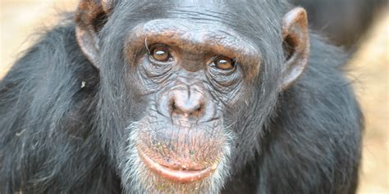 **Missy the Lying Chimp**

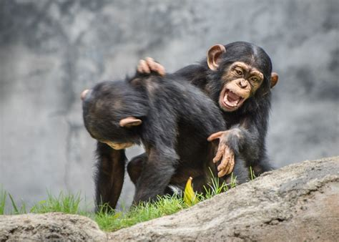Chimpanzees are clever, highly social animals. At the core of social structures are males, which patrol the territory, protect group members, and search for food. Males remain in their natal communities, while females generally emigrate at adolescence. As such, males in a community are more likely to be related to one another than females are to each other. Among males there is generally a dominance hierarchy, and males are dominant over females. All of this complex social maneuvering requires that chimps be quite socially intelligent and capable of manipulating others. So researchers have been devising experiments to evaluate whether or not chimps are capable of deceit. They can test this by allowing a low-status animal to see where food is hidden, while the vision of a higher-status animal is blocked. The chimp in the know—in this case Missy—is perfectly capable of pretending the food isn’t there. At least, until the other chimp is too far away to interfere! But even though these animals have the capacity to be deceitful, such behavior is rarely observed. Why? For the same reasons that we would try to hide deceitful behavior! If they’re found out, their community won’t trust them anymore. Like us, chimps are social animals who must keep their societal rules so that they can continue to participate. Unlike us, they mostly adhere to those rules!

Amazon Prime

Inside Animal Minds

Season 1

Episode 3

Start: 36:10 (17:12 from End)

End: 40:35 (12:47 from End)