Slothfulness is bad news—and something that a Christian simply cannot tolerate in their life. We’re meant to be warriors, wearing the full armor of God, acting as His servants and representatives. There is just no room here for anything but maximum commitment and serious effort. Verse 13 greatly resembles Proverbs 22:13. A representative of Christ can’t really be making excuses like “there’s a lion in the street” in order to stay home. This is a curious observation indeed at the moment! Verse 14 notes that the slothful person tosses and turns on their bed because they aren’t truly weary. Real work certainly promotes better sleep—and Christians are meant to be up and doing, not just lying in bed. We have encountered something like verse 15 previously also. It’s a rather sarcastic statement that one can become too lazy to eat. Certainly sloth tends to lead to still more sloth! But verse 16 is the most striking verse about sloth yet. We’re speaking of mental laziness here. A lazy man believes himself wise because he accepts the easiest answer to every conundrum rather than reasoning it through himself. As Christians we simply cannot be mentally lazy! We must study to show ourselves approved, comparing verse upon verse, and reasoning with our Lord.

**Proverbs 26:13-16**

**The slothful man saith, There is a lion in the way; a lion is in the streets.**

**As the door turneth upon his hinges, so doth the slothful upon his bed.**

**The slothful hideth his hand in his bosom; it grieveth him to bring it again to his mouth.**

**The sluggard is wiser in his own conceit than seven men that can render a reason.**

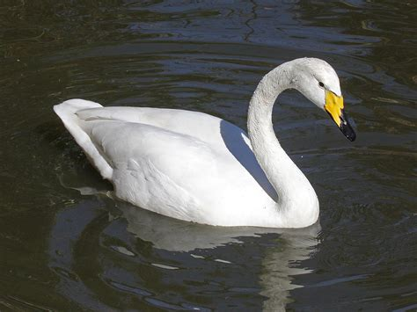**Whooper Swans**

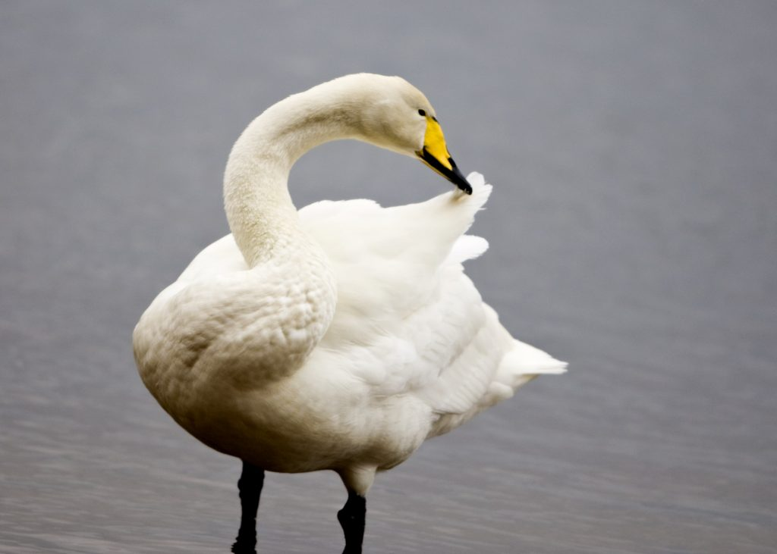Whooper swans, also known as common swans, are large eurasian birds known for their loud calls and hefty size. The average wingspan for a whooper swan is between 81 and 108 inches. They weigh, on average, up to 31 lbs, although the largest on record, a male, weighed 34 ¼ lbs. They are among the heaviest flying birds. Despite their size, they are powerful flyers. They are also very noisy, with a deep, honking call. Whooper swans can migrate hundreds or even thousands of miles to their wintering sites in southern Europe and eastern Asia. For such a large, heavy bird, flying such distances is very impressive. In order to fly, the swans must run on the surface of the water. Their large, webbed feet pushing into the water provide both upward force and forward thrust, while their heavy wings are extended, creating lift. In order to launch into the air, the swan must reach 13 miles per hour, the rate at which the upward lift on swan wings cancels out the downward force of gravity. But the hard work isn’t over. Swans aren’t slick, streamlined fliers like falcons or even albatross. Their heavy wings create so much drag that the swan must keep flapping steadily to provide forward thrust. Otherwise, they would slow and, before long, fall out of the sky. Now these swans aren’t brilliant fliers, but they still put in the effort to migrate great distances to reach feeding and breeding grounds. Of course, there are very few (non-human) lazy animals out there, but there’s no denying that these heavy, flapping, migrating swans are hard workers! And if a swan is willing to go the distance, then it seems like God’s people could manage the same!

Amazon Prime

SuperNature: Wild Flyers

Season 1

Episode 2: Masters of the Sky

Start: 1:43 (52:03 from End)

End: 7:01 (46:45 from End)