So far in this chapter, we’ve seen advice for dealing with fools and sluggards. The rest of the chapter describes other types of troublemakers. And, of course, it gives us some good reasons not to actually become troublemakers ourselves! Meddlers get involved with strife which is none of their business. Verses 18-19 describe a person who plots against his neighbor and (when his machinations are discovered) claims to have been only joking. The talebearer is the subject of verses 20 and 22. These troublemakers keep strife going, and as you may recall from Prov. 18:8, they swallow down slander with eagerness, preserving it for later use. All of these: meddlers, maniacs, and talebearers, could be said to be contentious. They create trouble as well as encouraging and prolonging it. The thing that unites these categories of mischief-maker is that they don’t have a genuine motive or even a specific target for their malice. They really do fire at random, like the madman of verse 18. And it is so easy to become one of them! Have you ever gotten caught up in someone else’s drama? Claimed to be “teasing” after you’ve been caught saying something mean? Caught yourself gossiping, or just stirring the pot and watching the sparks fly? We get stressed, tired, bored, depressed, angry, or grumpy, and find ourselves falling all too easily into these categories! But this is friendly fire, harming our own communities and churches. As the children of God, we need to remain focused on Him so that we DO NOT fall into such behaviors!

**Proverbs 26:17-22**

**He that passeth by, and meddleth with strife belonging not to him, is like one that taketh a dog by the ears.**

**As a mad man who casteth firebrands, arrows, and death,**

**So is the man that deceiveth his neighbour, and saith, Am not I in sport?**

**Where no wood is, there the fire goeth out: so where there is no talebearer, the strife ceaseth.**

**As coals are to burning coals, and wood to fire; so is a contentious man to kindle strife.**

**The words of a talebearer are as wounds, and they go down into the innermost parts of the belly.**

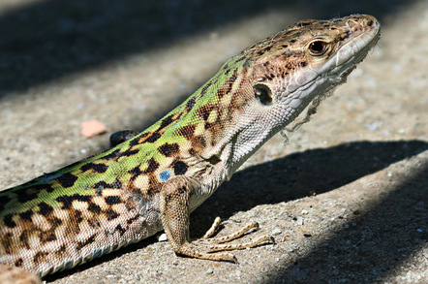**Aegean Wall Lizards**

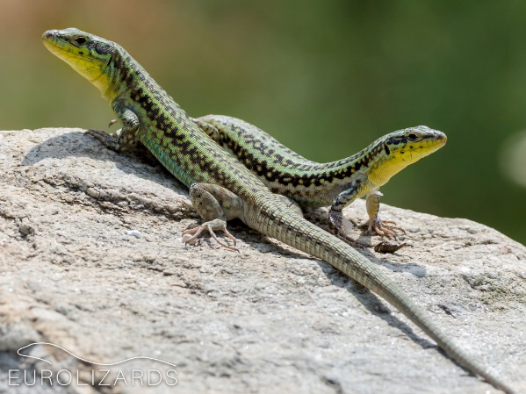Aegean wall lizards (also called Erhard’s wall lizards) live in Southeast Europe. They’re just under three inches long when fully grown, with a wide head and smooth skin. There are a number of color variations, but most lizards are grey or brown, sometimes green. They are often striped or spotted in a range of patterns. The belly and often throat are white, yellow, orange or red, and in the Aegean Islands also green, blue or grey. Many Aegean wall lizards live on tiny, rocky islands in the Aegean Archipelago. One such island is Parthenos, a sunny, rocky mound in the sea. There are no predators on this island at all, but there are lots and lots of lizards. Now these lizards are supposed to be insect-eaters, and Aegean wall lizards that live on the mainland are indeed eating insects. But there aren’t so many insects on Parthenos. The lizards that live there have come up with a grim solution to the problem—cannibalism. The lizards don’t have any predators on Parthenos unless you count the lizard next to them. Now there’s no reason to think that a particular wall lizard has something specific against their neighboring wall lizard; they’re just hungry. Similarly, the kinds of troublemakers we’re talking about in these verses don’t have any particular grudge. They’re just stressed, tired, bored, depressed, angry, or grumpy. But the effect on their community is no less harmful just because there’s not a specific motivation! The cannibalistic lizards are no less horrific because they aren’t feuding. Arbitrary, indifferent malice is still malice, and still evil. All of which is a good reason to remember to control ourselves, even when we’re stressed, tired, bored, depressed, angry, or whatever. We can do better than those horrible lizards!

Nature: Natural Born Rebels

Season 1

Episode 1: Hunger Wars

Start: 46:38 (6:01 from End)

End: 51:01 (1:38 from End)