These verses continue our previous discussion about fools, though from a slightly different angle. Giving a message, a task, a parable, an honor, even a thorny stick to a fool is, according to verses 6-9, fraught with danger. One who “despises wisdom and instruction” (Prov. 1:7) can evidently create disaster given the smallest opportunity. This message isn’t addressed to the fool. And it’s a call to good judgement. Thus the one who is sending the message, giving the honors, or listening to the parable must examine those around him and determine which of them is—or is not—a fool. We are accountable for those we allow to influence us. Parables (simple stories illustrating a moral or religious point) are as dangerous in the hands of a fool as a thorny stick in the hands of a drunkard. That seems pretty dangerous! Verses 10-12 give us a few additional warnings about dealing with fools. First, God will ultimately reward everyone appropriately—both the fool and those who chose or declined to listen. Second, people tend to fall back in to old patterns. So those who have been foolish are going to be tempted to return to folly. But despite that truth, the fool still has a better chance than one who is wise in his own conceit, because that characteristic usually precludes correction. So we are called to good judgement and simultaneously urged not to rely on our own! Good judgement, then, is God’s judgment. And we can always fall back on Him!

**Proverbs 26:6-12**

**He that sendeth a message by the hand of a fool cutteth off the feet, and drinketh damage.**

**The legs of the lame are not equal: so is a parable in the mouth of fools.**

**As he that bindeth a stone in a sling, so is he that giveth honour to a fool.**

**As a thorn goeth up into the hand of a drunkard, so is a parable in the mouths of fools.**

**The great God that formed all things both rewardeth the fool, and rewardeth transgressors.**

**As a dog returneth to his vomit, so a fool returneth to his folly.**

**Seest thou a man wise in his own conceit? there is more hope of a fool than of him.**

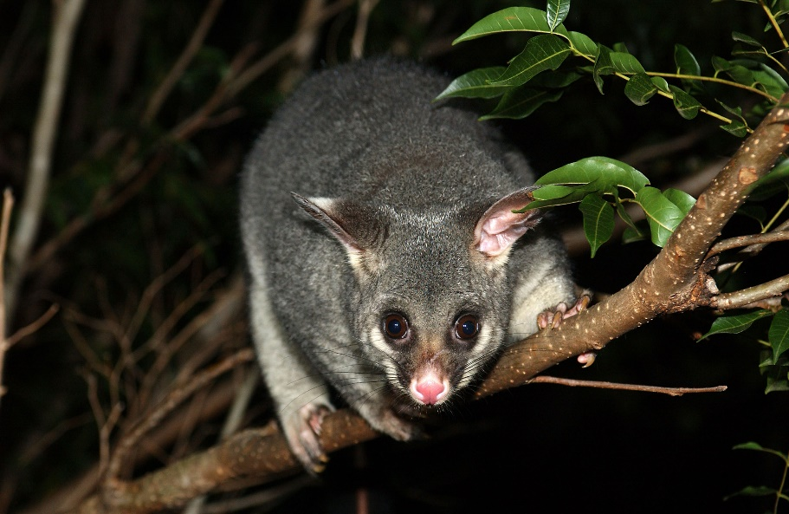**Common Brushtail Possum**

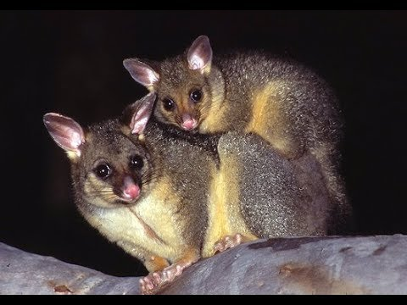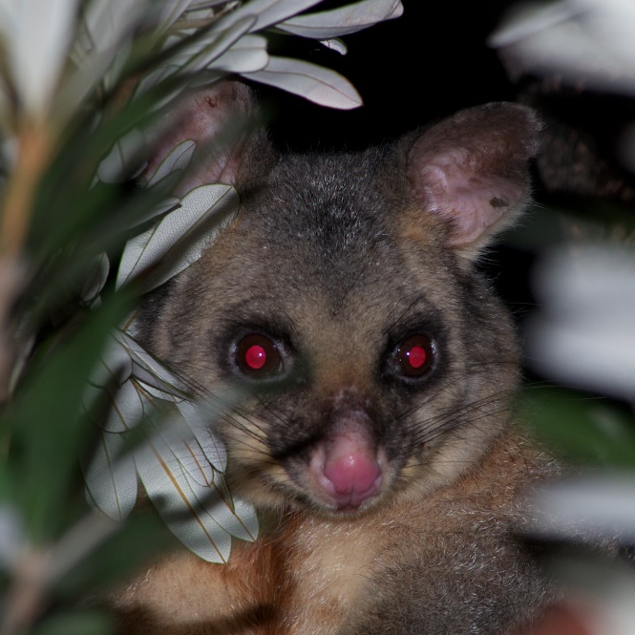The common brushtail possum is the Australian marsupial most often seen by city dwellers, as it is one of few that thrive in cities and a wide range of natural and human-modified environments. Possums are usually vegetarian, nocturnal, and semi-arboreal. But when they live in town, they are also inventive and determined foragers with a liking for fruit trees, vegetable gardens, and kitchen raids. City-dwelling possums don’t usually have any particular difficulty in finding food. There’s plenty on offer in town. As such, the city-dwellers breed quickly. This gives rise to the real challenge of town living: den space. Country-dwelling possums generally den alone, but their city cousins have real trouble finding an unoccupied tree. Fortunately, possums have come to accept less natural den opportunities, like sheds, garages, attics, and so forth. Evidently, some of these city-bred marsupials prefer such shelters to more natural denning options. There’s no question, though, that these animals must have good judgement in order to select the right location to call home! Just crossing the necessary roads is a tricky proposition. Also, not every Australian is going to be delighted to house a possum—particularly when trash day rolls around. Fortunately, we know that the animals listen to their Creator, even when the humans do not. And the town possum populations are doing very well indeed as a result! If we learn to follow God’s good judgement, then we will also do very well, even in perilous places and times.

Amazon Prime

The Magical Land of Oz

Season 1

Episode 3: Human

Start: 2:43 (52:02 from End)

End: 8:11 (46:34 from End)