These verses identify four of the universe’s most destructive qualities: pride, arrogance, anger, and envy. Pride is certainly the root of all these things. The rest of the list arises from the idea that others are unimportant, or at least, not as important as my wants. Pride separates us not only from our fellow man, but also from God. As verse 1 suggests, we can never learn to rely on Him as long as we allow pride into our hearts. The arrogance referenced in verse 2 also stems from pride and, as this verse implies, tends to make us look foolish. Verse 3 reads literally, “heaviness of stone, weight of sand, the vexation of a fool is heavier than both.” These are curious comparisons! Anger here is compared to a heavy burden, pressing down not solely on the “fool” who indulges it, but also on everyone around him. I think of anger, perhaps incorrectly, as a hot, lively thing. It is probably more accurate to think of it as Proverbs depicts: a stifling, smothering weight. But it could be worse. Apparently even worse than the dead weight of anger is envy. Anger eventually goes away. You can’t really sustain anger over the long term (possibly because it’s too heavy a burden). But envy and jealousy are slow-working passions that can persist for years. Envy is still based in pride: the idea “I am more important than anything else.” But it has the potential to really poison joy. No matter what you have, there’s always someone with something better. Envy prevents you from enjoying anything you have (relationships, possessions, accomplishments), instead focusing on being unhappy because of what you don’t have. With the constant prodding of envy, you could never be happy with or grateful for anything. And that is just no way to live!

**Proverbs 27:1-4**

**Boast not thyself of to morrow; for thou knowest not what a day may bring forth.**

**Let another man praise thee, and not thine own mouth; a stranger, and not thine own lips.**

**A stone is heavy, and the sand weighty; but a fool's wrath is heavier than them both.**

**Wrath is cruel, and anger is outrageous; but who is able to stand before envy?**

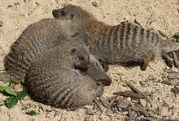**The Banded Mongoose**

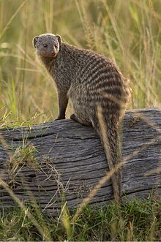The banded mongoose (Mungos mungo) is a mongoose species native to Africa. They live in savannas, open forests and grasslands and eat mostly beetles and millipedes. There is generally no strict hierarchy in these groups and aggression between group members is low. It’s all mostly pleasant and peaceful within the family group, but there is still a problem. Females need breeding partners, but they are usually related to the males within their group. Inbreeding is very rare within wild animal groups, but the banded mongoose is an unfortunate exception. But for the banded mongoose, going outside the group creates major issues. Relations between groups are violently aggressive. Some scientists go so far as to rate the banded mongoose (along with chimps and humans) as creatures capable of waging war. Mongooses can be killed and injured during intergroup encounters—up to a sixth of the group may die from their injuries. As it turns out, not only will breeding females often mate with males from a rival group during fights, they will actually initiate the encounter! Even though they may well lose members of their own family in the fracas, breeding females will initiate the encounter in order to have access to unrelated males. In the case of the banded mongoose, of course, this is apparently a necessary thing. But it still serves as a pretty good example of the horrific consequences of pride. These animals value what they want above the well-being of their own family. As Christians—as humans!—we should be able to do much better than this. We must evict all four of these things from our lives, and learn to value others even more than ourselves.

Nature: Natural Born Rebels

Season 1

Episode 3: The Mating Game

Start: 16:55 (36:09 from End)

End: 21:23 (31:41 from End)