Foresight has a curiously bad reputation in society today. Having foresight involves anticipating future events, especially the action and behaviors of other people. Of course, it’s easy to see how society confuses this with “judging” other people (which in turn is equated with shaming other people, but that’s another story.) Foresight, however, is something that Proverbs encouraged us to develop. It’s linked with wisdom which, as we know, can only come from God. The wise, godly person anticipates future events and reacts accordingly, while the “simple” suffer for their lack of foresight. We see several examples of this in quick succession in the following verses. Proverbs has lots to say about standing “surety.” Here we see that the loan-giver is encouraged to protect himself when the loan involves a stranger—anticipating that a stranger, having few ties to the community, might take advantage. Verse 14 anticipates that the first, loudest flatterer is out to cheat the object of their attentions. Verses 15-16 warn against getting involved with a contentious person, anticipating that they will be both exceedingly irksome and impossible to stifle. The subtext here involves choosing your spouse with a focus on the future—foresight—rather than a focus on immediate gratification. God does give us insight into the most probable course for people and events, and we are expected to use that foresight in His service!

**Proverbs 27:11-16**

**My son, be wise, and make my heart glad, that I may answer him that reproacheth me.**

**A prudent man foreseeth the evil, and hideth himself; but the simple pass on, and are punished.**

**Take his garment that is surety for a stranger, and take a pledge of him for a strange woman.**

**He that blesseth his friend with a loud voice, rising early in the morning, it shall be counted a curse to him.**

**A continual dropping in a very rainy day and a contentious woman are alike.**

**Whosoever hideth her hideth the wind, and the ointment of his right hand, which bewrayeth itself.**

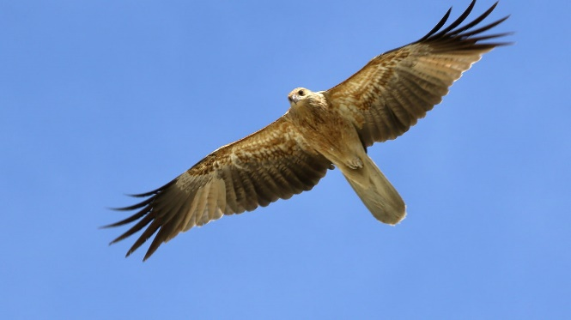**Black Kites**

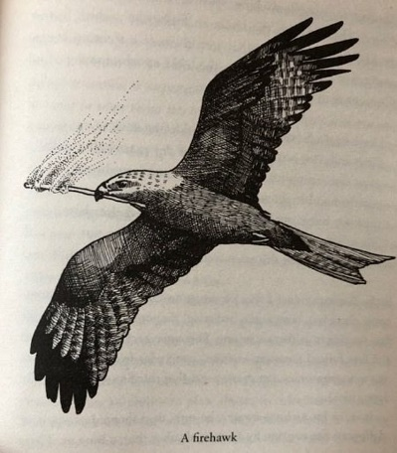 The savanna country of northern Australia is one of the most fire-prone natural habitats in the world. Lightning starts wildfires, and people regularly start controlled burns to trigger early germination and prevent uncontrolled fires later. As in many places with regular wildfires, the vegetation does well with the cycle of burning and growth. The grass blazes up for a moment, but the flames sweep quickly across the plains, leaving trees largely untouched. The animals that live there are less fire-resistant. So the fire drives lizards, insects, and others in front of it. Waiting at the fire’s margins are birds of prey, such as the Black Kites, called from great distances by the rising smoke. But growing evidence indicates that Black Kites aren’t merely opportunists, taking advantage of natural fires. They encourage wildfires to spread! They pick up burning sticks in their talons and carry them off to unburned patches of savanna. This creates new margins of fire, and new opportunities to catch creatures escaping from the flames. During the 2016 fire season in Australia, two scientists collected data to document this phenomenon. Accounts from fire fighters, park rangers, and other stewards of the land echo the knowledge of indigenous people of northern Australia, who have long known about birds propagating fires. It seems completely remarkable that a bird is able to associate carrying fire with easily caught prey. It looks like amazing foresight, like the kite is able to anticipate the reactions of other animals to fire and work backwards from that reaction to the act of spreading fire. We can’t know what they think, but it sure looks like the kites are anticipating the reactions of other wildlife. And if the birds can do it, then it certainly seems like we could manage to anticipate some of the reactions around us, as Proverbs directs!

Amazon Prime

Magical Land of Oz

Season 1

Episode 1: “Land”

Start: 47:18 (7:26 from End)

End: 52:48 (1:56 from End)