Diligence is not a very popular topic today—or possibly ever. Exhortations to diligence and personal responsibility are not really that much fun. We would far rather focus on the assurances that God will supply all our needs! But the truth is that God works in cooperation with human effort. God promised Abraham that his descendants would inherit the land of Canaan, but when the time came for them to claim that inheritance He instructed them, “Every place that the sole of your foot shall tread upon, that have I given unto you” (Joshua 1:3). God gave them that land, but He did require that they work diligently to claim it. We see similar ideas here. We are urged to work diligently for our own support and the support of our families, but as long as we fulfill that requirement, God will bless our efforts. We are assured that there will be sufficient resources for clothing and land and food. God promises to provide everything we need. But He does require something of us first! Diligence may not be the most popular topic, but it is a necessary first step to accessing the many blessings that God has reserved for our use.

**Proverbs 27:23-27**

**Be thou diligent to know the state of thy flocks, and look well to thy herds.**

**For riches are not for ever: and doth the crown endure to every generation?**

**The hay appeareth, and the tender grass sheweth itself, and herbs of the mountains are gathered.**

**The lambs are for thy clothing, and the goats are the price of the field.**

**And thou shalt have goats' milk enough for thy food, for the food of thy household, and for the maintenance for thy maidens.**

**Upgrade your digital Bible study experience with Bible Gateway Plus. Try it FREE for 30 days.**

**FEATURED**

**King James Study Bible Notes**

**King James Study Bible Notes**

**PLUS10 entries**

**Zondervan KJV Commentary**

**Zondervan KJV Commentary**

**PLUS19 entries**

**How to Read the Bible Book by Book**

**How to Read the Bible Book by Book**

**PLUS3 entries**

**STUDY BIBLES**

**NIV Quest Study Bible Notes**

**NIV Quest Study Bible Notes**

**PLUS8 entries**

**NIV Student Bible Notes**

**NIV Student Bible Notes**

**PLUS6 entries**

**King James Study Bible Notes**

**King James Study Bible Notes**

**PLUS10 entries**

**NIV Jesus Bible**

**NIV Jesus Bible**

**PLUS2 entries**

**NIV Biblical Theology Study Bible**

**NIV Biblical Theology Study Bible**

**PLUS27 entries**

**NKJV Maxwell Leadership Bible**

**NKJV Maxwell Leadership Bible**

**PLUS1 entry**

**NKJV Chronological Study Bible Notes**

**NKJV Chronological Study Bible Notes**

**PLUS4 entries**

**NASB Charles F. Stanley Life Principles Bible Notes**

**NASB Charles F. Stanley Life Principles Bible Notes**

**PLUS7 entries**

**NKJV Charles F. Stanley Life Principles Bible Notes**

**NKJV Charles F. Stanley Life Principles Bible Notes**

**PLUS4 entries**

**NIV First-Century Study Bible**

**NIV First-Century Study Bible**

**PLUS3 entries**

**Case for Christ Study Bible**

**Case for Christ Study Bible**

**PLUS3 entries**

**New Spirit-Filled Life Bible**

**New Spirit-Filled Life Bible**

**PLUS8 entries**

**NKJV Study Bible**

**NKJV Study Bible**

**PLUS12 entries**

**NKJV Lucado Encouraging Word Bible**

**NKJV Lucado Encouraging Word Bible**

**PLUS1 entry**

**NIV Study Bible Notes, Fully Revised Edition**

**NIV Study Bible Notes, Fully Revised Edition**

**PLUS26 entries**

**NKJV MacArthur Study Bible, 2nd Edition**

**NKJV MacArthur Study Bible, 2nd Edition**

**PLUS18 entries**

**NKJV Abide Bible**

**NKJV Abide Bible**

**PLUS3 entries**

**NIV Cultural Backgrounds Study Bible**

**NIV Cultural Backgrounds Study Bible**

**PLUS4 entries**

**NRSV Cultural Backgrounds Study Bible**

**NRSV Cultural Backgrounds Study Bible**

**PLUS4 entries**

**Orthodox Study Bible**

**Orthodox Study Bible**

**PLUS9 entries**

**Reformation Study Bible**

**Reformation Study Bible**

**19 entries**

**ENCYCLOPEDIAS**

**Encyclopedia of The Bible**

**26 entries**

**COMMENTARIES**

**Halley's Bible Handbook Notes**

**Halley's Bible Handbook Notes**

**PLUS1 entry**

**How to Read the Bible Book by Book**

**How to Read the Bible Book by Book**

**PLUS3 entries**

**Zondervan Bible Commentary (One Volume)**

**Zondervan Bible Commentary (One Volume)**

**PLUS1 entry**

**Expositor's Bible Commentary (Abridged Edition): Old Testament**

**Expositor's Bible Commentary (Abridged Edition): Old Testament**

**PLUS23 entries**

**Olive Tree Bible Overview**

**Olive Tree Bible Overview**

**PLUS1 entry**

**Zondervan Illustrated Bible Backgrounds Commentary of the Old Testament**

**Zondervan Illustrated Bible Backgrounds Commentary of the Old Testament**

**PLUS4 entries**

**New Bible Commentary**

**New Bible Commentary**

**PLUS3 entries**

**NIV Application Commentary**

**NIV Application Commentary**

**PLUS12 entries**

**Essential Bible Companion**

**Essential Bible Companion**

**PLUS1 entry**

**Zondervan KJV Commentary**

**Zondervan KJV Commentary**

**PLUS19 entries**

**Believer's Bible Commentary**

**Believer's Bible Commentary**

**PLUS22 entries**

**Theology of Work Bible Commentary**

**Theology of Work Bible Commentary**

**1 entry**

**Matthew Henry's Commentary**

**20 entries**

**The Bible Panorama**

**1 entry**

**Asbury Bible Commentary**

**1 entry**

**DICTIONARIES**

**Mounce's Complete Expository Dictionary**

**Mounce's Complete Expository Dictionary**

**PLUS12 entries**

**Zondervan Illustrated Bible Dictionary**

**Zondervan Illustrated Bible Dictionary**

**PLUS14 entries**

**New International Dictionary of New Testament Theology**

**New International Dictionary of New Testament Theology**

**PLUS12 entries**

**Essential Bible Dictionary**

**Essential Bible Dictionary**

**PLUS3 entries**

**NKJV Open Bible**

**NKJV Open Bible**

**PLUS29 entries**

**All the Men of the Bible**

**1 entry**

**Dictionary of Bible Themes**

**65 entries**

**Easton's Bible Dictionary**

**11 entries**

**Smith's Bible Names Dictionary**

**8 entries**

**King James Version (KJV)**

**Public Domain**

**BIBLE GATEWAY RECOMMENDS**

**KJV, Baby's First Bible, Hardcover, Multicolor: A special keepsake for your new arrival**

**KJV, Baby's First Bible, Hardcover, Multicolor: A special keepsake for your new arrival**

**Retail: $14.99**

**Our Price: $10.49**

**Save: $4.50 (30%)**

**Buy Now**

**KJV, Vest Pocket New Testament, Red Letter Version: Holy Bible, King James Version**

**KJV, Vest Pocket New Testament, Red Letter Version: Holy Bible, King James Version**

**Retail: $4.99**

**Our Price: $3.49**

**Save: $1.50 (30%)**

**Buy Now**

**KJV, Open Bible, Red Letter Edition, Comfort Print: Complete Reference System**

**KJV, Open Bible, Red Letter Edition, Comfort Print: Complete Reference System**

**Retail: $29.99**

**Our Price: $20.99**

**Save: $9.00 (30%)**

**Buy Now**

**VIEW MORE TITLES**

**ABOUT**

**About**

**Statement of Faith**

**Mobile App**

**Store**

**Blog**

**Newsroom**

**Support Us**

**HELP**

**FAQs**

**Tutorials**

**Use Bible Gateway on Your Site**

**Advertise with us**

**Contact us**

**Privacy policy**

**California Privacy Rights**

**Do Not Sell My Personal Information**

**Site: Terms of use**

**Widget: Terms of use**

**OUR NETWORK**

**FaithGateway**

**StudyGateway**

**ChurchSource**

**HarperCollins Christian Publishing**

**Grupo Nelson**

**Editorial Vida**

**Thomas Nelson**

**WestBow Press**

**Zondervan**

**SOCIAL**

**Facebook**

**Twitter**

**Instagram**

**PREFERENCES**

**Versión en español**

**Preferences**

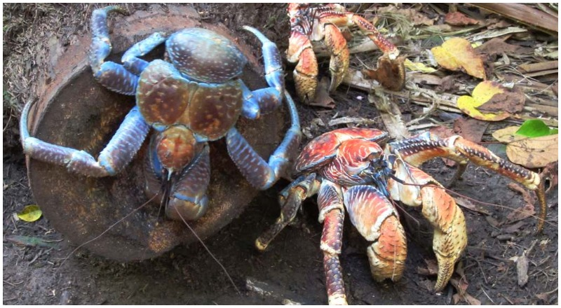**Coconut Crabs**

Coconut crabs are big. They’re the largest terrestrial arthropod in the world, weighing up to 9 pounds with a 3 foot, 3 inch length from leg tip to leg tip. Coconut crabs live on islands across the Indian Ocean, and parts of the Pacific Ocean. They’re strong, too, and surprisingly clever. Coconut crabs are known to rip open the husk of a coconut, then take the inner nut up a tree (up to 33 feet) in order to drop it on the ground and thereby break it open. Although coconut crabs seem to enjoy coconuts, they feed primarily on fleshy fruits, nuts, seeds, and the pith of fallen trees. But coconut crabs are flexible and opportunistic eaters, willing to eat whatever they can locate. Anything left unattended on the ground is a potential source of food, which they will investigate and may carry away—thereby getting the local name of “robber crab.” It seems that they are so efficient at locating new potential sources of food that they investigate any new object they come across. Within minutes of placing a shoe or a bag or a water bottle on the ground, coconut crabs appear and drag off any objects they judge to be possible sources of food. It seems that coconut crabs have a highly sensitive system chemical detection, serving a similar purpose to our sense of smell. They can “smell” new objects from a considerable distance, and they diligently come to investigate right away. Of course, these crabs understand that their prosperity is closely linked to their diligence! And if an arthropod is capable of grasping such a thing, then it seems likely we can too!

Amazon Prime

Nature: Natural Born Rebels

Season 1

Episode 1: “Hunger Wars”

Start: 1:55 (50:44 from End)

End: 8:22 (44:17 from End)