Relationships are a deeply necessary part of our lives. Good relationships make us happier, healthier people, while poor relationships shorten our lifespan. Fortunately, Proverbs has quite a bit to say about relationships. Verses 5 and 6 here make some surprising observations about friendship. Those interactions that we think of as positive often are not. Enemies can be deceitful rather than openly hostile. Secret love is useless, and probably insincere—real regard is expressed. Open rebuke from a friend, on the other hand, can help us. It’s intended to help us live better lives. True friends will risk angering us in order to help us. Verse 7 points out that scarcity breeds appreciation, and real friends are always in short supply! The metaphor of verse 8 features a bird “wandering” from her nest. Of course, if a bird abandons her nest then her chicks do not long survive. Perhaps verse 8 is intended to remind us to hold closely to our families. Good advice is an important part of many of our relationships, both from family and from friends, as verse 9 suggests. And verse 10 emphasizes the importance of maintaining good relationships with the people that we see every day. Good friends help us when we’re in trouble, tell us the truth when we need to hear it, and are always in short supply. Of course, we see also see here that real friendship may look rather surprising! We have to be willing to listen to a “rebuke” for our own good!

**Proverbs 27:5-10**

**Open rebuke is better than secret love.**

**Faithful are the wounds of a friend; but the kisses of an enemy are deceitful.**

**The full soul loatheth an honeycomb; but to the hungry soul every bitter thing is sweet.**

**As a bird that wandereth from her nest, so is a man that wandereth from his place.**

**Ointment and perfume rejoice the heart: so doth the sweetness of a man's friend by hearty counsel.**

**Thine own friend, and thy father's friend, forsake not; neither go into thy brother's house in the day of thy calamity: for better is a neighbour that is near than a brother far off.**

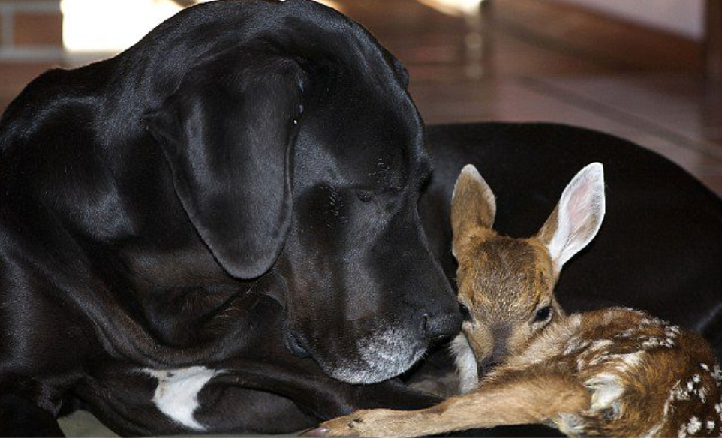**Kate and Pippin**

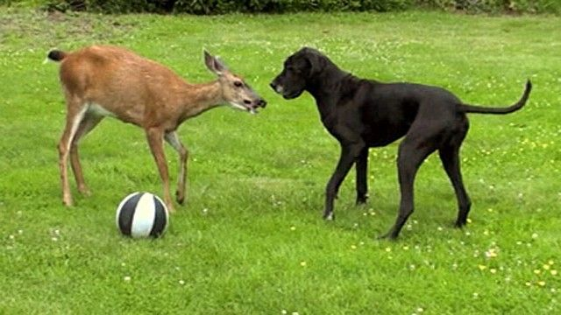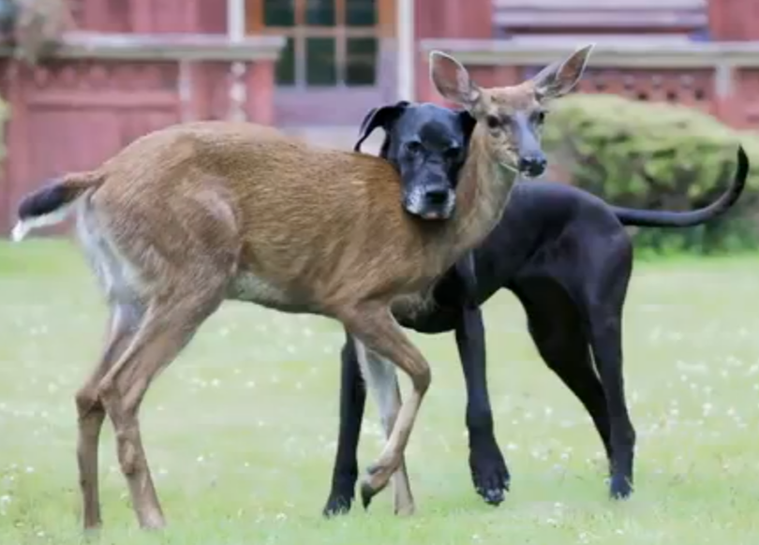When Kate (a Great Dane) heard a strange crying noise from the pasture, she insisted that her owner Isobel Springett take a look. They located a fawn, only a few days old, apparently abandoned by her mother. After a couple of days it was clear that the fawn, soon named Pippin, was an orphan no longer. Kate immediately bonded with the young deer. Kate tolerated Pippin’s rough attempts to nurse from her, shepherded her around the yard, and even encouraged her to graze as she got older. As Pippin grew to be an adult, she came and went in the nearby forest, joining a nearby herd. But she still comes to visit her friend Kate regularly. They greet each other and even nap together. Now an adult doe, Pippin has had several of her own babies within Kate’s yard, apparently confident that her own young will be safe with Kate standing guard. Pippin and Kate’s relationship is certainly evidence that good intentions make for a positive relationship, even though that friendship may be expressed in surprising ways! It’s important for us to work at maintaining good relationships. We need close friends and family in order to be the people God wants us to be!

Amazon Prime

Animal Odd Couples

Start: 45:40 (7:23 from End)

End: 51:31 (1:32 from End)