Have you ever thought about how much of being a decent Christian is about focusing on the big picture? It’s easy to get caught up in the small stuff, but the Bible constantly reminds us of the bigger picture. Have you ever done something wrong, imagining that it will be to your benefit, only to find that your own guilt makes the supposed gains horrible to live with? That’s the experience of the wicked in verse 1. They’re so haunted that they flee even though nothing is giving chase. Remembering the big picture can mean anticipating this result and avoiding the problem entirely! On a similar note, moral degradation tends to increase the number of rulers in a country—while shortening their periods of power. Unrest increases. It’s not so good in the big picture! But godly leadership can bring stability. Verse 3 compares a poor man oppressing other poor people as a beating rain that washes topsoil away and actually prevents growth. This is bad for everybody—even the instigator will go hungry! In verse 4, “praising,” or complementing someone doesn’t sound like it could possibly be a bad thing! If we think in the small picture, we’re just helping someone feel good about themselves. Yet in the big picture we’re called to “contend,” or struggle against the wicked for the greater good. It’s a good thing that the Lord is working on our judgment!

**Proverbs 28:1-5**

**The wicked flee when no man pursueth: but the righteous are bold as a lion.**

**For the transgression of a land many are the princes thereof: but by a man of understanding and knowledge the state thereof shall be prolonged.**

**A poor man that oppresseth the poor is like a sweeping rain which leaveth no food.**

**They that forsake the law praise the wicked: but such as keep the law contend with them.**

**Evil men understand not judgment: but they that seek the Lord understand all things.**

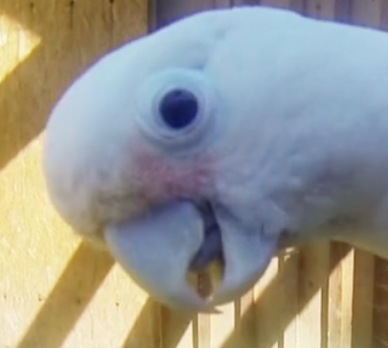**Muppet the Cockatoo**

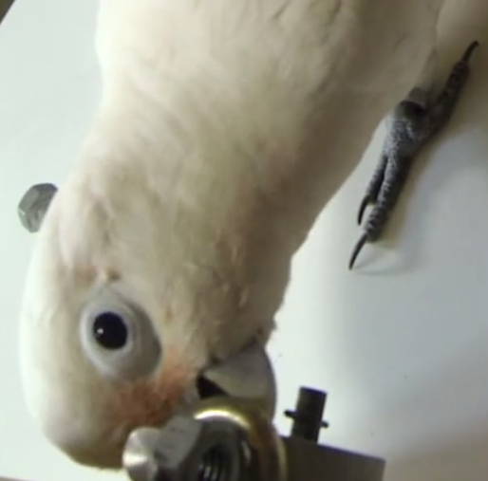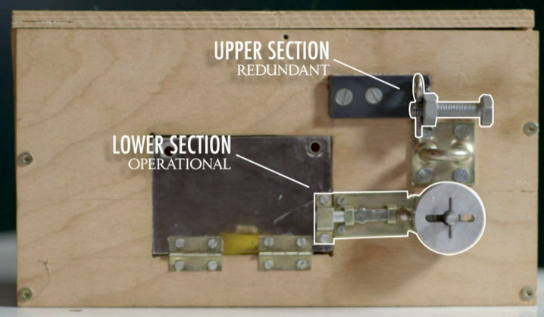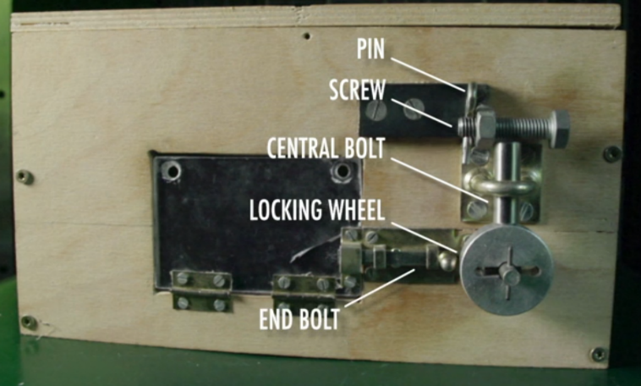Muppet is a Goffin’s cockatoo, and he’s involved in a study regarding animal cognition. As such, he’s a very clever bird! Like others at the research center, he is able to make and use tools. Cockatoos learn most readily from other cockatoos and they have the ability to solve quite complicated mechanical problems. One of the birds at the center spontaneously worked out how to open a five-part mechanism in sequence to retrieve a food item! It probably looked very much like the lock-box to the left. Although another bird was the innovator with this box, Muppet has learned to unlock this box by example. But the scientists wanted to know whether he really understood the mechanisms or he had simply memorized a sequence of steps for unlocking this arrangement. So they took the central bolt out of the equation, as shown here on the right. If Muppet had memorized a sequence of steps for unlocking the box, he would start with removing the pin in the (now) redundant upper section. But it turns out that Muppet’s mechanical comprehension is not unlike our own. The first time he was presented with the new setup, he looked over the problem and immediately began with the locking wheel. Rather than going step by step, Muppet has the sense to stand back and look at the big picture—seeing how it all fits together. And with God’s help, we can too!

Amazon Prime

Inside Animal Minds

Season 1

Episode 1: “Bird Genius”

Start: 32:30 (20:53 from End)

End: 36:42 (16:41 from End)