God gave us—humanity—so many gifts. He made us strong, clever, creative, and so much more. Between this and our unfortunate tendency to pride, we frequently overreach ourselves. We arrogantly attempt things we have no business doing, go places we have no business going, and feel it unfair when disaster follows. Verse 10 warns against attempting to lead others astray. What a terrible thing to try! Of course it doesn’t work. God is with the “upright,” and even if they fall, they soon climb back to the right path. The “tempter” in this scenario falls in the pit and stays there. Verse 11 mentions the rich man “wise in his own conceit,” who is certainly walking on thin ice! Only the godly can be wise. And of course, as verse 12 suggests, people very, very often overreach themselves as leaders—particularly as rulers. A very great many people believe themselves suited to leadership, but only a few are truly able for it. When a righteous person leads, everyone can “rejoice,” and things go really well. But sometimes a person with no business in leadership takes over anyway. Unworthy leaders cause others to “hide,” to conceal their resources and avoid drawing attention from those in power. Everything in the country goes downhill. Worse still is the situation in verse 13. This individual has placed him or herself in the position of attempting to deceive God. A truly hopeless situation! God loves and forgives us, but He can never be deceived. Placing ourselves in opposition to God is both foolish and pointless. Confess and forsake your sins. Don’t put yourself in that place!

**Proverbs 28:10-13**

**Whoso causeth the righteous to go astray in an evil way, he shall fall himself into his own pit: but the upright shall have good things in possession.**

**The rich man is wise in his own conceit; but the poor that hath understanding searcheth him out.**

**When righteous men do rejoice, there is great glory: but when the wicked rise, a man is hidden.**

**He that covereth his sins shall not prosper: but whoso confesseth and forsaketh them shall have mercy.**

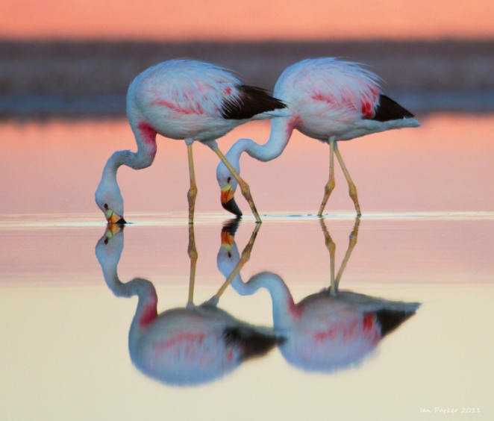**Andean Flamingos**

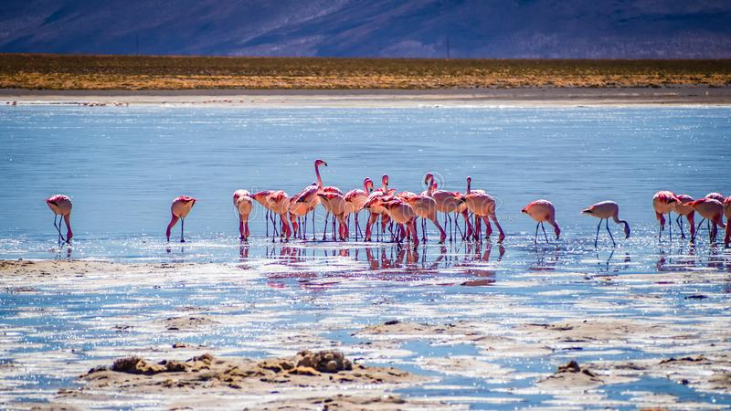The Andean flamingo is the rarest flamingo in the world. They possess the typical elegant body shape, with a long curved neck and long legs. Their body is pale pink, and they have bright pink upper parts and distinctive large black wedges at the rear. Andean flamingos have yellow legs large, curved bills. Like other flamingos, young birds are gray until they develop the adult pink plumage. They are beautiful, fabulously pink tropical birds. Right? It turns out that—no, they aren’t. They are certainly beautiful. And absolutely pink. But they aren’t tropical. These flamingos inhabit the high Andes in South America, where it’s more frigid and wind-swept than tropical. Like other flamingos, Andean flamingos are filter feeders. They feed from the bottom layer of a lake for small particles, mainly diatoms. They forage in shallow salty waters. But at 14,000 feet, this is the highest flamingo colony in the world. And there can be issues with being a filter-feeding bird in a lake at 14,000 feet. At night, it gets pretty cold. And the flamingos are standing in a lake. And water freezes. Fortunately, the morning sun eventually thins the ice enough for the birds to break free. Now it’s true that apparently Andean flamingos are quite native to these cold mountain lakes. But it certainly seems to the casual observer that flamingoes have no business being away from the tropics. And, being in chilly high-altitude lakes, the birds do find themselves actually frozen into position, where they are potentially prey for any number of other mountain animals until the sun releases them. You would think they would find a less risky feeding spot. But, then, you would think that humans would develop less risky habits too. But no, we continue doing things we have no business doing, going places we have no business going. Despite the fact that we know giving into such impulses leads to even worse consequences than getting frozen into place. We should do better than the birds!

Planet Earth II

Episode 2: “Mountains”

Start: 32:11 (26:00 from End)

End: 34:37 (23:34 from End)