Let’s be honest here! Not unlike certain acquisitive crows of our acquaintance, we humans are attracted to shiny objects. We like fame—we love fortune—and have an often unhealthy attraction to wealth. And we have real difficulty in distinguishing between those things of true value and those things which are sparkly but worthless. All of which contributes to the perennial popularity of get-poor-quick schemes, as we see right here in Proverbs. Verse 19 offers following after “vain persons” as an efficient way to find an amply sufficient supply of poverty. Who are “vain persons?” Pretty much everybody except Christ. Following Him leads to a city with streets of pure gold, but following anybody else assures of “poverty enough.” If that isn’t an adequate warning, verse 20 adds that get-poor-quick schemes come with collateral damage: both your innocence and your blessings. Yikes! This constant hunger for gain also tends to make people unjust. To have “respect of persons” sounds at first like a positive, but here it refers to injustice. Some people are treated with kid gloves and others with cruelty, usually based on the benefits that they are able to provide. Proverbs tells us that the unjust person will be swayed by even the most trivial benefits, like a bit of bread. The avarice of the wicked knows no bounds! Verse 22 continues this idea, observing that the person who “hasteth to be rich” has an “evil eye.” Why? Because his eye is fastened firmly on things of limited, temporary value. He is blinded to things of genuine value because his eye is fixed on fool’s gold. We need healthy eyes, fixed on Christ, to distinguish between useless dross and true gold.

**Proverbs 28:19-22**

**He that tilleth his land shall have plenty of bread: but he that followeth after vain persons shall have poverty enough.**

**A faithful man shall abound with blessings: but he that maketh haste to be rich shall not be innocent.**

**To have respect of persons is not good: for for a piece of bread that man will transgress.**

**He that hasteth to be rich hath an evil eye, and considereth not that poverty shall come upon him.**

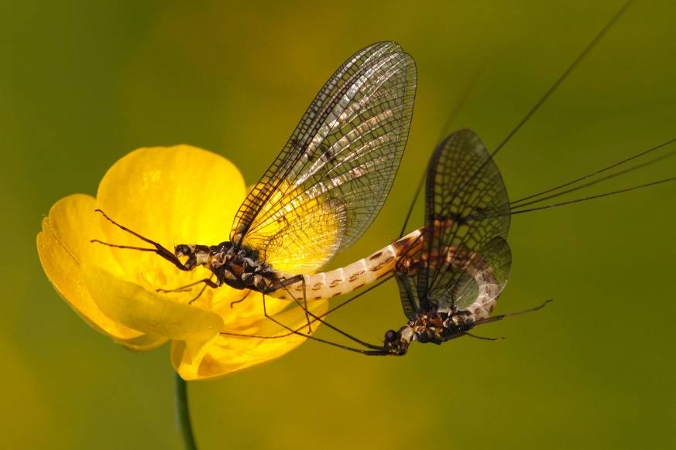**Mayflies**

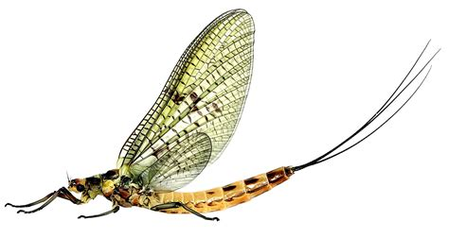Immature mayflies are aquatic and are referred to as nymphs. In contrast to their short lives as adults, they may live for several years in the water. They have an elongated, cylindrical or somewhat flattened body that passes through a number of stages, molting and increasing in size each time. Mayflies "hatch" (emerge as adults) from spring to autumn, not necessarily in May, in enormous numbers. The brief lives of mayfly adults have been noted by naturalists since Aristotle and Pliny the Elder in classical times. Often, all the mayflies in a population mature at once, and for a day or two in the spring or autumn, mayflies are everywhere, dancing around each other in large groups, or resting on every available surface. In many species the emergence is synchronized with dawn or dusk, and light intensity seems to be an important cue for emergence, but other factors may also be involved. The lifespan of an adult mayfly is very short, and intended primarily for reproduction. Adults do not feed, and lack usable mouthparts, while their digestive systems are filled with air. Their goal is to mate and lay their eggs in the river. But there can be complications. Mayflies navigate by flying at a fixed angle to the moon. Unfortunately, there are a great many beacons in the night sky which may fool the insects. They get lured into town by more terrestrial lights, where they may mistake the reflections on the roadways for the light off the water. Mayflies, it appears, struggle to differentiate between the moon and neon signage. They evidently believe that there is little difference between a river’s surface and moonlit asphalt. From our perspective, of course, this confusion seems ridiculous. How could anything confuse water with roadbed, or moonlight with a red neon storefront marker? How could the mayflies be so very mistaken? I wonder if God watches us and thinks the same thing! Humans struggle to distinguish between the eternally invaluable, and the worthless. Happily, we have Proverbs to help us distinguish between these things. The mayflies have no such resource!

Amazon Prime

The Gathering Swarms

Start: 17:04 (36:00 from End)

End: 21:31 (31:33 from End)