We hear a lot about faith in religious settings. And there’s a reason for that! ***“For by grace are ye saved through faith; and that not of yourselves: it is the gift of God: Not of works, lest any man should boast.”-Ephesians 2:8-9.*** So we need to understand what faith really looks like. And these verses in Proverbs give us some marvelous examples of applied faith, also known as trust. We trust that we can stand up for the truth (rebuking somebody) and still find “more favor” than a flatterer. We trust that honoring our parents will truly benefit us, as the commandment says. We trust that giving freely of our resources will not cause us to lack anything. And of course we know that we cannot trust “the wicked,” especially wicked leaders! We know where we can place our trust, and it isn’t in other people or even in ourselves. Those that walk wisely place their trust solely in the Lord. And that means following His directions all the time, even in some extremely difficult situations. (Rebuking wrongdoing, for instance, is exceedingly socially awkward.) But in addition to trusting God’s directions, we may absolutely trust His assurance that doing the right thing turns out well in the end!

**Proverbs 28:23-28**

**He that rebuketh a man afterwards shall find more favour than he that flattereth with the tongue.**

**Whoso robbeth his father or his mother, and saith, It is no transgression; the same is the companion of a destroyer.**

**He that is of a proud heart stirreth up strife: but he that putteth his trust in the Lord shall be made fat.**

**He that trusteth in his own heart is a fool: but whoso walketh wisely, he shall be delivered.**

**He that giveth unto the poor shall not lack: but he that hideth his eyes shall have many a curse.**

**When the wicked rise, men hide themselves: but when they perish, the righteous increase.**

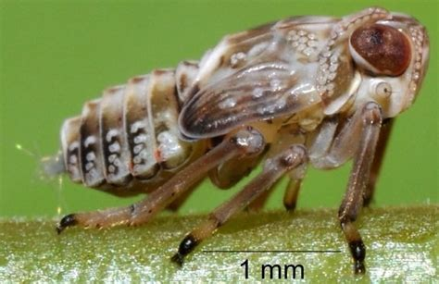**Planthoppers**

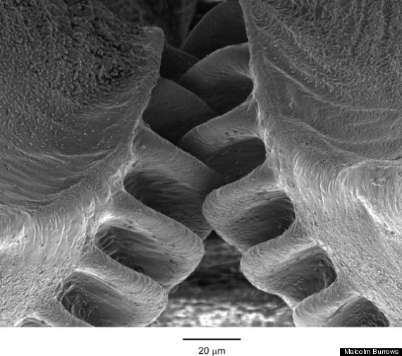The name “planthopper” describes several different species of small insects (of the superfamily Fulgoroidea). The particular insect with which we are concerned here is in the family Issidae, genus Issus. These tiny insects are flightless, with a stocky, brown body. They feed on the sap of plants, particularly grass. And since they can’t fly, these little bugs often find themselves in danger from larger creatures. Fortunately, as their name suggests, planthoppers have an extraordinary ability to jump out of the path of danger. For a bit of comparison, we know that a person standing at sea level experiences a (gravity) G-force of one. The record for highest G-force on a roller coaster is 6.3, which is 6.3 times the force of gravity. Fighter pilots may have to endure G-forces of 8 or 9. It’s estimated that one minute at a G-force of 10 would be fatal for most people, although one Air Force officer survived a G-force of 46.2 for just a few seconds. So back to planthoppers. Planthoppers can jump accurately in a straight line with a G-force of nearly 400 in two milliseconds. To achieve this fabulous acceleration, planthopper nymphs (immature insects) have gears to lock their legs together. As a result, the legs move in almost perfect unison for a straight jump, giving the insect more connected power as the gears rotate together. The jump is high powered, but rather unpredictable in trajectory. As planthoppers, these insects are often launching off of unsupported blades of grass and other bits of plant matter. Presumably the resultant leap usually takes the insect out of range of the threat, albeit in a random direction. The planthopper must simply launch in faith, trusting that God will control their landing. That is real trust! And if this miniscule insect can trust that God is watching over their every leap, then we can trust Him too!

Amazon Prime

SuperNature: Wild Flyers

Season 1

Episode 1: “Defying Gravity”

Start: 12:31 (41:15 from End)

End: 16:49 (36:57 from End)