Our heavenly Father loves us. He abounds in mercy and forgiveness. And these are the qualities we like to focus on! These are the truths about God that give us hope that we might one day be accepted into His presence. But God is also represented as the Great Judge, and justice is an aspect of His character that makes us afraid. Most of us are fully aware that our own sinful actions condemn us. We’re afraid that the suddenly destroyed sinner of verse 1 has a very familiar face. So we would much rather focus on His mercy than on His justice. This leads many people choose to believe in a god of their own making, a god of endless mercy, love, favor and grace who eschews justice, judgement, integrity or righteousness. Happily, the Bible gives us guidance that can help us avoid this deception. By God’s vast mercy, we hope to be with Him in heaven, and ultimately to live with Him on the new earth. But verses 2 and 4 tell us clearly that both places must be ruled by a just King. Otherwise we wouldn’t even want to live there! In order for our hope—the hope of eternal life with our Father—to be worth having, we must appreciate that mercy and justice are not opposite, but complementary aspects of God’s character. He must be righteous or His grace has no meaning. And like any father, our heavenly Father cares about our behavior. See verse 3! Our God is just, and as we become more like Him that justice will be reflected in our own characters. There is no need to fear God’s justice! Like His mercy, it is necessary to our hope of eternal life.

**Justice:**

**The maintenance or administration of law or what is right.**

**The principle or ideal of just dealing or right action: conformity to this ideal: righteousness**

**Proverbs 29:1-4**

**He, that being often reproved hardeneth his neck, shall suddenly be destroyed, and that without remedy.**

**When the righteous are in authority, the people rejoice: but when the wicked beareth rule, the people mourn.**

**Whoso loveth wisdom rejoiceth his father: but he that keepeth company with harlots spendeth his substance.**

**The king by judgment establisheth the land: but he that receiveth gifts overthroweth it.**

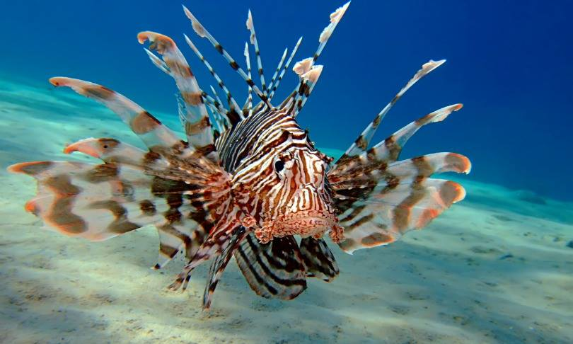**Red Lionfish**

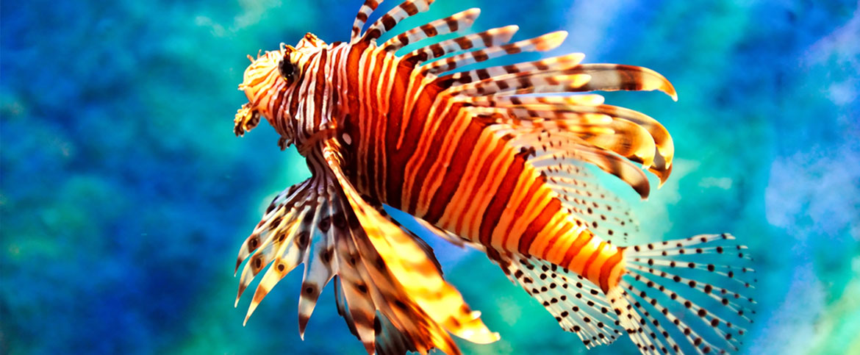Red lionfish are spectacular venomous coral reef fish native to the Indo-Pacific region. They can grow to 18.5 inches in length and live around 10 years. Red lionfish have large, venomous spines that protrude from the body, similar to a mane, giving it the common name lionfish. Lionfish venom is extremely painful and may cause breathing difficulties, but is not usually fatal to humans. However, the venomous spines make the fish inedible for many other potential predators. Lionfish also reproduce monthly and are able to quickly disperse during their larval stage. These qualities make the lionfish a particularly devastating invasive species. This is bad news as they have established themselves off the east coast of the US and in the Caribbean. It seems that the red lionfish was introduced off the Florida coast in the early to mid-1980’s. Some misguided individuals released their aquarium fish into the ocean. Unfortunately, they prospered, and adult lionfish may now be found along the east coast from the Cape Hatteras, North Carolina, to Florida, and in Bermuda, the Bahamas, and throughout the Caribbean, including the Turks and Caicos, Haiti, Cuba, the Dominican Republic, Guadeloupe, Puerto Rico, St. Croix, Belize, Honduras, Aruba, Cayman Islands, Colombia and Mexico. The lionfish are voracious feeders and have outcompeted the native fish, especially snapper and grouper. This is drastically changing and disrupting the food chains holding the marine ecosystems together. As these chains are disrupted, other fish populations are declining. Though beautiful, red lionfish are a menace to the areas they have invaded. All of this began with a misguided act of mercy—releasing the aquarium fish instead of killing them. And the invasive results offend our human sense of justice to the extent that the Bahamas government is encouraging people to hunt these unclean fish. (“Eat ‘em to beat ‘em” is the motto.) This seems a very awkward blend of mercy versus justice! The Bible demonstrates justice and mercy blended in such a way that each are enhanced rather than compromised. We must continue to imitate that model and not our own!

Amazon Prime

Conquerors

Season 1

Episode 1: “Lionfish”

Start: 9:57 (39:57 from End)

End: 16:51 (33:03 from End)