These verses make up the close of Solomon’s part of the book of Proverbs. And the final verse should make the principal point of the book clear. There are two possible directions that a person can go in life: God’s way and the way of the wicked. There is no crossover, no gray area, and no fence-sitting. The good man finds it impossible to even maintain close relationships with wicked men. Their aims, activities, and standards are in conflict. Wicked men will find the moralistic stance of the righteous intolerable—unless they are willing to change. The righteous trust in God and the wicked refuse to trust. It’s a strictly binary choice. And it seems to have a lot to do with fear. The wicked fend desperately for themselves—stealing and lying as in verse 24, or toadying up to someone who seems to be in authority as in verse 26—because they are afraid and refuse to trust in God’s care. And fear, as verse 25 mentions, brings “a snare.” It’s a trap. We make wrong decisions oftentimes because we are afraid and want to imagine that we are in control of our own future. We like to feel in control—it seems safe. But it’s an illusion. Worse, it’s a fear-based illusion that can never give us true security. Safety comes only and always from God. As we see in verse 25! Those who trust in the Lord can be fearless. The righteous need no illusions of control because they know the One who IS in control. Fear and trust are opposites. We can only choose one of them. We can trust in our heavenly Father and be fearless. How? Romans 10:17 lays it out simply enough: “So then faith cometh by hearing, and hearing by the word of God.” Keep studying to trust Him and be fearless!

**Proverbs 29:24-27**

**Whoso is partner with a thief hateth his own soul: he heareth cursing, and bewrayeth it not.**

**The fear of man bringeth a snare: but whoso putteth his trust in the Lord shall be safe.**

**Many seek the ruler's favour; but every man's judgment cometh from the Lord.**

**An unjust man is an abomination to the just: and he that is upright in the way is abomination to the wicked.**

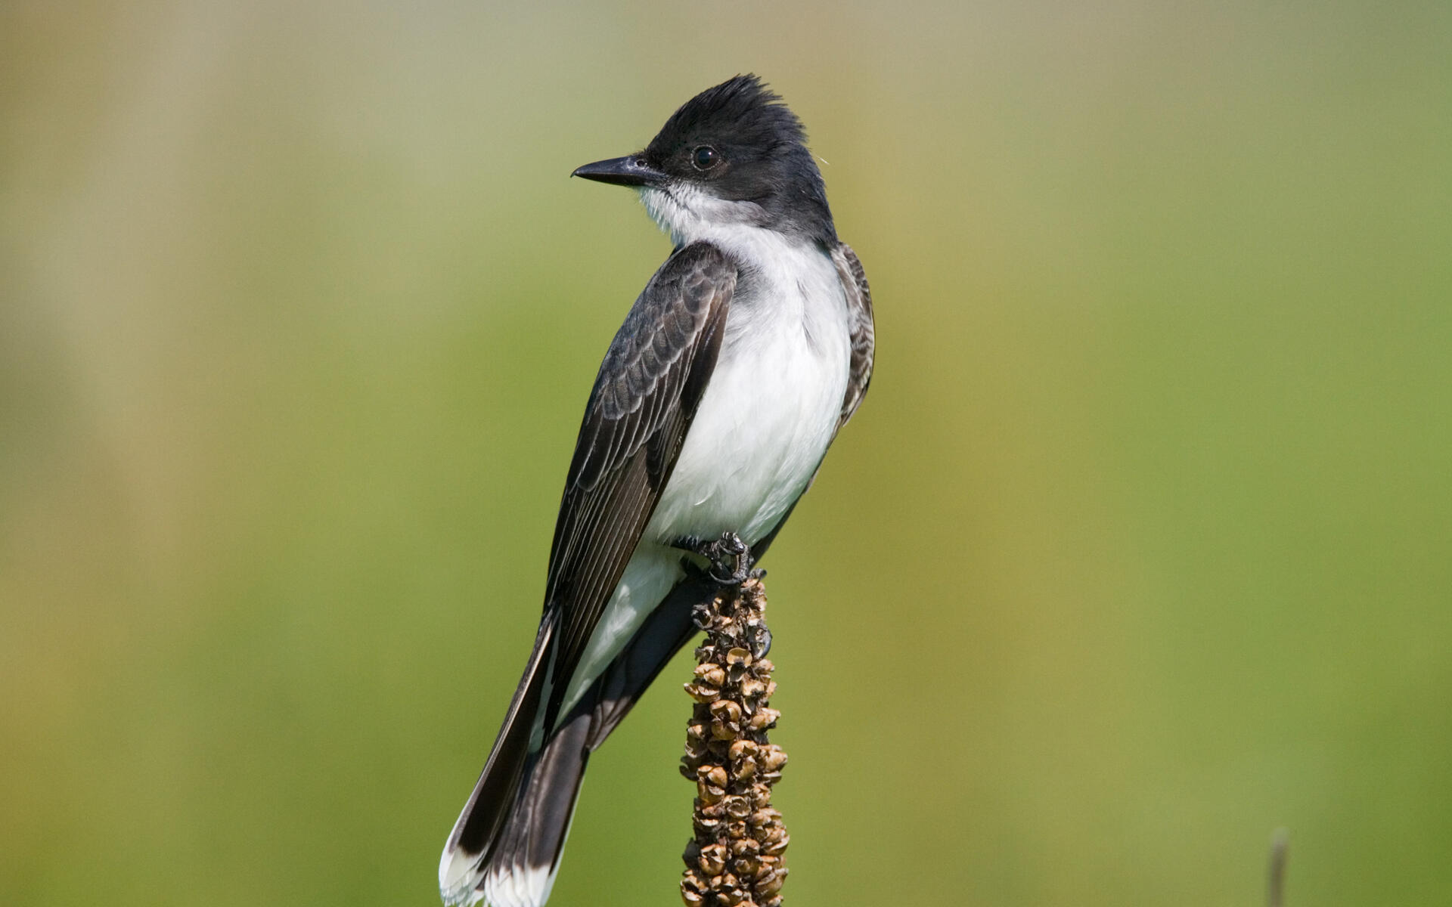**Kingbirds**

Kingbirds are found throughout North America, with wintering grounds in Central and South America. They’re fairly small, insect-eating birds, only seven and a half to nine inches long with a 13 to 15 inch wingspan. Kingbirds only weigh in at about 1.2 to 1.9 ounces. They like open areas scattered with trees and shrubs, where they can perch while hunting for insects, especially dragonflies. Kingbirds have astounding maneuverability, enabling them to catch their quick-moving prey in flight. It’s a necessary skill, especially in springtime, when the kingbirds have a family to feed. But the spectacular flying skills of the kingbird pay off in other ways too. It seems that kingbirds, especially the males, use their finesse in flight to defend their nests. They’re extremely aggressive, even with birds that are much, much larger than themselves. Ravens are predators that would willingly eat kingbird eggs and chicks. Ravens are four times the size of the kingbird, but that doesn’t stop him. The kingbird will attack, peck, harass, and otherwise drive off any perceived threats to their nests. Including large birds of prey and low-flying planes! They’re fearless. Of course, I’m sure that the kingbirds have no doubts on the One that they can trust. The good news is that we can absolutely trust Him too!

Amazon Prime

SuperNature: Wild Flyers

Season 1

Episode 3: “Crowded Skies”

Start: 20:00 (33:45 from End)

End: 24:33 (29:12 from End)