These verses contain a curious common thread: the notion of a trap. Like sin, traps are easy to get into, but difficult to escape from. Without God’s help, none of us have the strength to escape from the pitfalls of sin. Fortunately, we do have God’s help—but only if we accept it. We either accept His help to escape from Satan’s trap and help others to do otherwise, or we sink ever deeper and lead others into bondage as well. Verse 5 observes that flattering a neighbor is the same as creating a trap for them. Flattery is hard to resist, but it seldom leads to positive decisions! In this sense, the flatterer is creating danger, spreading “a net” in which to catch the unwary. In contrast, a godly neighbor creates an opportunity for God’s blessings to flow. As verse 6 mentions, the sinner has put himself into a trap, even though he may not become aware of it until too late. The righteous man may sing and rejoice in safety, knowing that God has given him wisdom and strength to resist evil. Even in the same circumstances, the wicked person is trapped, while the righteous person is free and rejoicing! This freedom allows the righteous person to be concerned with the rights of others, as verse 7 implies. A godly person has a clear view of justice regardless of the wealth of the parties involved. The wicked person is trapped within their own concerns and unable to either perceive or care about justice. Verse 8 demonstrates a similar issue city-wide: scornful men, focused solely on their own good, encourage discontent and lead the whole city into injustice, infighting, and other wicked behaviors (represented here as a “snare”). In contrast, wise, godly men turn away wrath, keep the peace, and hold to hope and good judgement. We can live in a dreary snare, with bickering, deceit, and injustice, or in peaceful security, knowing that we can look forward to Jesus’ coming. It comes down to our choices!

**Proverbs 29:5-8**

**A man that flattereth his neighbour spreadeth a net for his feet.**

**In the transgression of an evil man there is a snare: but the righteous doth sing and rejoice.**

**The righteous considereth the cause of the poor: but the wicked regardeth not to know it.**

**Scornful men bring a city into a snare: but wise men turn away wrath.**

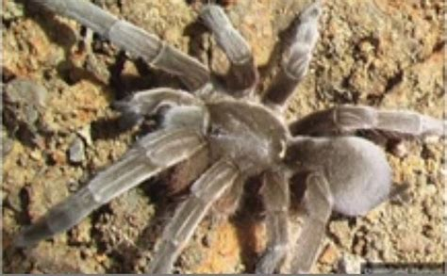**Diving Tarantulas**

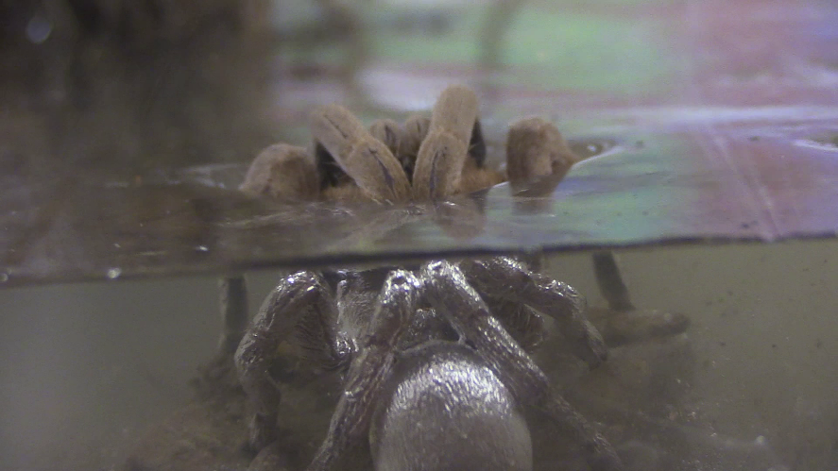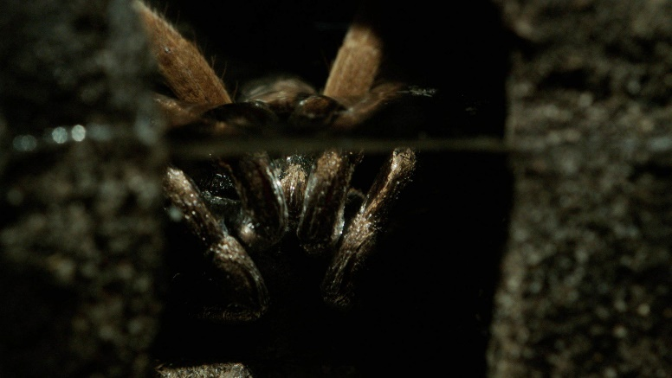In the sparsely populated Northern Territory of Australia, there’s a new science star. It’s a tarantula native to the area and so newly discovered that it lacks a scientific name—it’s just called the diving tarantula. These large spiders live in burrows on a floodplain near the small town of Maningrida. This originally gave scientists pause. How does a burrowing spider survive during the wet season on a floodplain? Doesn’t that create, well, drowning issues? It appears not. It seems that these particular tarantulas have an extremely surprising plan for the flood season. The spiders coat themselves in a thin, silvery layer of bubbles, trapped there by the hairs covering their bodies. Since the tarantulas breathe through holes in their abdomens, they have no trouble staying submerged in their burrows for extended periods of time. It’s not yet clear exactly how long the spiders can remain underwater, although it seems to be a pretty long time. Local students are calling the tarantulas “impossible” to drown. These spiders are doing amazingly well in extremely difficult conditions. They’ve taken an underwater burrow, which would be a deathtrap for most creatures, and made it into a place of great security. Safe in this burrow, even during the flood season, these diving tarantulas are doing very, very well. This floodplain is thought to be home to the world’s highest concentration of tarantulas, estimated to be 25,000-strong. The righteous accomplish a similar feat, turning this sinful deathtrap into a place of great security. The wicked are quickly caught in the trap. If we develop a close relationship with God then we can be like these unique spiders, allowing God to provide security in a world of floodplains and other traps.

Amazon Prime

Magical Land of Oz

Season 1

Episode 1: “Land”

Start: 41:35 (13:09 from End)

End: 46:39 (08:05 from End)