**Proverbs 30:1-6**

**The words of Agur the son of Jakeh, even the prophecy: the man spake unto Ithiel, even unto Ithiel and Ucal,**

**Surely I am more brutish than any man, and have not the understanding of a man.**

**I neither learned wisdom, nor have the knowledge of the holy.**

**Who hath ascended up into heaven, or descended? who hath gathered the wind in his fists? who hath bound the waters in a garment? who hath established all the ends of the earth? what is his name, and what is his son's name, if thou canst tell?**

**Every word of God is pure: he is a shield unto them that put their trust in him.**

**Add thou not unto his words, lest he reprove thee, and thou be found a liar.**

These verses begin chapter 30 of Proverbs, which was probably not written by Solomon. Whoever the author is, he frankly admits that he has not achieved the intellectual advancement that he should have. His spiritual advancement, too, has not reached its fullest extent. This honest admission is one that I believe most of us can share. The subject here is humility. We need to recognize that as humans we are all weak, ignorant, sinful, and underdeveloped in both our intellectual and spiritual lives. It’s especially important that we remember these things when we’re talking to or about God! Verse 4 reminds me of Job 38 and 39, in which God speaks out of the whirlwind and demands to know, “Who is this that darkeneth counsel by words without knowledge?” We humans are indeed fearfully and wonderfully made, with intellectual and spiritual gifts unparalleled in Earth’s creation, but we are vapid and “without knowledge” when compared to our Creator! It’s important that we study God’s word with humility, keeping this fact firmly in mind. Our task is to simply trust in God’s word, not to adjust it!

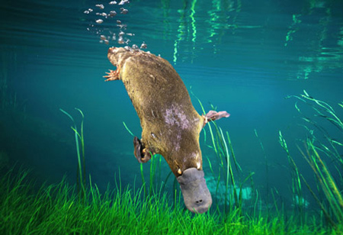**The Platypus**

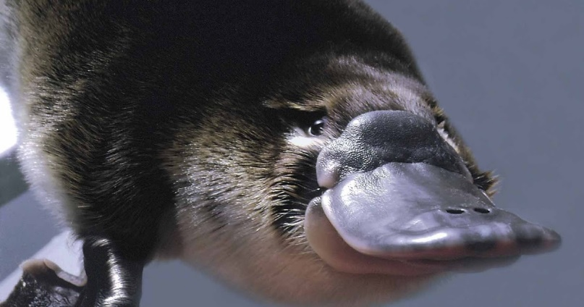The platypus is a semiaquatic, egg-laying mammal endemic to eastern Australia. Together with the four species of echidna, it is one of the five extant species of monotremes, the only mammals that lay eggs instead of giving birth to live young; they are all native to Australia. The remarkable appearance of this egg-laying, duck-billed, beaver-tailed, otter-footed mammal baffled European naturalists when they first encountered it, and the first scientists to examine a preserved platypus body (in 1799) judged it a fake, made of several animals sewn together. But it was this creature’s unusual process of reproduction that made real trouble. Much of this surrounded a brilliant scientist named Richard Owen. Owen was a recognized scientist of the era, and the driving force behind the establishment in 1881 of the British Museum of Natural History. Owen was one of the first to examine a platypus specimen, and he had determined the unusual creature to be a mammal. It had a furry body and glands that were thought to produce milk. As such, Owen insisted that a platypus could not lay eggs. Of course, he was eventually and publically proven wrong, since the platypus does indeed lay eggs despite being a mammal. The problem, of course, is that Owen’s pride got in the way of honest study. He made a determination based in his own experience rather than actual, humble study. We should learn from Owen and the platypus! We need to study in humility and trust.

Amazon Prime

Natural Curiosities

Season 1

Episode 2: “A Curious Hoax?”

Start: 7:13 (15:04 from End)

End: 11:35 (10:42 from End)