Yikes! That generation sounds really bad. Who are these dreadful people? Thank goodness we aren’t like that, right? We’re getting better all the time; just ask popular culture. Of course, that belief is also held by the generation described in these verses: they’re “pure in their own eyes” and “lofty” in their own minds. Looking over the other traits possessed by this generation leads to additional causes for concern. I’m rather sorry to acknowledge the level of disrespect for parents in our own youth-centric culture, but it is high and it has been on the rise since the 60’s. As far as devouring “the poor from off the earth,” I expect our own generation is going to have a hard time defending themselves. There’s little doubt that the weakest members of our society are suffering more hardship than ever. Abortion rates are up and assisted suicide for the ill and elderly is gaining ever greater legal traction. This dreadful generation has apparently been around since Proverbs 30 was written, but it seems they’re still around today! This “generation” isn’t a group of people born around the same time, but a consistent mindset that is prideful and wicked. This generation has persisted throughout human history. And it seems unlikely that we’ll get rid of it any time soon. But we don’t have to be part of it! With Proverbs’ guidance, we can avoid prideful, hateful traits, and become part of an altogether different generation—the Redeemed!

**Proverbs 30:11-14**

**There is a generation that curseth their father, and doth not bless their mother.**

**There is a generation that are pure in their own eyes, and yet is not washed from their filthiness.**

**There is a generation, O how lofty are their eyes! and their eyelids are lifted up.**

**There is a generation, whose teeth are as swords, and their jaw teeth as knives, to devour the poor from off the earth, and the needy from among men.**

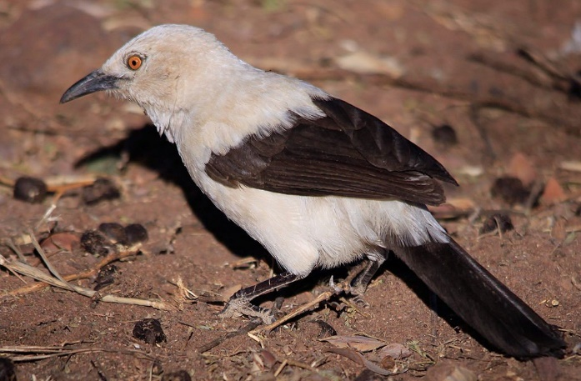**Southern Pied Babblers**

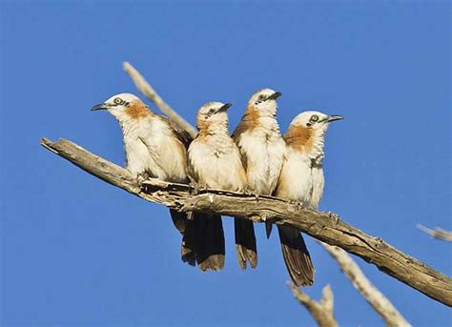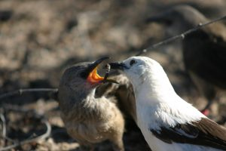Southern Pied Babblers are medium-sized birds (2.6 to 3.4 ounce) native to the dry savannah of Botswana, Namibia, South Africa, and Zimbabwe, also known as the Kalahari Desert. Life can be tough in this arid region, so pied babblers live in groups. They breed cooperatively. Each group has a dominant breeding pair and the others in the group help raise the young. This help is desperately needed, because groups can raise up to three successful clutches per breeding season, but the young birds need to stay with their families for up to four months after fledging. Even after they fledge (grow feathers), the young birds don’t fly very well for quite a while. It also takes them a long time to learn to forage effectively for food. So the adults need to supply food for the young birds for an extended period. All of the adult birds—parents, aunts, uncles, cousins, older siblings—scramble to keep these ravenous youngsters fed. And with up to three clutches a season, there can be a lot of youngsters (of various ages) to feed! But there’s never enough, so the young birds have a plan to snag even more food from the busy adults: they run straight into danger and scream their heads off. When the youngsters think there’s a predator nearby (due to alarm calls either from their own sentinels or those of other animals), they all run out into the open and scream for food. The adults rush frantically to cram any available food into the open mouths, trying to silence the youngsters. It’s straightforward blackmail: *“feed me right now or I’ll bring a predator down on the whole group.”* Apparently the young birds feel that their own wants are more important than the lives of the adults in the group. It sounds like the generation described in Proverbs, doesn’t it? So next time you’re tempted to put your own wants first, remember: you DON’T want to be a pied babbler!

Amazon Prime

Nature: Natural Born Hustlers

Season 5

Episode 3: “Sex, Lies, and Dirty Tricks”

Start: 46:26 (06:36 from End)

End: 51:11 (01:51 from End)