These verses begin a sequence of superlatives. The first of these gives us four things “that are never satisfied.” Death can never be filled. The childless Israelite woman was always desperate to have children. Dry ground, especially in dry, salty, and sandy desert climates can never be so filled with water as to become permanently fertile, loamy soil. And of course a fire never receives so much fuel as to be satisfied. It will only devour everything it is given and reach for more. The wicked, exemplified in verse 17 by those who disrespect their parents, are also permanently unsatisfied and discontent. The only completed, contented life is found in cooperation with God. Sadly, many people utterly fail to work this out. They don’t understand; it is “too wonderful” for them. The events listed in verse 19 are similarly untraceable to human eyes. We can’t tell where an eagle has flown or a serpent has slithered. We don’t know which bit of water has held a ship or whether a man and a woman have been together. But our ignorance does not in any sense imply that these things are unknown! God holds a complete record. The adulteress’ claim to innocence will be proven false in His judgement. We cannot allow our own blindness to deceive us into thinking that God is similarly afflicted. There is an external standard of truth, even if we can’t properly see it.

**Proverbs 30:15-20**

**The horseleach hath two daughters, crying, Give, give. There are three things that are never satisfied, yea, four things say not, It is enough:**

**The grave; and the barren womb; the earth that is not filled with water; and the fire that saith not, It is enough.**

**The eye that mocketh at his father, and despiseth to obey his mother, the ravens of the valley shall pick it out, and the young eagles shall eat it.**

**There be three things which are too wonderful for me, yea, four which I know not:**

**The way of an eagle in the air; the way of a serpent upon a rock; the way of a ship in the midst of the sea; and the way of a man with a maid.**

**Such is the way of an adulterous woman; she eateth, and wipeth her mouth, and saith, I have done no wickedness.**

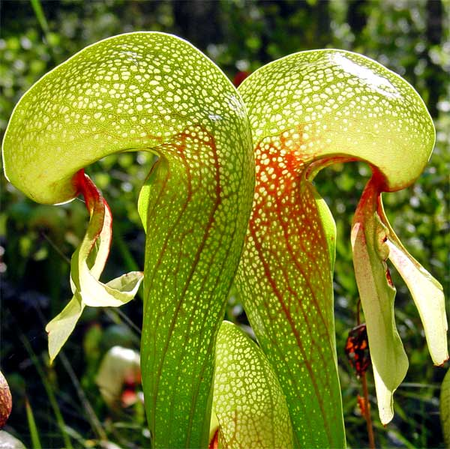**The Cobra Lily**

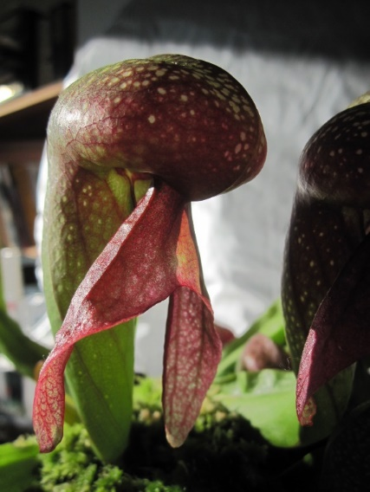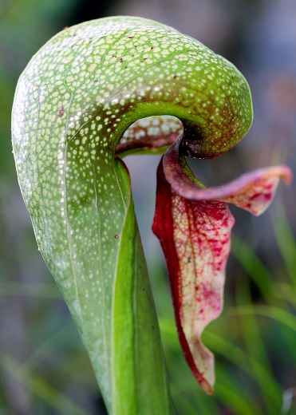The cobra lily is a variety of pitcher plant native to Northern California and Oregon. It grows in nutrient-poor bogs and seeps with cold running water. Like other pitcher plants, the cobra lily is carnivorous and supplements its nitrogen with that captured from small flying insects. The cobra lily traps insects by tempting them into the tube with nectar on the rim and inside the hood of the plant. When an insect has eaten enough nectar, it naturally flies up, toward the light. But the cobra lily has many translucent “windows,” false exits through which the insect can see the light of day but not reach it. After many attempts to escape, it eventually tires. Then the slippery walls and downward-pointing hairs lead the insect to fall into the liquid trap at the base of the cobra lily. This is a remarkably devious trap, using the insects’ own instincts against them. From a fly’s point of view, there is no difference between the light of the outdoors and the light that comes through the false windows of the cobra lily. Note that this doesn’t mean they are actually the same! The flies essentially fool themselves into believing the sweet nectar is safe to eat. They can, after all, see light. In the same way people fool themselves into believing that they are quite safe, that they “have done no wickedness” simply because other people cannot detect the evidence. It doesn’t matter, since no one will know. Of course, this is every bit as false as the translucent windows that make the flies feel safe! Our only true safety lies in staying far away from the tempting nectar of sin and living securely in God’s will.

Amazon Prime

Plants Behaving Badly

Season 1

Episode 1: “Murder and Mayhem”

Start: 34:49 (18:29 from End)

End: 36:24 (16:54 from End)