Here we see four creatures “which are little upon the earth,” but they are named “exceeding wise.” The ants, individually speaking, are not particularly mighty. But they do work hard at collecting and storing food. This isn’t the first time that the foresight and dedication of ants is mentioned in Proverbs! Yet a person who isn’t paying attention might easily overlook them. The “conies” mentioned here are probably what we would call rock hyrax. Living in colonies in the rocks, they appoint sentries to stand guard while the rest of the group forages. They flee to their stony burrows at the first chirped warning. The locusts certainly have no king or any other command structure, but they certainly march across the land like a consuming army. Spiders certainly are small and not particularly powerful, but they go everywhere—even inside the palaces! The creatures listed all have different strengths, but they employ those strengths to succeed in their environments. God gives us gifts too! And He expects us to employ those strengths wisely in His service. If we can be as hard working as the ants, as firmly grounded as the conies, organized as the locusts, and pervasive as the spiders, we will be doing very well with the gifts that we’ve been granted!

**Proverbs 30:24-28**

**There be four things which are little upon the earth, but they are exceeding wise:**

**The ants are a people not strong, yet they prepare their meat in the summer;**

**The conies are but a feeble folk, yet make they their houses in the rocks;**

**The locusts have no king, yet go they forth all of them by bands;**

**The spider taketh hold with her hands, and is in kings' palaces.**

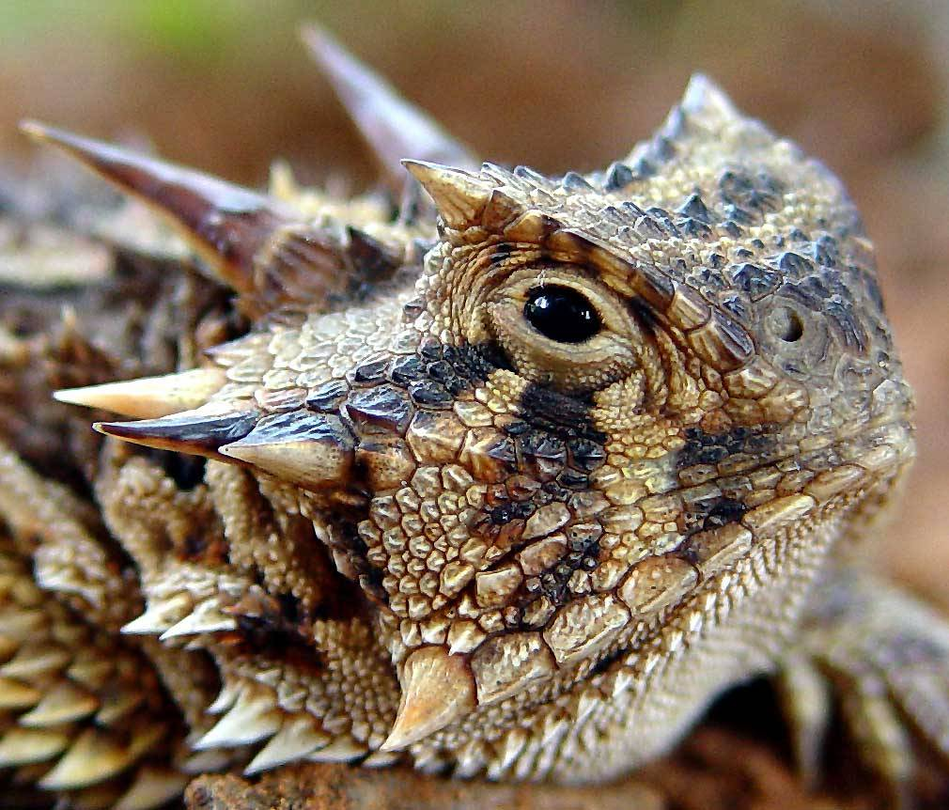**The Horned Lizard**

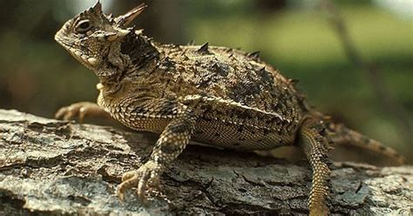Horned lizards, also known as horny toads, are native to North America. Of the 22 species of horned lizard, 15 live in the US. They are hardy inhabitants of the southwest, and they have an astonishing array of defenses which help them defeat their predators. At least eight species are able to squirt foul-tasting blood from their eyes! The first line of defense, for all species of horned lizard, is their camouflage coloration. They hold perfectly still to avoid detection. This is very helpful for the females, because female horned lizards guard their eggs. But they have to time their reactions carefully, because some predators will eat their eggs while others are interested in the mother. When confronted with an egg-eating snake, for instance, mother horned lizards will attack, driving off the potential egg-eater. When a lizard-eating snake comes along, however, such an approach is too dangerous. Instead, the horned lizard will puff up their bodies, causing their horns to stick out. Hopefully the snake will see that the inflated lizard is too difficult to swallow. Failing this, however, the horned lizard will abruptly deflate and flip on her back, legs in the air. Holding perfectly still, eyes shut, the horned lizard pretends to be dead. Since snakes will not eat carrion, the confused potential lizard-eater will go looking for an easier target. Once it has gone, the revived lizard flips herself back over again and resumes guard duty. Now that’s a lot of discernment—not to mention acting skill—for a lizard! The mother horned lizard does her very best with the gifts she’s been given. Hopefully we can follow her good example!

Amazon Prime

Nature: Natural Born Hustlers

Season 5

Episode 1: “Staying Alive”

Start: 47:02 (6:00 from End)

End: 51:26 (1:36 from End)