These verse describe four things that “go well” and “are comely in going.” It seems that these four are beautiful in their motion as well as ideally suited to it. Notice we’re speaking of beauty in action, not appearance! The first is the lion, which is “strongest” among animals. They are certainly powerful, confident creatures. The phrase translated here “greyhound,” *zarzir mothnayim*, literally means “one girt in the loins.” It’s not clear what kind of creature this is, but it must be a bold one! Goats are famous for their incredible balance and skill at negotiating tricky slopes. We’ve probably all heard of those that climb trees, or seen video of mountain goats fearlessly dashing around on sheer cliff faces. Possibly the most curious in the list, we conclude with a king “against whom there is no rising up.” What kind of king would never face an uprising? Only one who is strong as well as just, tempering judgement with mercy. His actions, like the activity of the animals in the list, are described as “comely.” These are all examples of strength, courage, and commitment. And in this context, all of these words might be synonyms for faith! We also are called to be “comely” in our action. We can only have this firmness of heart and purpose because of our faith in God. We can always trust Him to back us up!

Comley:

Pleasing and wholesome in appearance; attractive; decent; suitable; proper, becoming.

**Proverbs 30:29-31**

**There be three things which go well, yea, four are comely in going:**

**A lion which is strongest among beasts, and turneth not away for any;**

**A greyhound; an he goat also; and a king, against whom there is no rising up.**

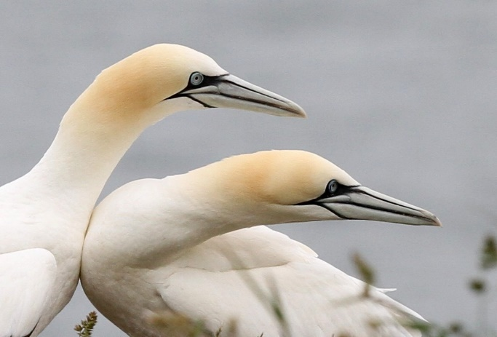**Cape Gannets**

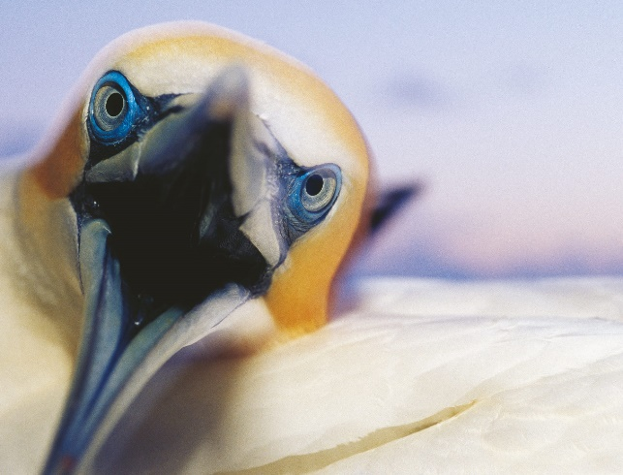Cape gannets are large white seabirds with yellowish heads, black-tipped wings, black tails, and long blueish bills. They have a six foot wingspan and an unbelievable high dive. They’re not stunningly beautiful like some of their tropical brethren, but hunting gannets are poetry in motion. They hunt fish by diving into the sea from a height and pursuing their prey underwater. It’s an extraordinary setting for a bird, and such a lifestyle takes special preparations! They dive from the sky, hitting the water at over 60 mph, fast as a fired bullet. At that speed, the water is as hard as concrete—the impact would crush any other bird. God has given them special tools as well as skills to accomplish this. Their nostrils are inside their beak, keeping their forceful dives from driving water into their airways. Gannets also have air sacks in the face and chest under the skin. These act like bubble wrap, cushioning the impact with the water. They also judge their impacts with care, reshaping their bodies and tucking in their wings to slice into the water instead of smashing into it. Once underwater, gannets swim with their wings. They maneuver surprisingly effectively, aided by their eyes which re-shape to adjust to underwater sight lines and clear eyelids to act as goggles. Gannets are stunningly agile, both in the sea and in the sky. One might say that they have “comely” motion! They dive strongly, more deeply than any other seabirds. But each dive is an act of faith. The bird is entirely committed, slashing into the sea like bullets. Hitting another creature is always a real risk in the frenzy of feeding. But doing so, or even entering the water at the wrong angle, has instant, fatal consequences. And once underwater, gannets are at risk from ocean-going predators. But they risk it all to go further than any other bird, because God has equipped them to do so. God has equipped us too! And with a little faith, we can go further than we ever thought we might. We just need firmness of heart—and true trust in our Father—to be just as “comely” in our own actions as these remarkable birds are in theirs.

Amazon Prime

SuperNature: Wild Flyers

Season 1

Episode 3: “Crowded Skies”

Start: 3:46 (49:59 from End)

End: 9:32 (44:13 from End)