These verses can be summed up readily by the command: “Stop creating problems!” According to verse 32, if you have already “done foolishly” by permitting arrogance or wickedness to flourish within your mind, you don’t need to compound the problem by running your mouth. Perhaps you have heard another proverb: “It’s better to remain silent and be thought a fool than to open your mouth and remove all doubt.” As sinful humans, we are only sort of able to control our minds. But as the book of James so often observes, we are also fairly bad at controlling our tongues, even though we technically have that ability! Proverbs gives us a lot of good advice about speech and communication, but this verse provides a handy rule of thumb for controlling that wayward mouth: When in doubt, shut it! Verse 33 adds that just as agitating milk brings out the butter, and wringing someone’s nose brings out blood, putting pressure on an angry person brings on a fight. In general, if someone is already angry, then something has already gone awry. But pressuring them can only make it worse! As Christians, we are supposed to be improving the world around us. Christ Himself compared His people to salt, which is spread throughout a dish to improve flavor, and to light, which is meant to shine out and improve everyone’s vision. We’re meant to be a positive force! As these verses suggest, the least that we can do is to avoid making matters worse. So try to leave unsaid the wrong thing at the tempting moment. It’s never easy, as James tells us, but with God’s help we can continue to make improvements to our self-control.

**Proverbs 30:32-33**

**If thou hast done foolishly in lifting up thyself, or if thou hast thought evil, lay thine hand upon thy mouth.**

**Surely the churning of milk bringeth forth butter, and the wringing of the nose bringeth forth blood: so the forcing of wrath bringeth forth strife.**

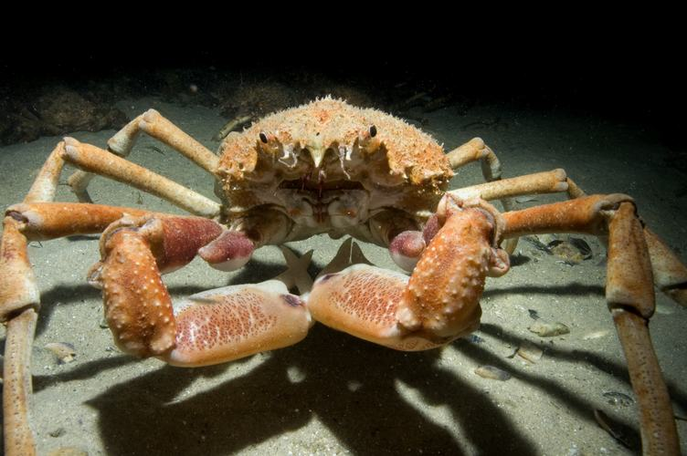**Giant Spider Crabs**

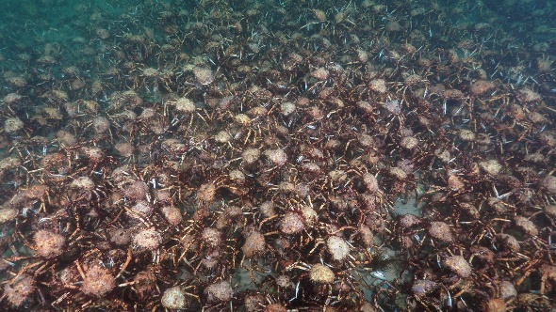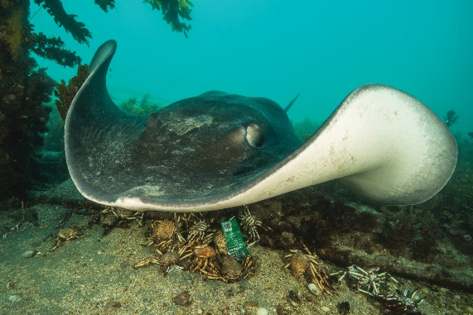Every winter, giant spider crabs gather in the shallow water off of Melbourne, Australia. Tens of thousands of these crabs come together at this time, but their purpose has nothing to do with mating. Like other arthropods, giant spider crabs are covered in a hard exoskeleton shell. But although giant spider crabs continue to grow as they get older, the exoskeleton does not change size. Instead, these crabs shed their smaller, older exoskeleton and grow into a bigger, newer one underneath. Giant spider crabs gather in these vast numbers every year so that they can molt, removing the old exoskeleton. This process is not without risk. The new exoskeleton is soft and spongy until it hardens, which makes the temporarily soft crab a tempting snack for predators, particularly stingrays. The crabs gather in their tens of thousands every year because they’re seeking safety in numbers. And it works—sort of. Even though smooth stingrays are the largest in the world, over 6 feet across, they cannot make much of an impact on the vast gathering. Though the stingrays eat many crabs, many more escape these large predators. But there’s another, more disturbing downside to congregating to molt in this fashion. Giant spider crabs are scavengers. They’ll eat anything they can find on the ocean floor. And it seems that they do not balk at cannibalism. The crabs have gathered for safety in numbers, but that doesn’t stop those who still retain their old, hard shells from feasting on their soft, newly molted neighbors. When growing a new shell, crabs apparently seek additional protein, and they’re not particular about the source. Giant spider crabs have taken a challenging situation—molting in the presence of their huge predators—and successfully made it much worse by preying on each other. These verses from Proverbs warn us not to make the same mistake. Between Satan, the accuser, and our own sinful impulses, we all have proud, wicked thoughts and struggles with temper. We are meant to help one another through these problems. We must do better than these vicious cannibal crabs!

Amazon Prime

Magical Land of Oz

Season 1

Episode 2: “Ocean”

Start: 21:40 (33:05 from End)

End: 27:55 (26:50 from End)