**Proverbs 30:7-10**

**Two things have I required of thee; deny me them not before I die:**

**Remove far from me vanity and lies: give me neither poverty nor riches; feed me with food convenient for me:**

**Lest I be full, and deny thee, and say, Who is the Lord? or lest I be poor, and steal, and take the name of my God in vain.**

**Accuse not a servant unto his master, lest he curse thee, and thou be found guilty.**

These words form a prayer to God. The writer is presenting requests to God, hoping to see them fulfilled during his life. Curiously, he asks that God preserve him from both poverty and riches. (Note “convenient” in this verse means “moderate” or “sufficient.” He’s not asking for easily accessed food, but for adequate food.) Now most people would ask that God preserve them from poverty. Poverty doesn’t seem very attractive, after all. But there are really a lot fewer people who would ask God to keep them safe from wealth! Wealth seems like it would be a pretty good time! But this individual asks that God preserve him from riches as well as poverty. Fortunately, he also explains his reasoning. The biggest danger of wealth is that it tends to make people think that they don’t need God. So having money tends to separate people from the only Source of true riches. Poverty, on the other hand, tends to make people think that God doesn’t care for them. As verse 9 suggests, this idea may lead a person to use unfortunate means to supply his own needs. Both extremes can cause problems! But all people, both rich and poor, must remember that they depend on God to provide for them. And He does! The final verse in this section, verse 10, reminds us that God uses His people to help provide for others as well. Accusing a servant to his master can have devastating effects for him. God requires that we take special care for those in lowly positions. God enacts a remarkable balance for His people. We mostly can’t afford to be rich, don’t want to be poor, but definitely want to be gentle with those in humble circumstances. Fortunately, God is in control!

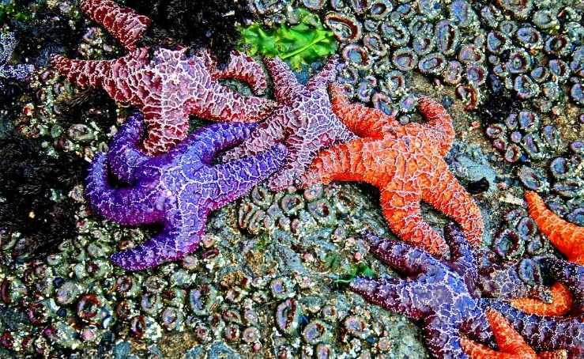**Starfish (Pisaster Ochraceus)**

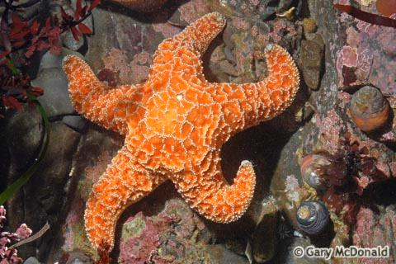Starfish are star-shaped echinoderms with a central disc and five arms, although the Pisaster Ochraceus can (very rarely) have as few as four or as many as seven. Their color ranges from pale orange to dark brown or deep purple. Pisaster Ochraceus live in tidepools along the coast from Prince William Sound in Alaska to Santa Barbara, California. They eat mostly mussels, although they will also eat barnacles, snails, limpets, and chitons when mussels are not available. It turns out that starfish are the top predators of the tidepools. They’re also key players in a revolution in the scientific understanding of ecosystems. A scientist named Robert Paine conducted an experiment in which he removed starfish from a certain set of tidepools for several years. Then he counted the number of species in the pools without starfish, comparing them to the number of species in the unaltered pools. While the tidepools containing starfish supported fifteen species, the pools without starfish contained only one: mussels. From this experiment, scientists began to understand the fact that ecosystems need predators. Predators (like starfish) help to keep the system in balance and prevent aggressive prey species (like mussels) from driving all others out. Robert Paine’s work led to similar experiments by other scientists in a wide range of habitats. It seems that across the board, predators are necessary to keep ecosystems balanced. Happily, God has provided just the right creatures to keep things in balance—in millions of ecosystems large and small across the globe, continually. He is certainly able to provide just the right balance for His people too!

Amazon Prime

The Serengeti Rules

Start: 22:53 (1:01:37 from End)

End: 28:46 (0:55:44 from End)