A great many verses in Proverbs remind us of the importance of self-discipline and self-denial. We have a higher calling, after all, and a job to do. Self-indulgence thins our connection to God, blurs our knowledge of right and wrong, and saps our firmness of character. We’ve all seen the consequences of self-indulgence (whether in wantonness, drink, or other things) come to their grim conclusion. These are clear in Bible history, recent history, and sadly often in our own lives or the lives of those close to us. Even though we know it as a trap, self-indulgence remains tempting! Verses 4 and 5 here bring out an additional point, namely, that “kings” and “princes” have an even greater obligation to avoid self-indulgence than the average person. A ruler’s responsibility over others demands that they remain in control over themselves. Otherwise they might, as Proverbs suggests, pervert the course of justice and create ever greater disasters. This is true of any variety of self-indulgence. Of course we all have responsibility over others to one degree or another, even if it is only the influence of our example. Self-control and self-denial are necessary to the Christian life regardless of our position or station!

**Proverbs 31:1-5**

**The words of king Lemuel, the prophecy that his mother taught him.**

**What, my son? and what, the son of my womb? and what, the son of my vows?**

**Give not thy strength unto women, nor thy ways to that which destroyeth kings.**

**It is not for kings, O Lemuel, it is not for kings to drink wine; nor for princes strong drink:**

**Lest they drink, and forget the law, and pervert the judgment of any of the afflicted.**

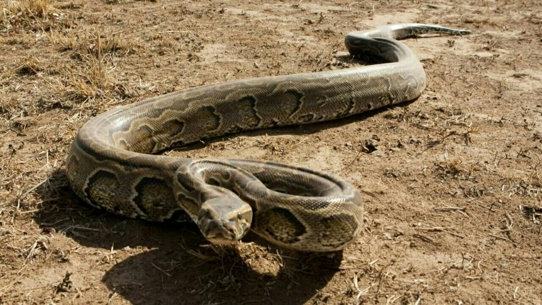**African Rock Pythons**

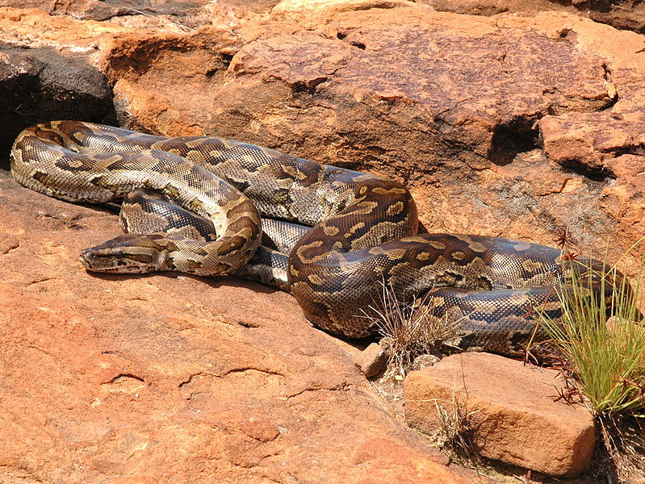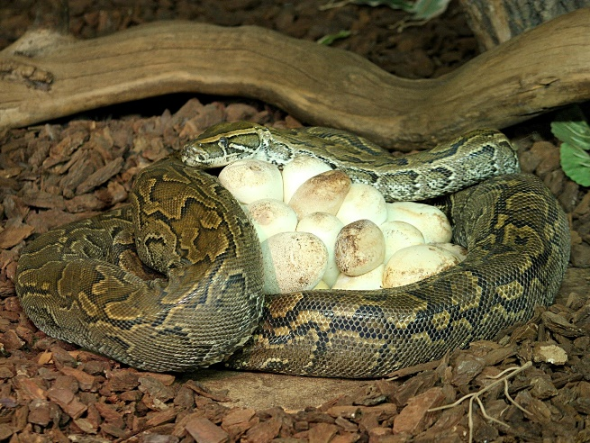African rock pythons are large constrictor snakes native to sub-Saharan Africa. Africa's largest snake and one of the six largest snake species in the world, the typical rock python is about 11 feet, 7 inches long, although particularly large snakes can exceed 20 feet. The African rock python kills its prey by constriction and often eats animals up to the size of antelope, occasionally even crocodiles. They reproduce by laying eggs. In the spring, a female rock python will lay beween 20 and 100 hard-shelled, elongated eggs in an old animal burrow, termite mound, or cave. And they’re shockingly good mothers! Like other snakes, rock pythons are cold-blooded. They’re not capable of producing body heat with which to incubate their eggs. So the mother snake basks in the sunlight, raising her body temperature to potentially dangerous levels. Just a few degrees short of a fatally high body temperature, the snake returns to her burrow. Wrapping herself around the eggs, she passes the heat to her incubating brood. A mother snake must do this every day for three months, substantially reducing her opportunities to hunt. The stress of repeated, extreme changes in body temperature could actually kill her. At the very least, it will take her three years to recover from incubating her brood. Even after the young snakes hatch, a female rock python will continue to protect them for predators for a couple of weeks. This is completely atypical behavior for a snake. Even other pythons do not act in this way. The surprisingly selfless maternal instinct of the African rock python is the first ever discovered in a reptile. Evidently even these large snakes feel that one who is responsible for others must exercise self-denial. Ideally, we humans would do better than these snakes!

Amazon Prime

Africa

Season 1

Episode 3: “Congo”

Start: 8:34 (39:55 from End)

End: 13:18 (35:11 from End)