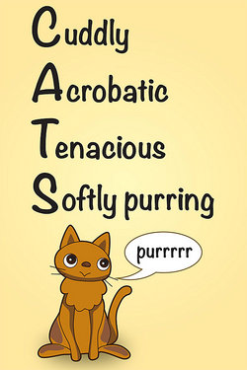These verses begin the final passage of the book of Proverbs. These verses take the form of an acrostic, a type of poem based on statements beginning with letters that form a name, word, or phrase. **Here’s an example:**  The acrostic here in Proverbs is built around the Hebrew alphabet of 22 letters. Verse 10 begins with the first letter, verse 11 with the second, and so on. A number of the Psalms are constructed in this same way (Psalms 9, 10, 25, 34, 37, 111, 112, 119, and 145). This acrostic takes as its topic the nature and behavior of a virtuous woman. Presumably Lemuel’s mother wanted him to find the right sort of wife. Curiously, the phrase translated “a virtuous woman” is literally, “a woman of power.” The phrase in the LXX is literally, “a masculine woman,” meaning that she is strong, vigorous, and possesses excellent qualities. The Hebrew may be understood to mean “a woman of firm character.” In these verses we see her described as utterly faithful. Such a wife may be trusted always to look after her husband’s interests, both emotionally and economically. He doesn’t need “spoil,” extra resources won from battle, because his substance is well and safely managed by his wife. She is focused on his best interest, rather than her own, all the days of her life. So she is entirely dedicated to her family’s needs above all. Such an example of selfless womanhood should indeed be priced “far above rubies!”

**Proverbs 31:10-12**

**Who can find a virtuous woman? for her price is far above rubies.**

**The heart of her husband doth safely trust in her, so that he shall have no need of spoil.**

**She will do him good and not evil all the days of her life.**

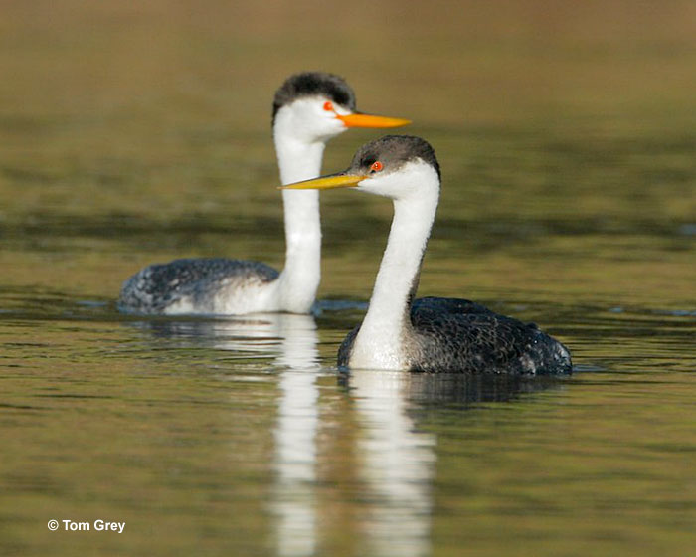**Clark’s Grebes**

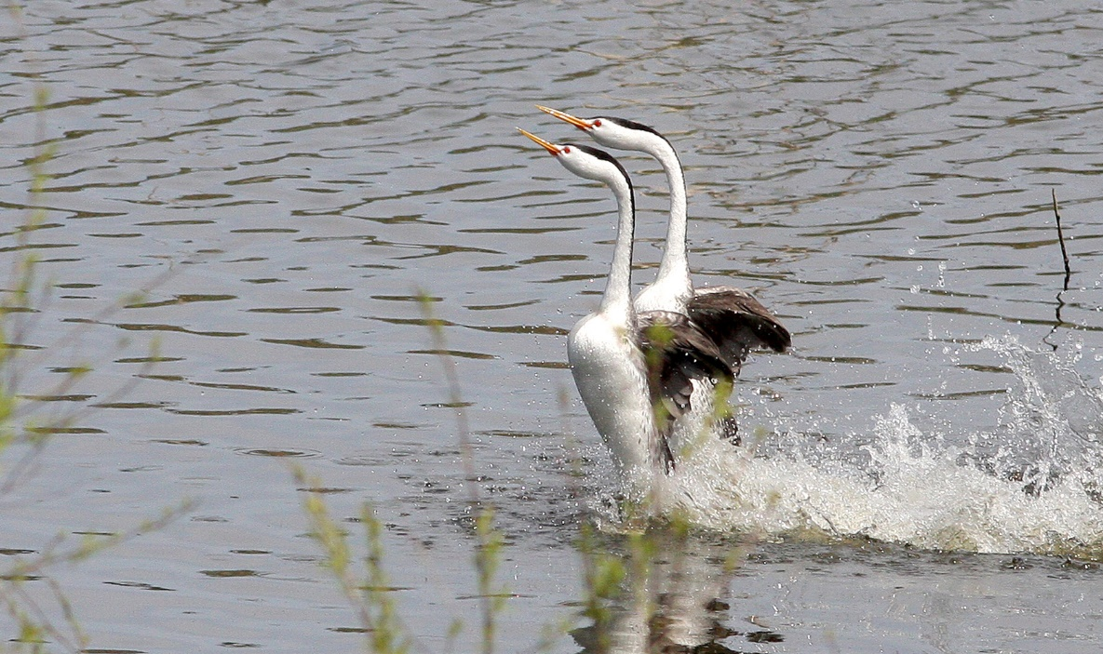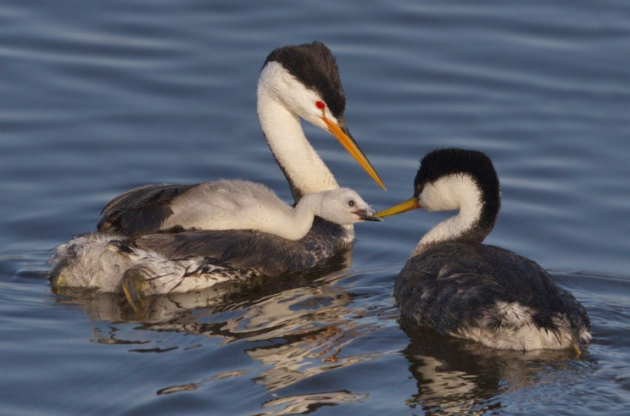Clark’s grebes are substantial North American water birds, growing up to thirty inches long and weighing up to nearly four and a half pounds. They nest in colonies on large inland lakes that have areas both of marsh vegetation and open water. Clark’s grebes are thought to mate for life, and they work together in all aspects of raising chicks. So the mated pairs have a close bond, which they demonstrate with a spectacular courtship display. These pairs have a couple of different “ceremonies” with which they celebrate their bond. They perform repeated motions: preening, splashing, and headshaking. Then, together, they lift their wings stiffly to the side, rear up, and patter across the water’s surface with heads held forward and necks curved. These displays are the most elaborate “dances” among water bird species. Mated pairs also work together in all aspects of raising chicks. Their nests, made of plant debris, are constructed by the partners working together. The male and the female take turns incubating the eggs, while the bird that is not currently sitting on the nest brings food to their mate. Both parents tend the young, carrying the newly hatched chicks on their backs. Parents make a ticking sound to warn their chicks of danger, and in response, chicks duck their heads beneath their parents’ feathers and remain silent until the coast is clear. When the adults cluck, the chicks respond by poking their heads out of their parents’ feathers so that their parents can feed them. It’s a well-organized and very cooperative family structure. The mated pair is completely dedicated to one another’s needs, and even the chicks seem obedient and polite. These amazingly faithful birds rather resemble the ideal wife described here in Proverbs!

Amazon Prime

Life

Season 1

Episode 5: “Birds”

Start: 34:31 (14:22 from End)

End: 37:24 (11:29 from End)